**Stock Trading Algorithm Using Beam Search and LSTM**

**Names and NetIDs of each group member**

Rich Jiang, rijiang

Pavan Kumar Vaddineni, pvaddine

Chaitanya Mandava, cmandava

Wanning Ding, wding04

**A link to the github repository:**

<https://github.com/rjiang1/StockTrade>

1. Manual Implementation

**A detailed explanation of the rules of the game you chose, including the required modification I sent you in my feedback:**

Run the Player_Turns.ipynb/ Player_Turns.py file.

Our game starts by initializing a window of historical stock data, say ‘n’ days long, where ‘n’ is the size of the game provided by the player.

The player portfolio will get Initialized to '0' Apple stocks [1] [2] and 10000 as your cash and displayed on screen.

This data is not revealed to the player all at once, but in little bits at each turn i.e. revealing one day apple stock data [1][2]. The turn starts by revealing apple stocks [1] [2] open, close, high, low and volume (1-day stock details).

The set of four valid actions that a player can select is:

* Buying a stock, one cannot buy stock worth more than his/her cash balance.
* Selling a stock, one cannot sell stocks whose count is more than what he/she owns.
* Do Nothing/ Hold, you will not buy/sell stocks, it’s just skipping your turn.
* Exit - you will be exited out of the prediction game and your portfolio, profit/ loss will be shown.

After choosing an action, it will again display players current portfolio i.e. company name, number of stocks that player owns, player current cash balance.

Once the player's prediction ends after n days (n is what you gave as input at first) we will be calculating totalCash as cash Balance + total shares cost that one holds according to (n+1) day apple stock [1][2] open price.

Next player portfolio, whether he/ she ended up in profit [win] i.e., totalCash > 10000 (starting balance) or loss i.e., totalCash < 10000 will be displayed.

After the game ends it will again prompt you to enter Y/ N to play the game again. Enter Y/y to play the game again or enter N/n to exit the game.

For each turn the player is given information on the current day's information of the stock AAPL.

* High - The highest price the stock traded for that day
* Low - The lowest price the stock traded for that day
* Close - The final price of the stock that day
* Volume - The amount of stocks everyone trades in the stock market on that day
* 20_day - The average price of the stock over the course of the last 20 days
* 50_day - The average price of the stock over the course of the last 50 days

It will update the value of your portfolio accordingly at the start of each turn.

The closing price of the previous day and the opening price of the current day will be different due to after-hours trading and pre-market trading.

**What is the state of the game at each turn and how did you represent it as a data structure?**

After each turn, we display the player's current portfolio that consists of the company name, number of shares of that company owned by player and player’s current cash balance. We are using dictionary to store portfolio i.e. {companyName: # of shares} and current cash balance is stored in a variable.

**What are the valid actions at each step?**

* Buy - Enter B/b to buy a stock and then you should enter the number of stocks you want to buy. One cannot buy stock worth more than his/her cash balance.
* Sell - Enter S/s to sell a stock and then you should enter the number of stocks you want to sell. One cannot sell stocks whose count is more than what he/ she owns.
* Do Nothing/ Hold - Enter H/h, you will be shown next day apple stock [1][2] just by skipping your current turn.
* Exit - Enter E/e you will be exited out of the prediction game and your portfolio, profit/ loss will be shown.

**When is the game over and how is the winner/score determined?**

Game can end in 2 ways:

* If a player enters the E/e option when he/ she prompted for action after displaying current day apple stock [1][2].
* When all his turns for predicting and taking actions gets finished i.e., predicting ‘n’ times, where n is the size of the game taken as input from the user.

**An explanation of how you varied the size of the problem instance in your experiments. Did you try different board sizes? Different numbers of pieces or players? Different numbers of cards in a deck? Different numbers of actions available?**

Yes, we tried with different sizes of problems while testing (number of days the player wants to predict and take action as 5,10,30, …). As of now, we just implemented our game as a single player game.

**Language and Libraries**

Python [11], numpy [12], pandas [13], tensorflow[18]/keras [19]

**Include an example with a picture and text description that illustrates a typical step during game- play.**

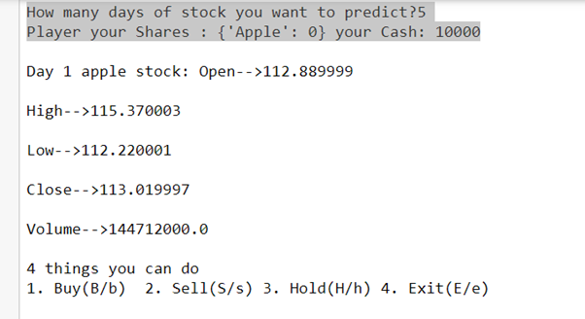

At First when we start the game, the player will be prompted to enter how many days prediction process should take place (game size). Next, we will be displaying initial values of player portfolio and cash as 10000 which is fixed whenever we start the game. Here we are considering apple stocks [1][2], so we maintained only the Apple [1] i.e AAPL [2] company name with 0 stocks in our portfolio.

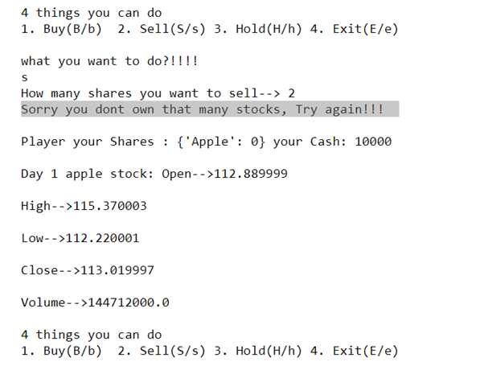

When a player tries to sell stocks more than what he/she owns, here the player is trying to sell 2 stocks but owns zero apple stocks [1][2], therefore we display an error statement and again display same day stocks data along with actions because error from his/her side should not skip the turn.

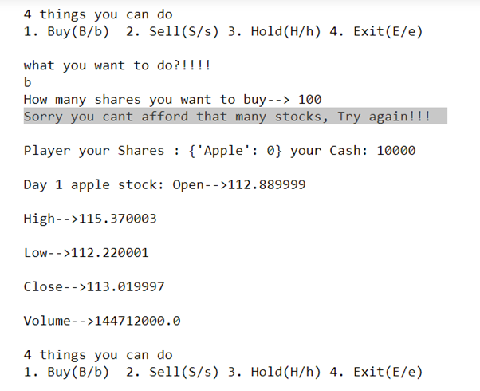

When player tries to buy stocks worth more than his/her current balance i.e., here player is trying to buy 100 stocks but has only 10K cash balance whereas stocks cost is 11288.99, therefore we display an error statement and again display same day stocks data along with actions because error from his/her side should not skip the turn.

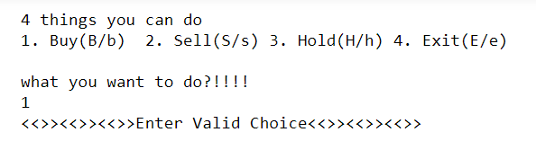

Whenever a player enters choices other than mentioned above, it will display the message above to re-enter his/her choice until he enters a valid choice. This mistake from players also doesn’t result in turns skipped.

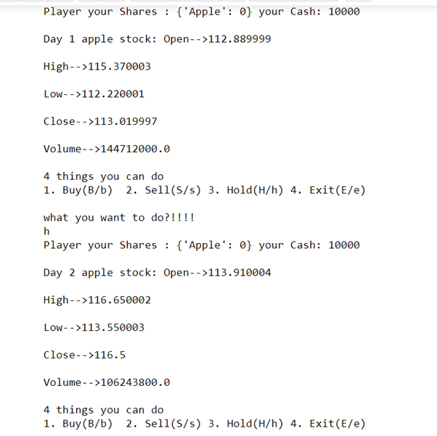

Here the player entered the hold option which means he did neither buy nor sell a stock which results in no update in portfolio and cash along with turn count gets increased by 1.

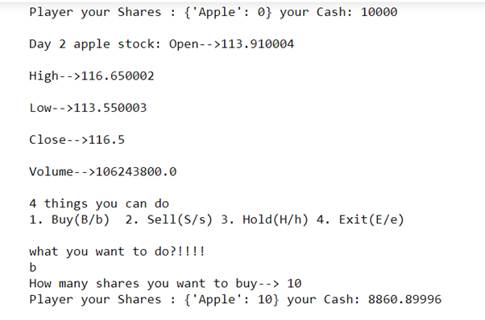

Here player buys 10 apple stocks [1][2] which resulted in Apple stock [1][2] count getting increased by 10 and cash reduction to shown amount (Cash decreases by # of shares bought * Open price on that day).

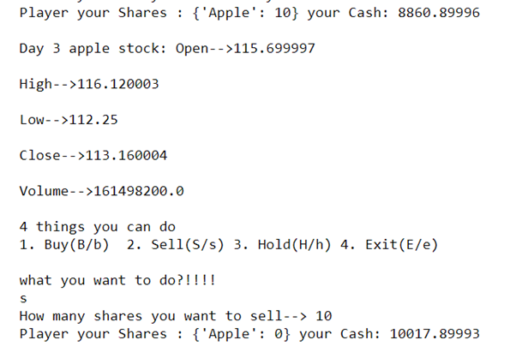

When player sells his stocks i.e., 10 stocks which is all the stock he/ she owns, count of shares get updated to 0 and Cash gets increased by amount (# of shares sold * Open price on that day).

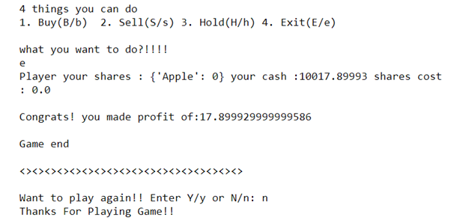

Here the player had entered the ‘e’ option which means exit or all turns got finished, that results in displaying the result along with the player's portfolio. If your cash + shares cost (# of shares he owns * cost of that share on n+1 day) > 10000 it displays profit (i.e., win case) with message shown above or if total cash < 10000 its lost case or else there is no loss or profit. After that, the game ends and it will prompt asking whether you wanted to play the game again or not. I entered n which means no, so it displays “Thanks For Playing Game!!” message, if you entered y/Y game will again start from the beginning.

1. Beam Search [3]

**Detailed explanation of the BeamSearch AI [3] and Pruning Strategy:**

The size of the search tree is limited by the player directly：

* Each node has at most 3 possible actions, [“buy”, “sell”, “hold”] shown as [‘b’,’s’,h’]. For each level, we choose k = 4 (beam size) nodes and therefore at most 12 child actions for each level are produced. There can be times where there are less than 12 actions available because some actions will be invalid. Therefore when this occurs, we choose less than 4 nodes due to this. Since we choose 4 nodes at each level, we prune 0-8 nodes depending on the number of available actions i.e.,prune of at most 8 nodes = difference of at most 12 actions at each level - size of the beam which is 4 in our case.
* The depth of the search tree is the number of days the player would like the AI to trade for. The player will be prompted to enter the number of days at the beginning of the “game”.

At the same time the cash with which AI should start with will also need to be set by the player. In addition, to show the player good performance of AI, it is better to set the entered cash at least **5000** as each apple stock [1][2] costs around 100-120 dollars.

The method used for choosing children is to choose the k best actions at each level (k is set by ourselves and is the beam size of our search), and the one best action at the last level. We determine the best by our heuristic that uses price moving averages [24] on a 20 day basis. In other words, we have a sliding window of averages for the past 20 days. We measure the difference of the price by taking the opening price and subtracting it by the moving average [24]. This way if the difference is negative that indicates a favorability towards buying. Positives favor the sell action. Before choosing we sort all nodes into three buckets; buy,sell,or hold. Then we decided that if the difference is 0 or less we will choose the two best buy actions in our buy bucket and the two best hold actions in our bucket. If the difference is more than 0 we choose two sell actions from the respective bucket and the other two from the hold bucket (as k- beam size is 4 we chose k/2 buys or sells along with k/2 holds at each level). We determine the best from each bucket by measuring the size value of the portfolio by summing the cash left with him by the total value of the stocks we own.

**How to Run the Program:**

1. Run the AI_turns.py file.
2. It's a single player trading game that AI (either baseline AI or beam search AI [3]) plays.
3. First you need to enter the number of days you wanted AI to predict and the cash with which AI should start with (try to enter cash > 5000 to see performance of AI).
4. Now you will be prompted to select AI you want to use as shown below to start trading

[Which AI you want to choose: BaselineAI (Enter B), BeamSearchAI (Enter BS):] Enter B/b to choose Baseline AI or enter BS/bs to choose beam search AI [3].

1. Next, AI’s portfolio gets initialized to zero apple [1] shares and cash as the value you entered .
2. Then it will show the level of tree generated by BeamSearch algorithm [3], number of nodes processed, (which is at most 12 i.e., 'k' * 3 (buy, sell or hold - 3 options) where k = 4 is beam size or number of random actions to be chosen in our algorithm for beam search [3] or baseline AI respectively) and set of actions that AI has taken at that particular level.
   1. b - Buy 5% of initial cash worth stocks
   2. s - Sell 5% of initial cash worth stocks
   3. h - hold/ do nothing

It also displays some error messages if AI performs some invalid actions saying not enough cash, not enough shares.

1. Next you can keep hitting the enter key to see the every next level action taken by AI until AI finishes the game after n steps (n is the number of days set by the player).
2. To trade again with AI, run the AI_turns.py file.

**Output**

This appears at the end of 7th step. The “game” will show the level of the tree generated by the BeamSearch algorithm [3], number of nodes AI processed and the set of actions that AI has taken at each particular level.

In the end (after n days):

* “Cash” which is the cash AI holds now will be shown.
* “AI portfolio” which is the shares AI holds now will be shown.
* “Last day Open Price” will also be shown according to the data in AAPL.csv.
* “Total Cash Value” calculated as cash Balance + total shares cost that one holds according to n+1 day apple stocks [1][2] open price will be displayed.
* Total number of nodes AI processed in the entire game.
* The outcome of the game whether AI ended up in profit [win] i.e., totalCash > Cash (starting balance) or loss i.e., totalCash < Cash will be displayed.

**Experimental Results**

Here we had shown 20 plots: 5 plots for performance of beam search AI [3] trading, 5 plots for performance of baseline AI trading for 5, 25, 45, 65, 85 days. 5 plots for efficiency of beam search AI [3] trading, 5 plots for efficiency of baseline AI trading for 5, 25, 45, 65, 85 days.

Set of the same 100 random starting cash values in USD used over 100 iterations for plotting performance and Efficiency graphs: Below the array represents randomly generated starting cash values, sorted, we used in our simulations / backtesting.

**[5002, 5071, 5232, 5235, 5389, 5439, 5514, 5628, 5765, 5894, 5953, 5984, 6112, 6152, 6159, 6314, 6320, 6376, 6429, 6694, 6752, 6821, 6879, 6927, 7120, 7179, 7270, 7278, 7621, 7694, 7710, 7711, 7723, 7748, 7792, 7849, 7856, 7893, 7905, 8000, 8046, 8476, 8592, 8636, 8820, 8913, 9058, 9084, 9160, 9419, 9499, 9666, 9683, 10140, 10145, 10203, 10366, 10450, 10473, 10481, 10522, 10680, 10684, 10697, 10776, 11012, 11064, 11207, 11213, 11396, 11478, 11747, 11823, 12043, 12217, 12420, 12446, 12517, 12716, 12961, 13055, 13401, 13402, 13406, 13413, 13416, 13452, 13472, 13488, 13675, 13741, 14006, 14036, 14081, 14193, 14245, 14548, 14616, 14948, 14987]**

**Performance Graphs of Beam search AI [3] and Baseline AI for 5, 25, 45, 65, 85 days:**

1. Our Beam search AI [3] performance graph for 5 days:

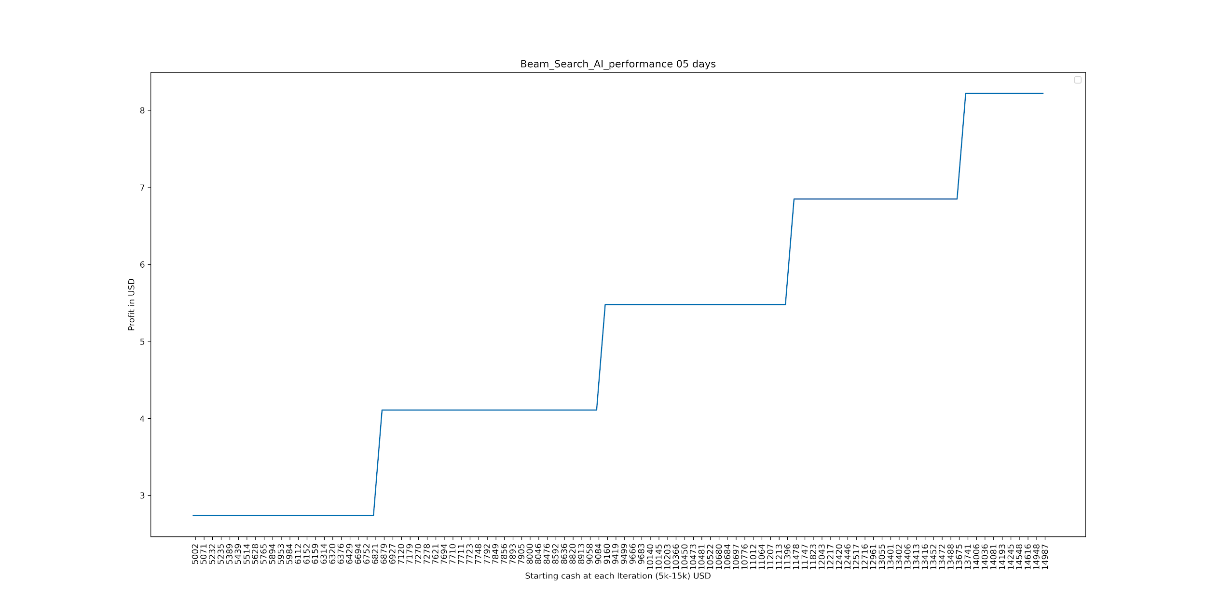

BaseLine AI performance graph for 5 days:

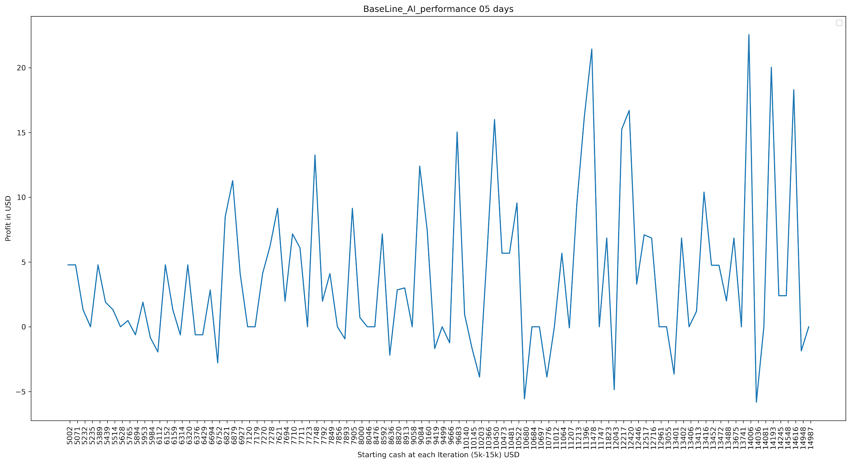

1. Our Beam search AI [3] performance graph for 25 days:

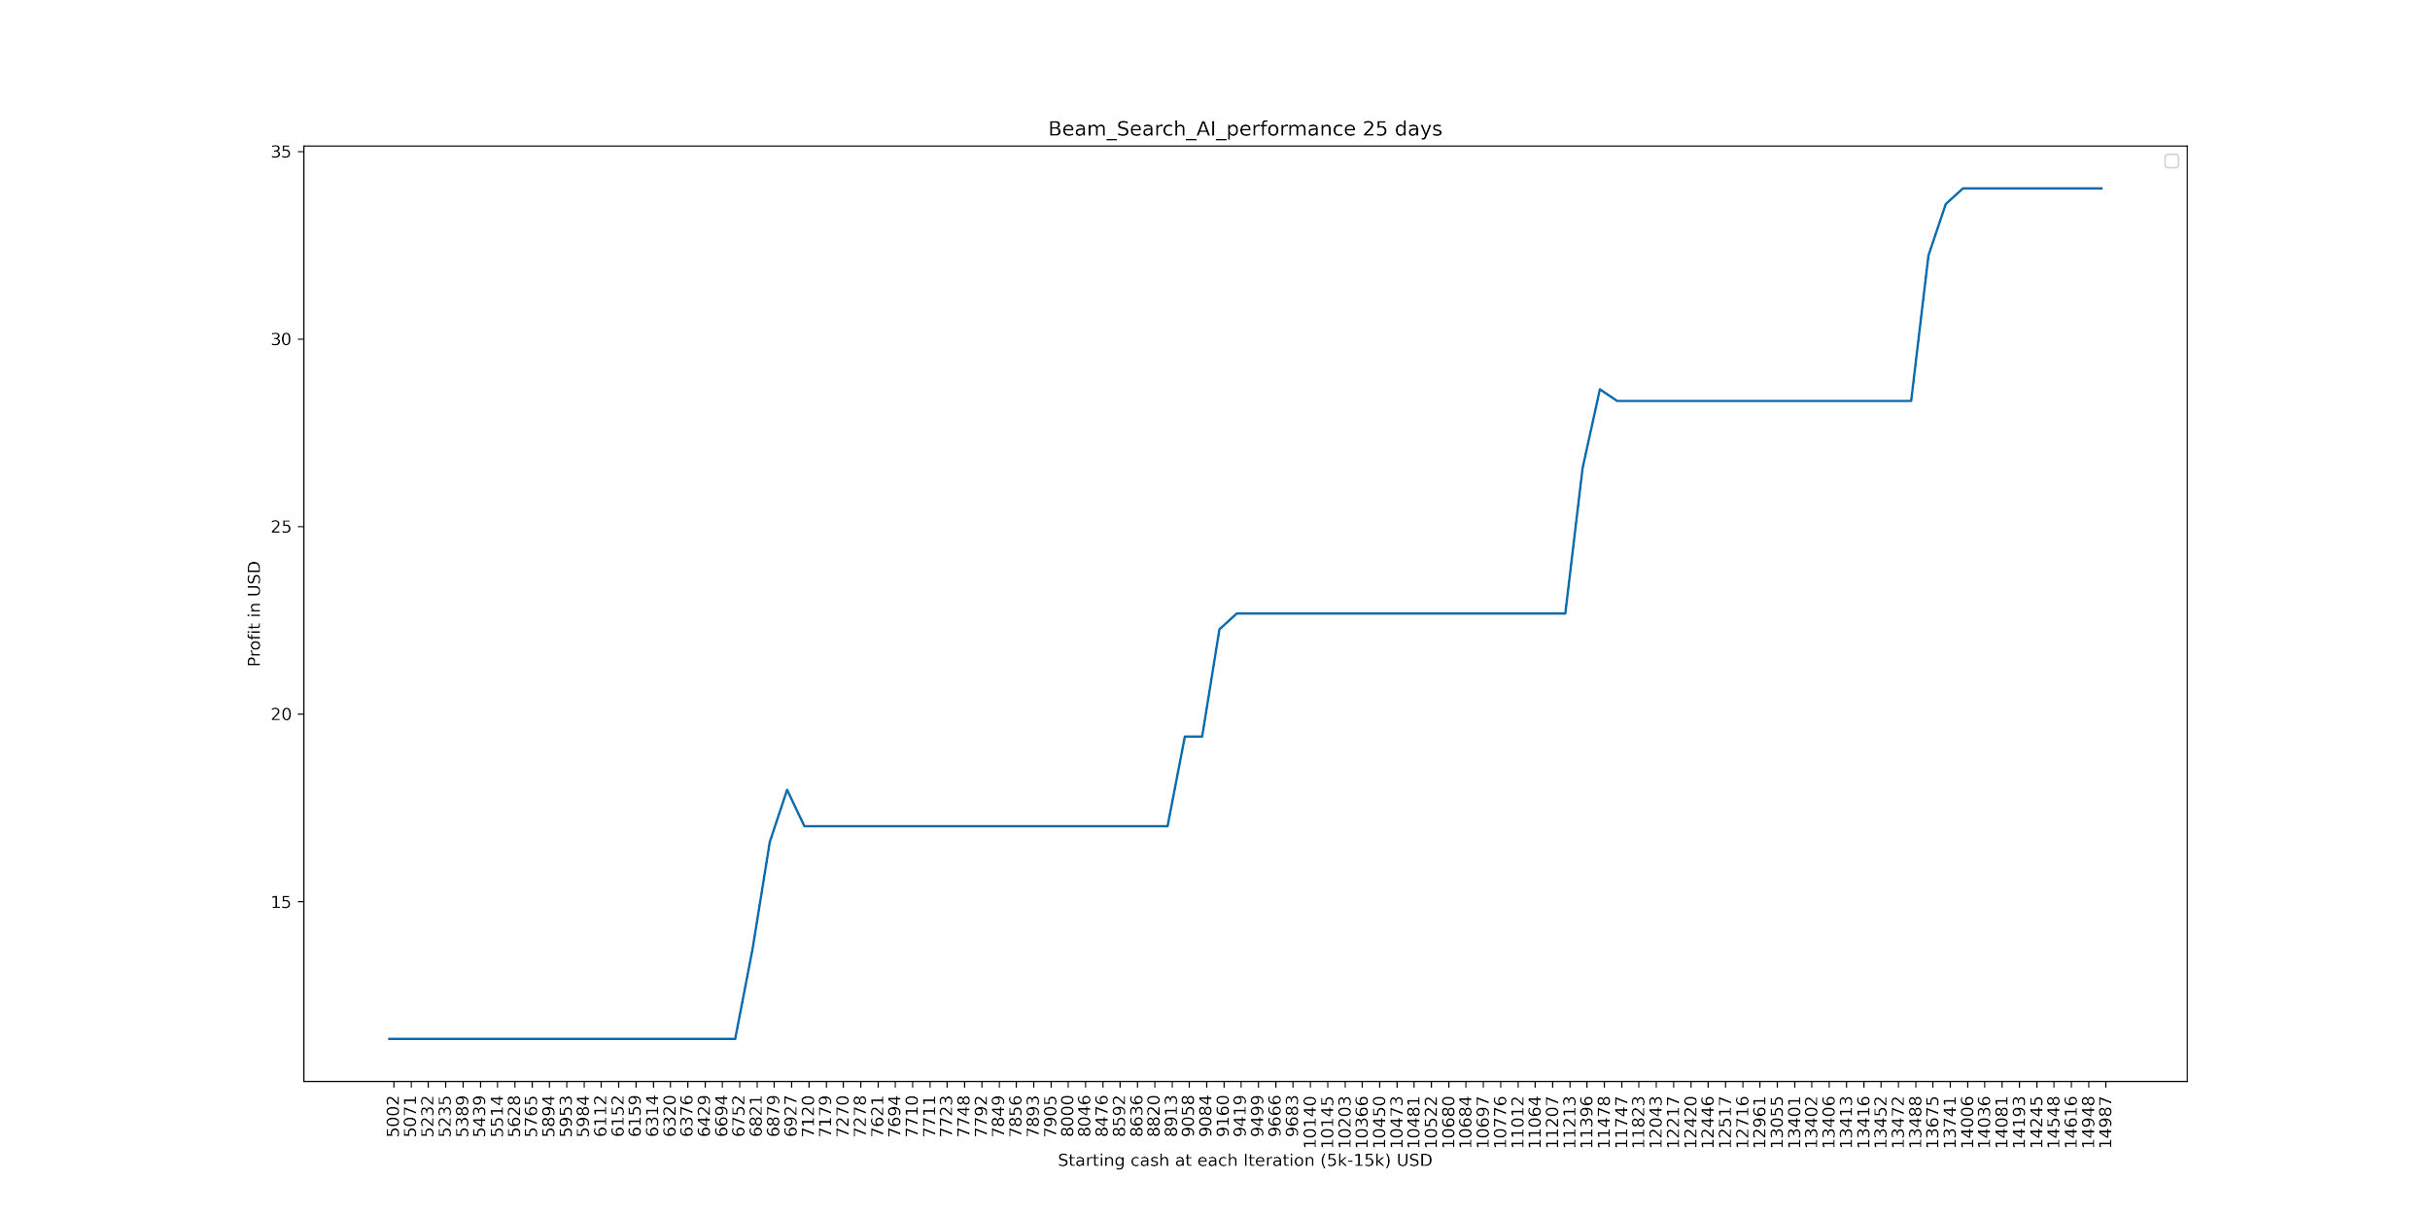

BaseLine AI performance graph for 25 days:

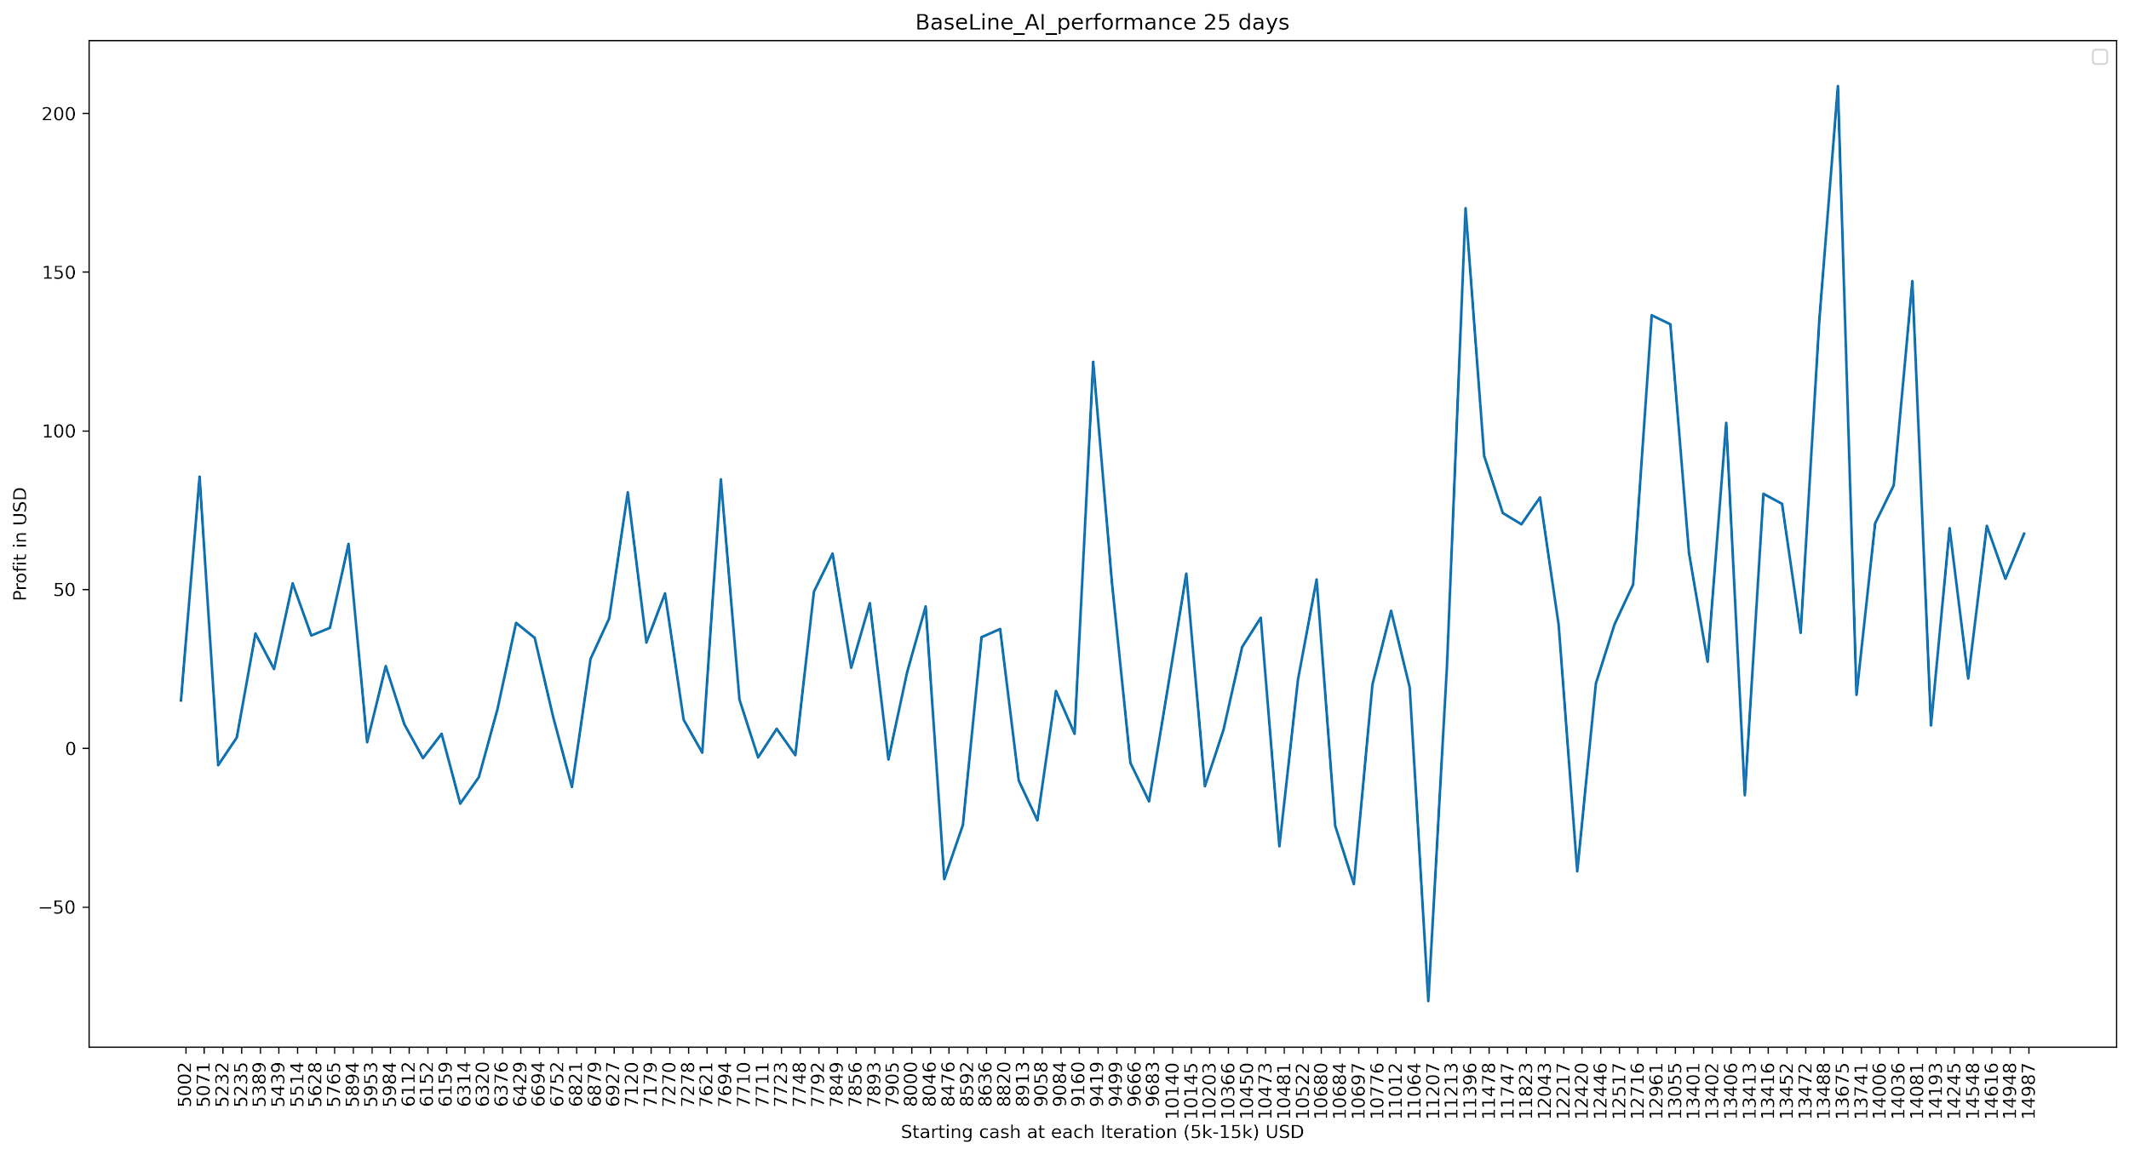

1. Our Beam search AI [3] performance graph for 45 days:

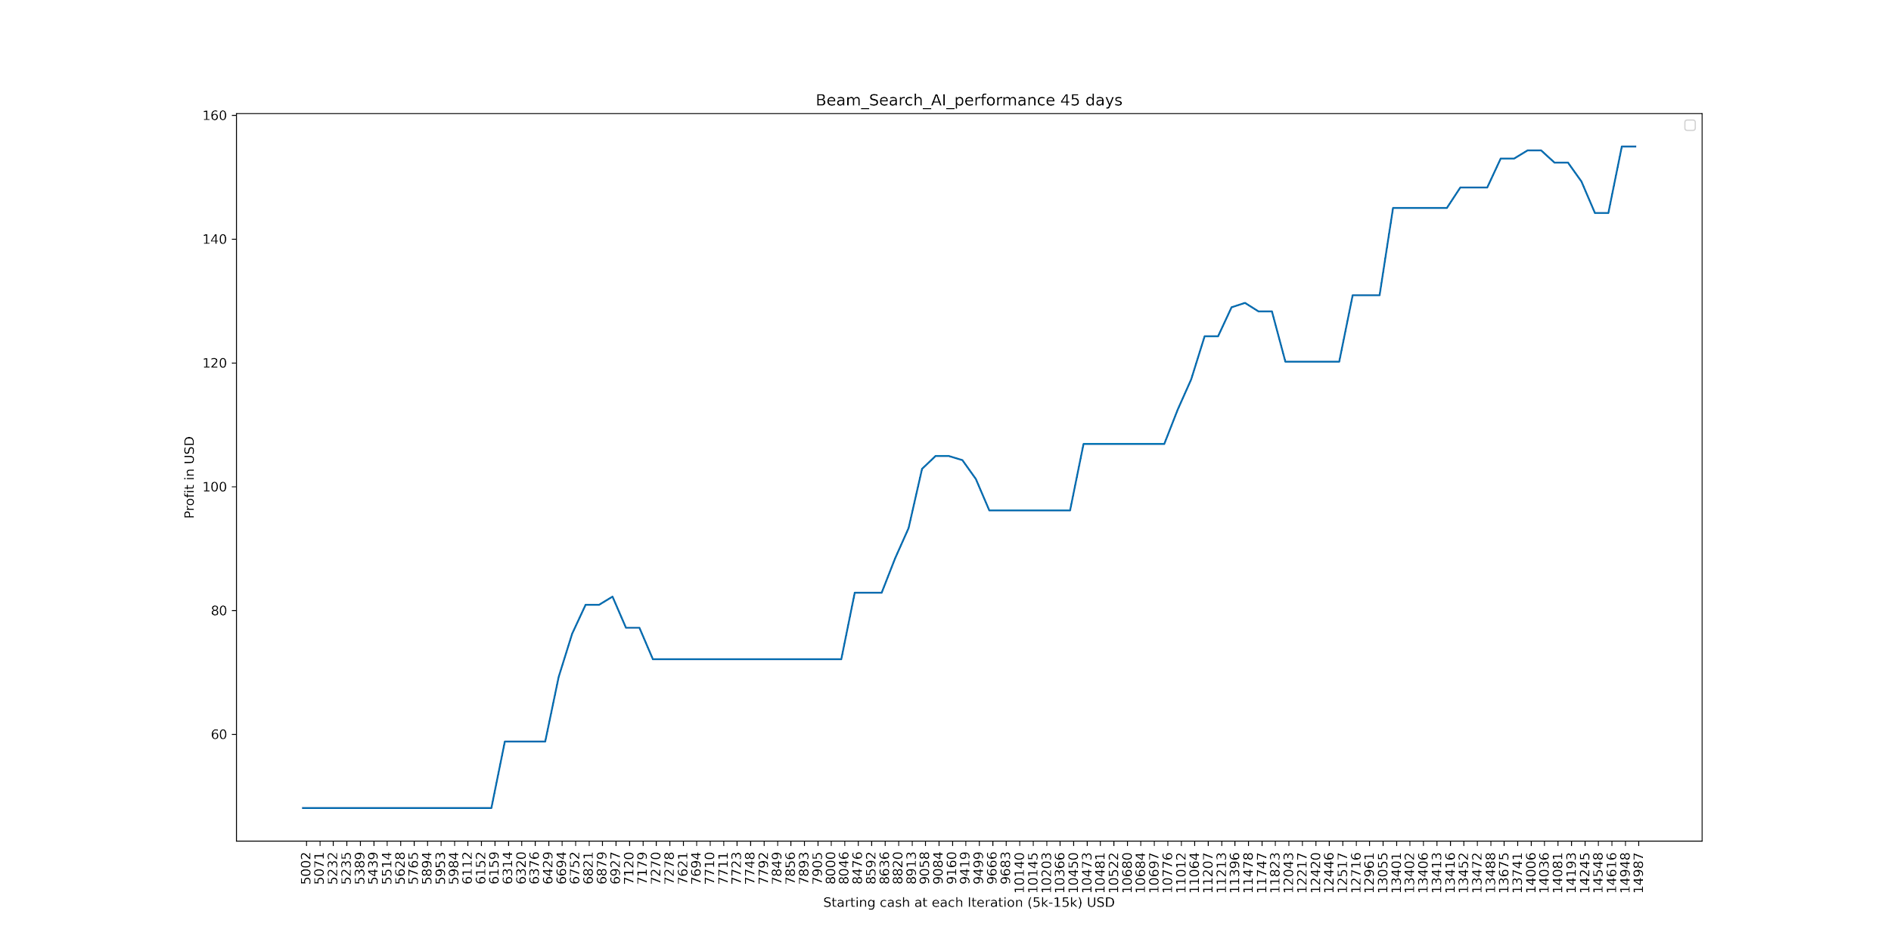

BaseLine AI performance graph for 45 days:

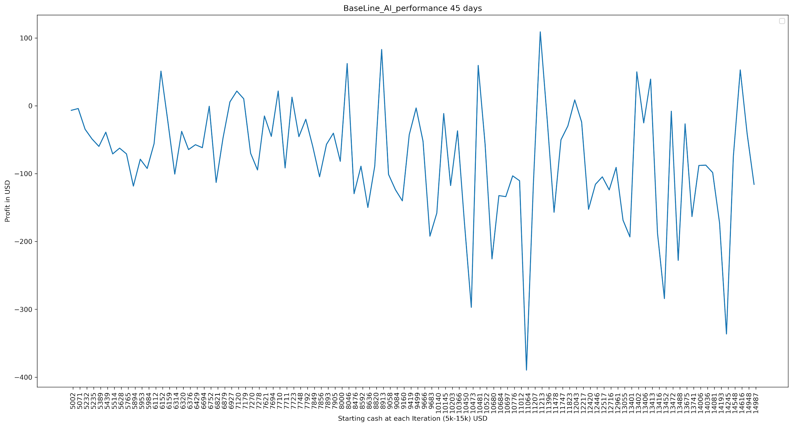

1. Our Beam search AI [3] performance graph for 65 days:

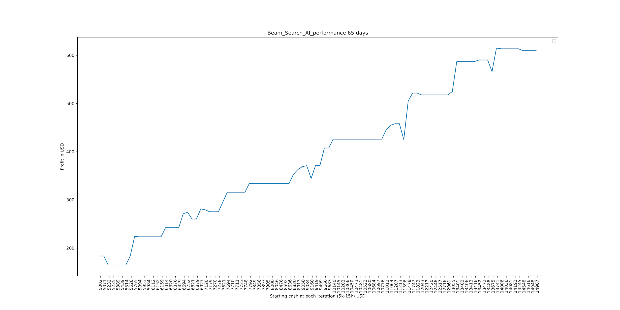

BaseLine AI performance graph for 65 days:

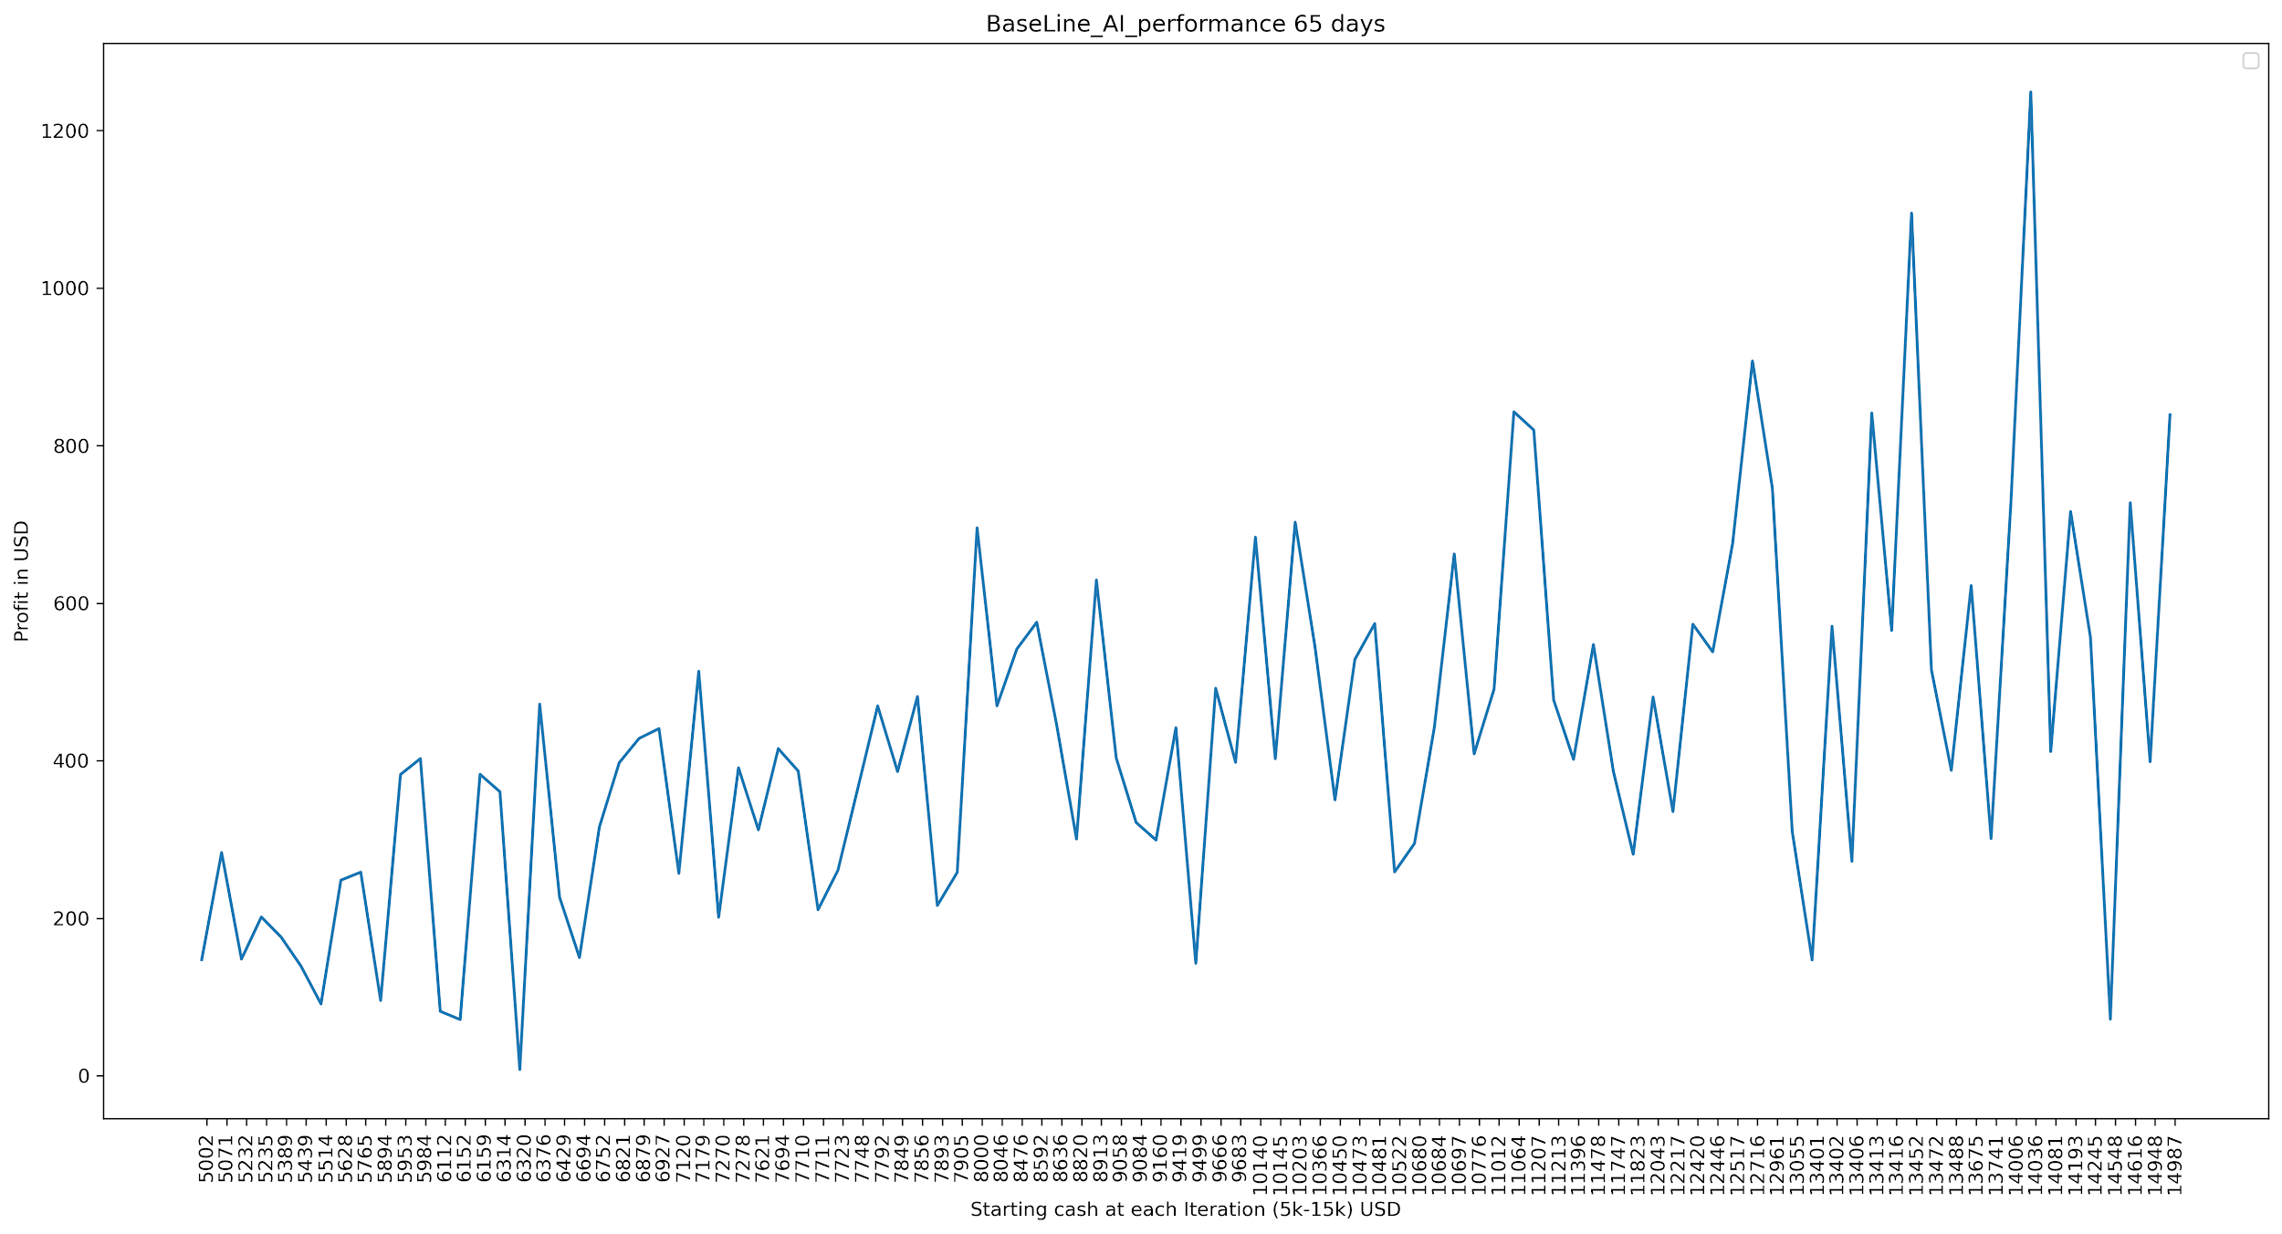

1. Our Beam search AI [3] performance graph for 85 days:

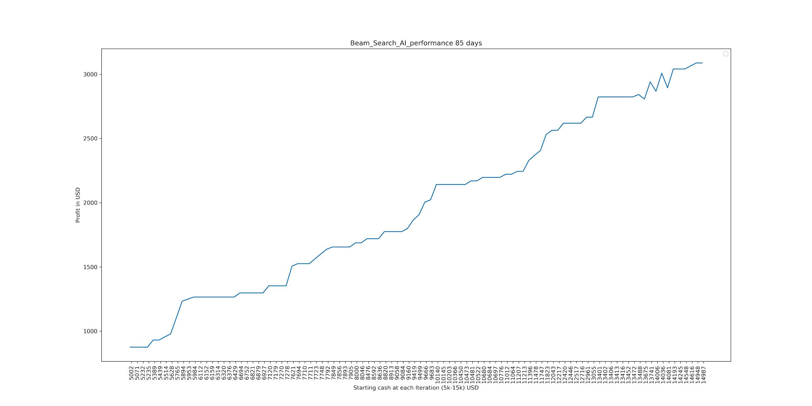

BaseLine AI performance graph for 85 days:

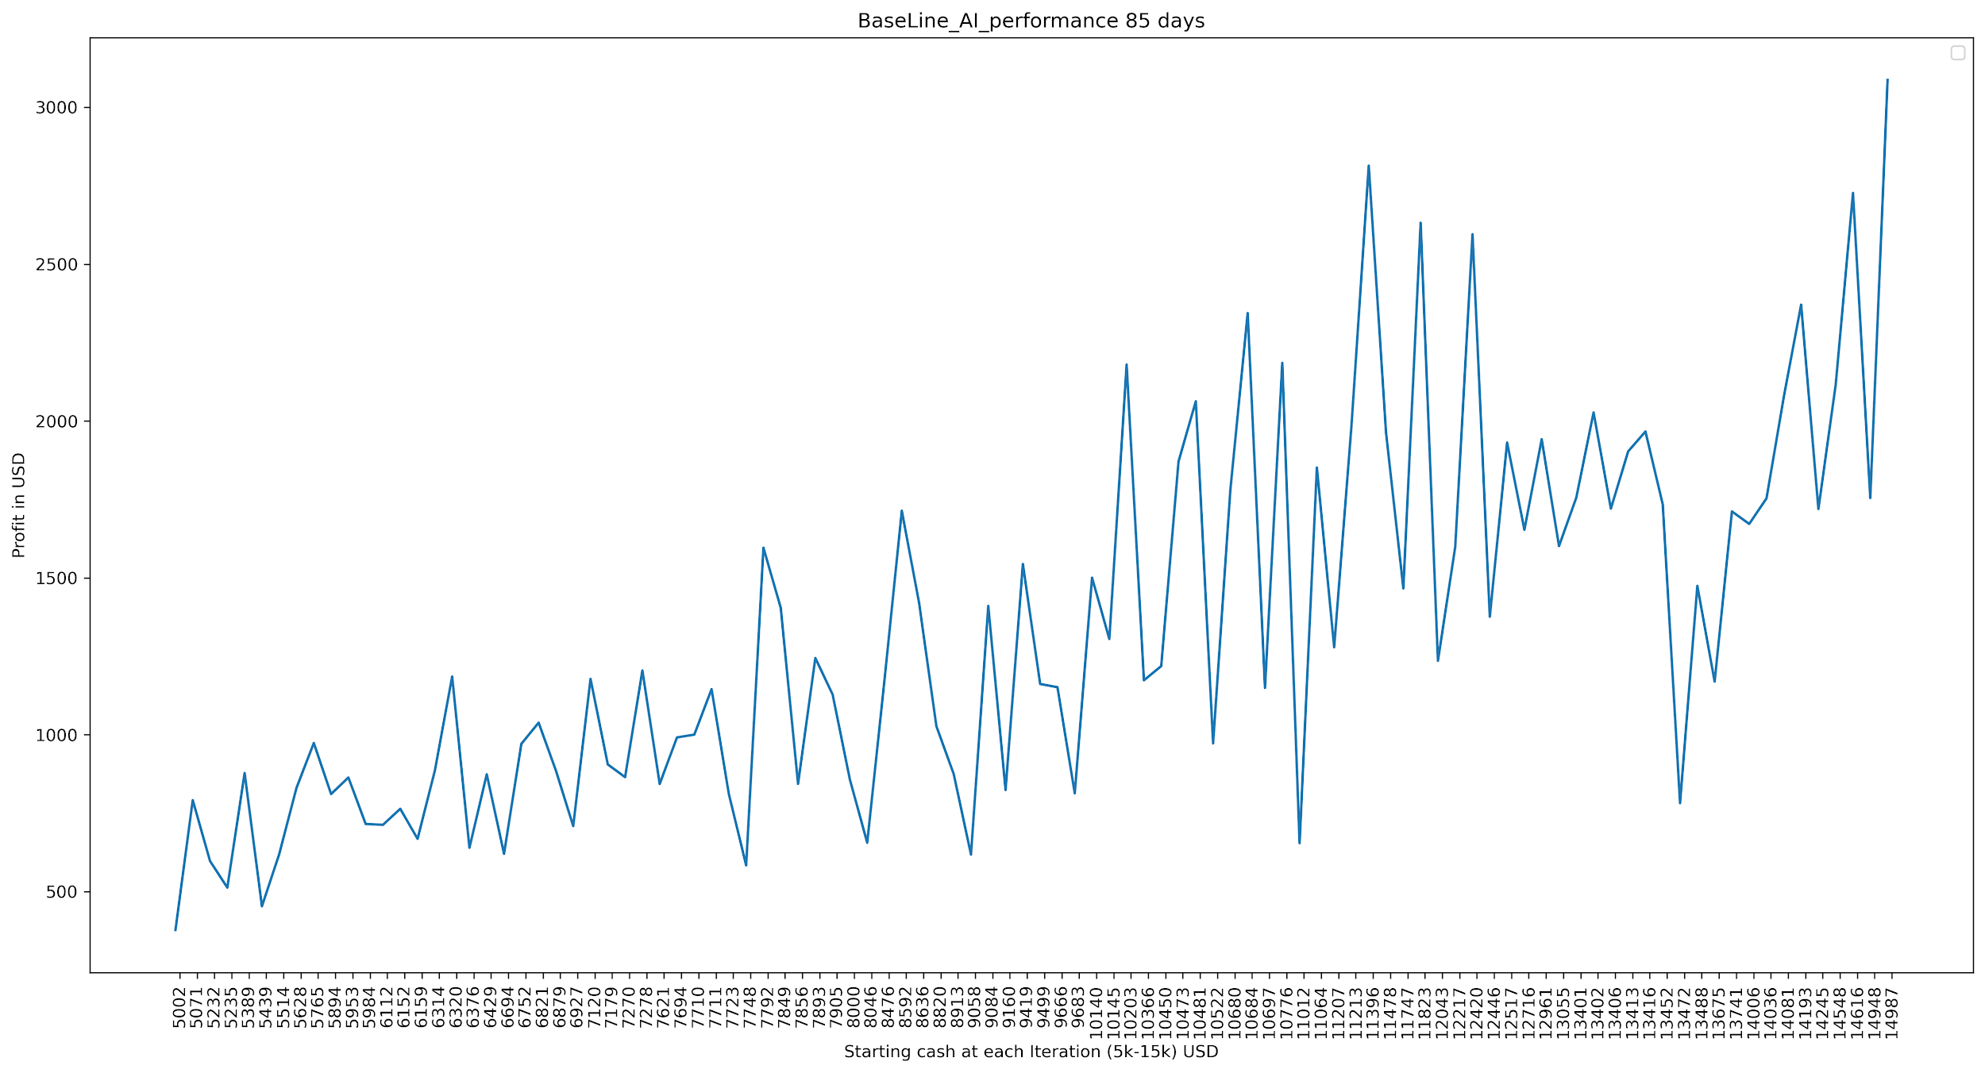

**Efficiency Graphs of Beam search AI [3] and Baseline AI for 5, 25, 45, 65, 85 days:**

1. Beam search AI [3] efficiency graph for 5 days:

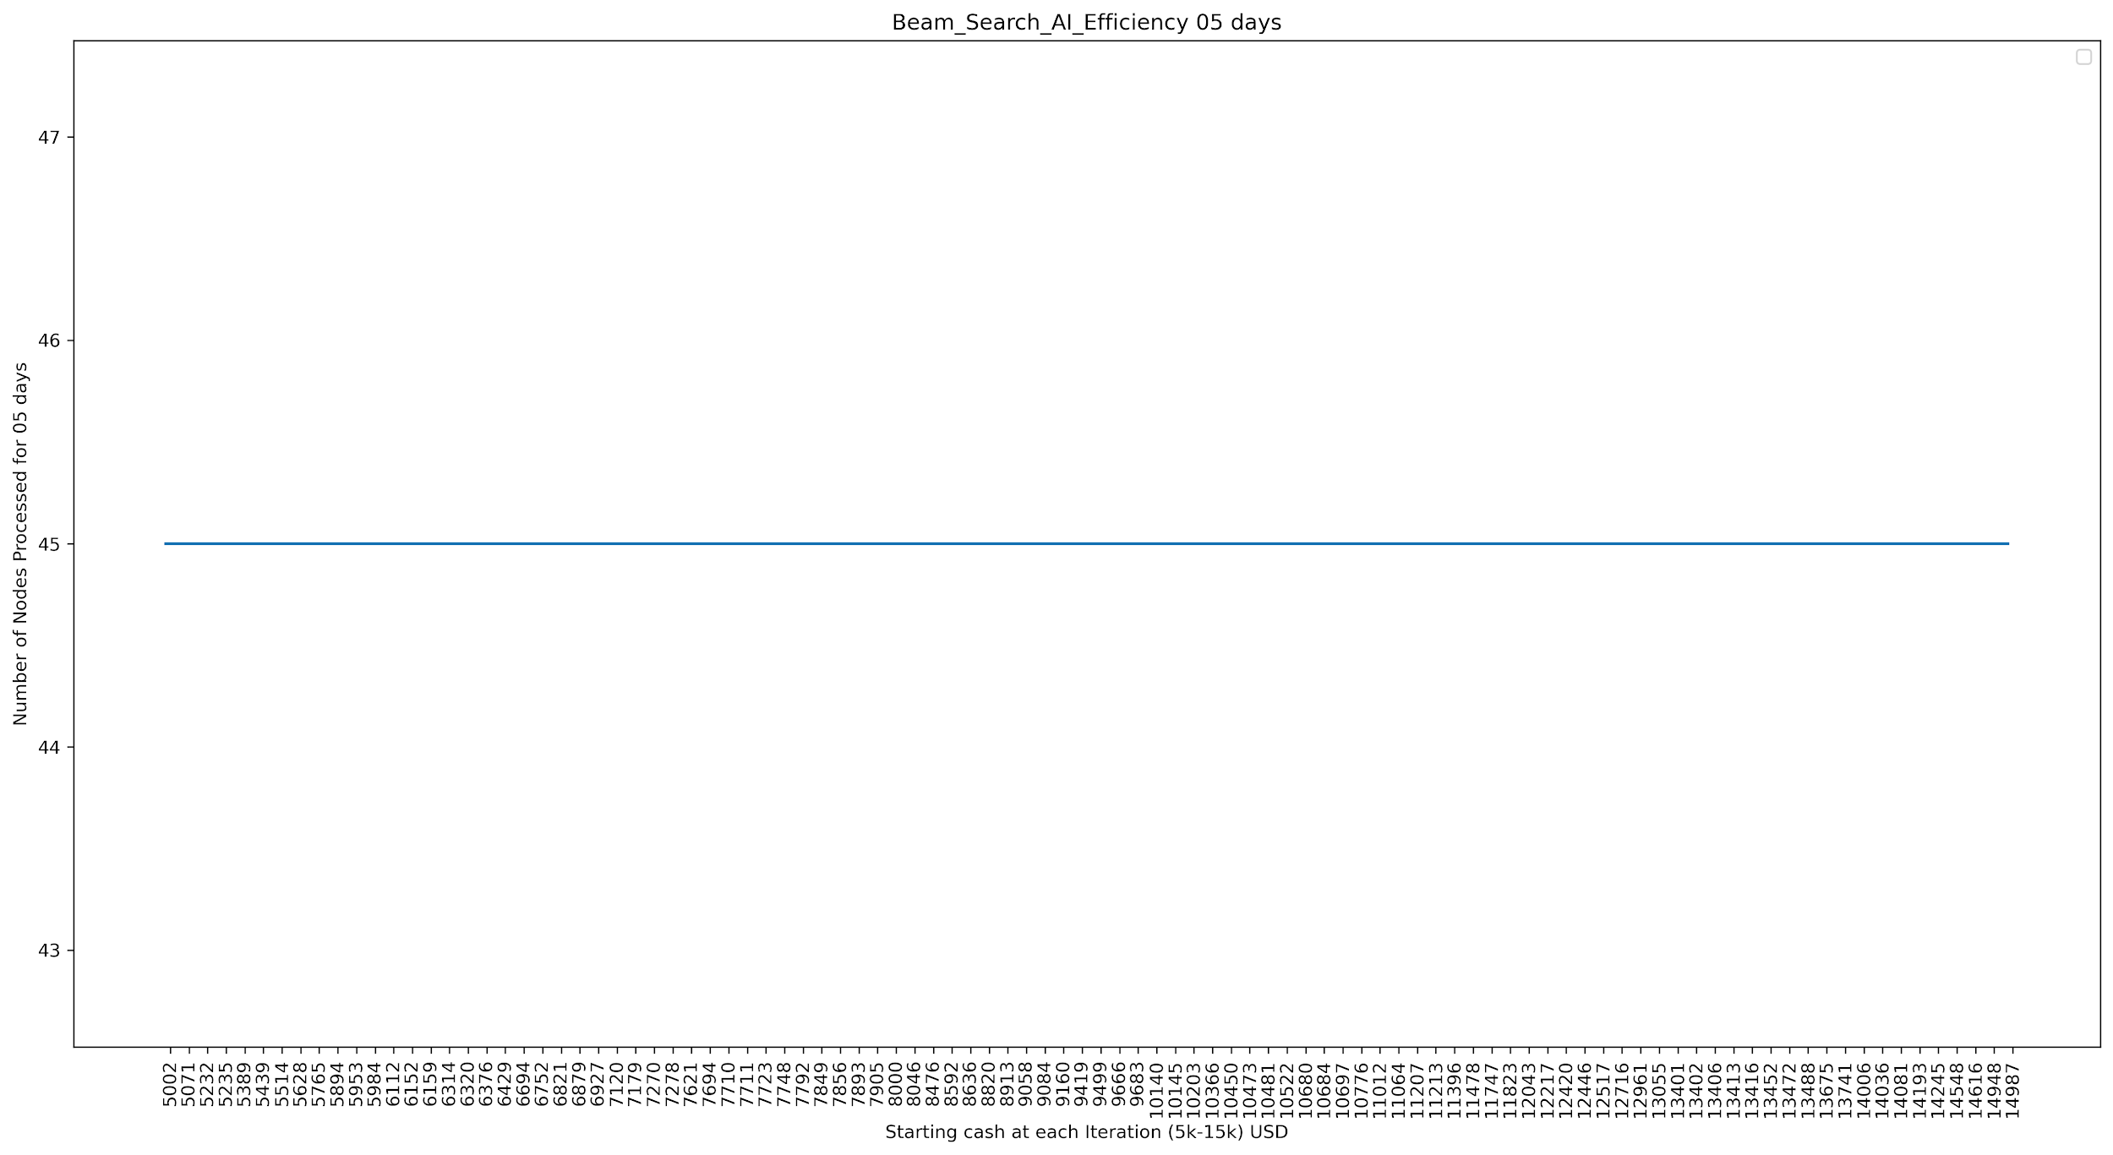

BaseLine AI efficiency graph for 5 days: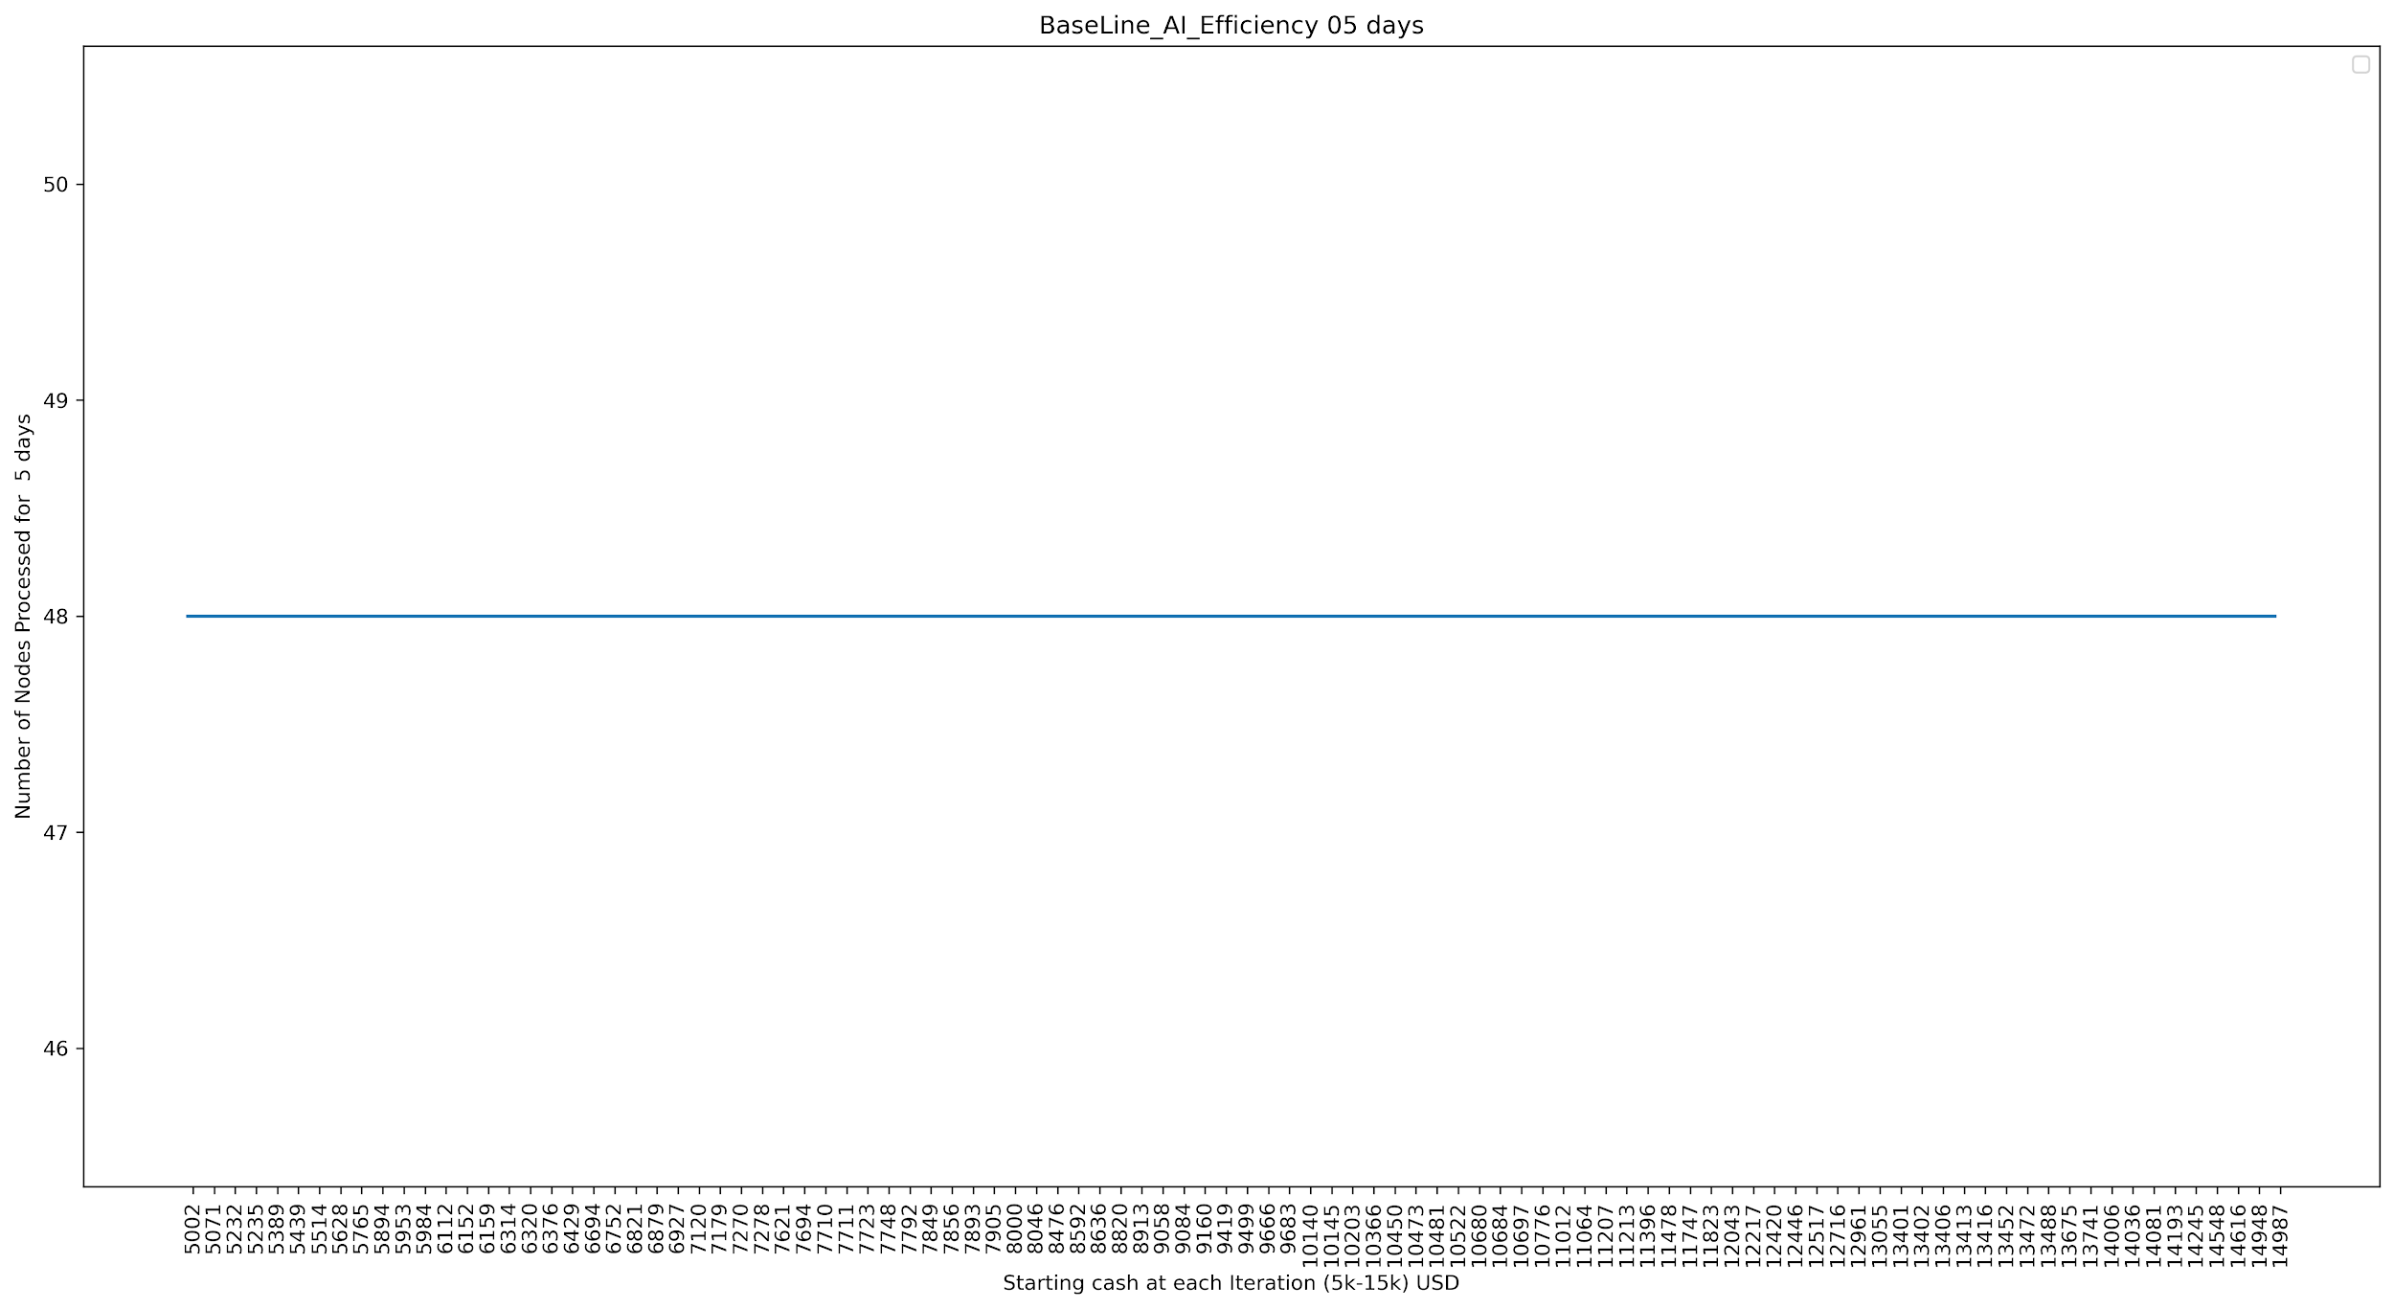

1. Beam search AI [3] efficiency graph for 25 days:

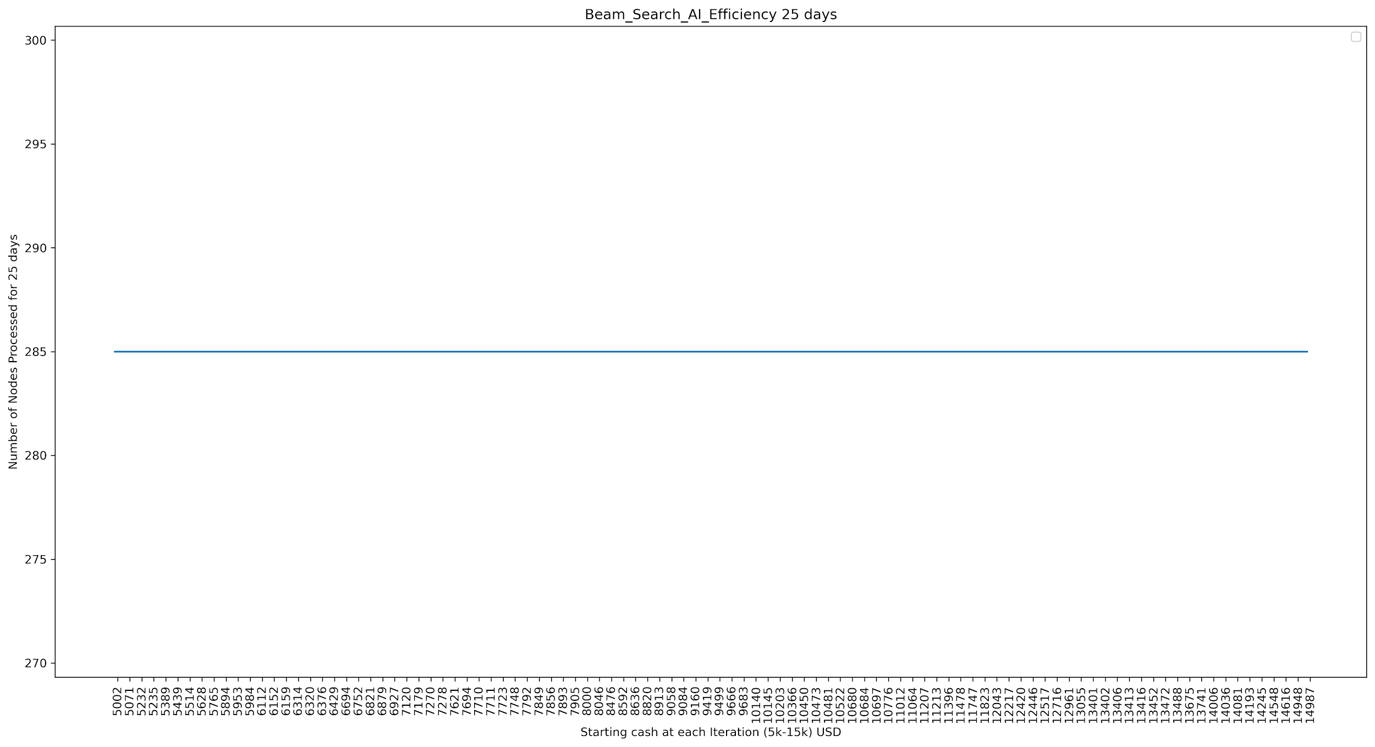

BaseLine AI efficiency graph for 25 days: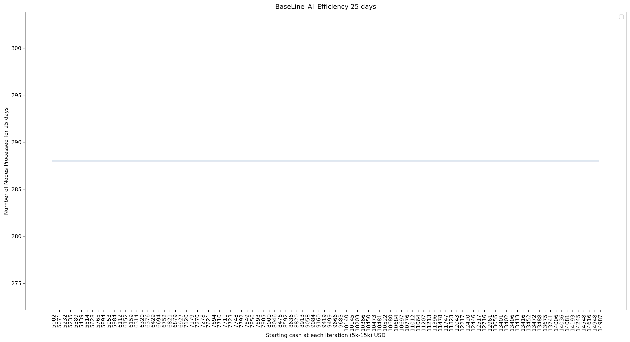

1. Beam search AI efficiency graph for 45 days:

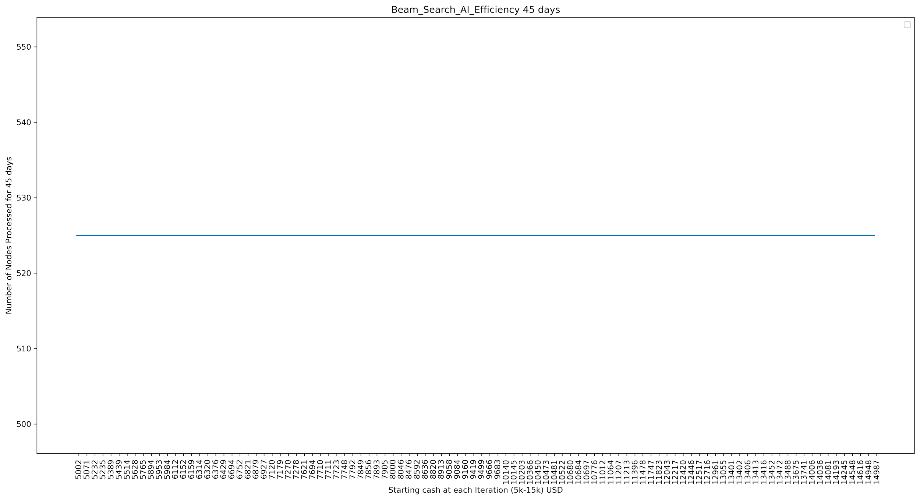

BaseLine AI [3] efficiency graph for 45 days:

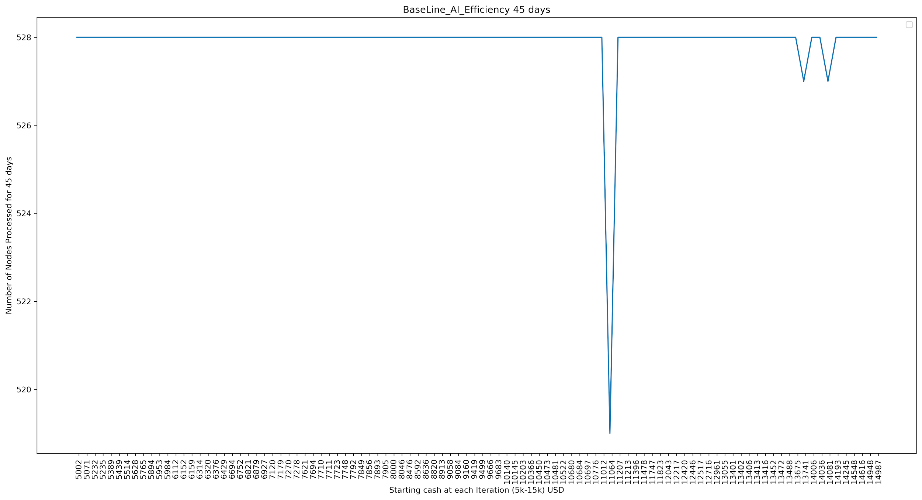

1. Beam search AI [3] efficiency graph for 65 days:

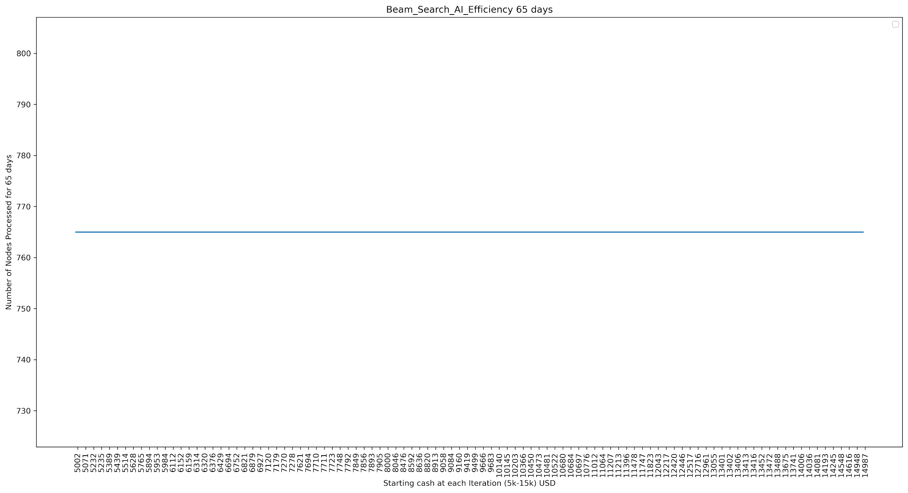

BaseLine AI efficiency graph for 65 days: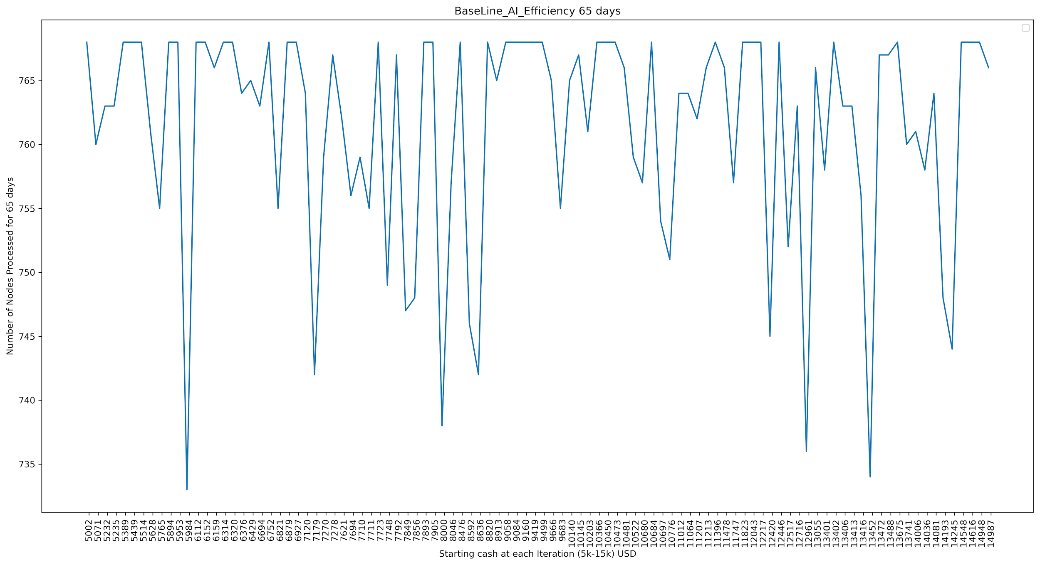

1. Beam search [3] AI efficiency graph for 85 days:

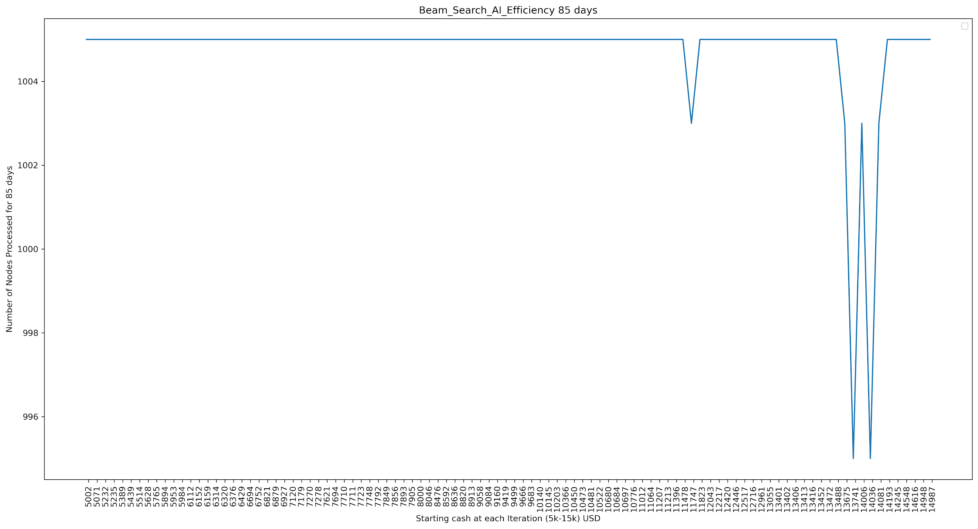

BaseLine AI efficiency graph for 85 days:

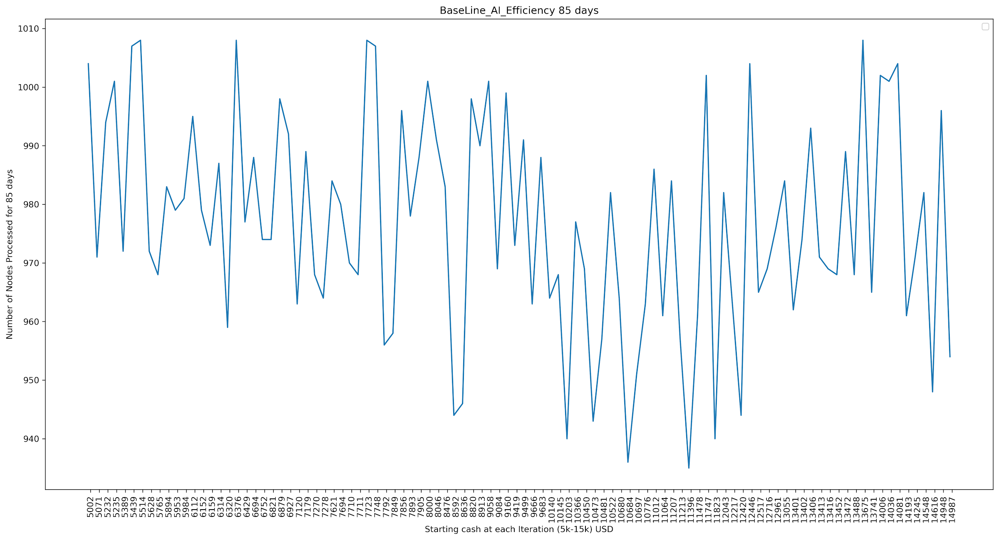

**Our Observations from results:**

Even though both BeamSearch AI [3] and baseline AI had processed almost the same amount of nodes for each game size, we can see beam search AI [3] has proven to be consistent (always increasing with increase in start cash) in generating profits no matter whatever the game size is and never resulted in losses, where as baseline AI is in consistent (lots of highs and lows in profit generated with increase in start cash) and even resulted in losses.

**Dataset Used**

[1][2] “Apple Inc. (AAPL) Stock Historical Prices & Data.” *Yahoo! Finance*, Yahoo!, 13 Nov. 2020, finance.yahoo.com/quote/AAPL/history/.

1. Beam Search [3] and Neural Network LSTM [4] [5] [6]

**Instructions to run game having options to be playable by human, baseline AI, beam search [3] tree AI, NN + tree AI:**

NN + BeamSearch_Tree_AI, BeamSearch_Tree_AI and Base line AI:

Run the NN_Tree_AI_turns.py file.

It's a single player trading game that Either Human or AI (NN + BeamSearch [3], BeamSearch [3] or Baseline)plays.

You will be prompted to enter the cash with which AI should start with. (Try to enter at least 5000 cash as each apple stock [1][2] costs around 100-120 dollars, this will help you to see the performance of AI)

Next you will be prompted to enter the number of days you wanted AI to trade the stocks, Enter one of 5 instances available i.e., 5, 25, 45, 65, 85 days.

Now you will be prompted to select AI you want to use as shown below to start trading [Which AI you want to choose: Human (Enter H) BaselineAI (Enter B), BeamSearchAI [3] (Enter BS), NN + BeamSearch [3] (Enter NNBS):]

Enter H to play the game by yourself, enter B to choose Baseline AI or enter BS to choose beam search AI [3] or enter NNBS to choose LSTM neural network + Beam Search AI [3].

Now the portfolio of AI gets initialized to zero apple shares [1][2] and cash as the value you entered.

If you choose human:

Apple stocks [1][2] open, close, high, low and volume gets displayed on screen (1 day stock details).

For each turn the player will be prompted for 4 actions

* Buy - Enter B/b to buy a stock and then you have to enter the number of stocks you want to buy, one cannot buy stocks worth more than his/ her cash balance.
* Sell - Enter S/s to sell a stock and then you have to enter the number of stocks you want to sell, one cannot sell stocks whose count is more than what he/ she actually owns.
* Do Nothing/ Hold - Enter H/h, you will be shown next day apple stock [1][2].
* Exit - Enter E/e you will be exited out of the prediction game and then your portfolio, profit/ loss will be shown.

If you choose any one of 3 AI's:

Then it will show the level of tree generated by BeamSearch algorithm [3], number of nodes processed (which is at most 12 i.e., 'k' * 3 (buy, sell or hold - 3 options) where k = 4 is beam size or number of random actions to be chosen in our algorithm for beam search [3] or baseline AI respectively ) and a set of actions that AI has taken at that particular level. b - Buy 5% of initial cash worth stocks s - Sell 5% of initial cash worth stocks h - hold/ do nothing

It also displays some error messages if AI performs some invalid actions saying not enough cash, not enough shares.

Next you can hit enter to see the each level actions taken by AI. In this way you should continue to hit enter until AI finishes the game.

Once AI/ human trading ends after n days (n is what you gave as input at first for our AI to trade), we will be calculating totalCash as cash Balance + total shares cost that AI/ human holds according to n+1 day apple stocks [1][2] open price.

Next AI's/ human's Cash, portfolio (number of shares AI holds), shares value + Cash as Total Cash, total number of nodes AI processed in entire game and whether AI/ human ended up in profit [win] i.e., totalCash > Cash (starting balance) or loss i.e., totalCash < Cash will be displayed.

To trade again with any one of 3 AI's or human, run the NN_Tree_AI_turns.py file.

**What were the inputs and outputs in your training data?**

The inputs are what we have used before. In other words, we use the data points named Open, High, Low, Close, 20_day, 50_day for our training data.Our neural network produces one hot encoding [9] that represents the actions of buy, hold, and sell in trading stocks.

**How did you represent states as arrays of numbers?**

We represented our data as a seven dimensional numpy[12] array. For our one hot encoding [9] we formatted it as 3 bits where each bit represents b,h, and s respectively.

**What error function did you optimize with gradient descent[10]?**

Our error function uses mean squared average (MSE) [20][21].

One optimizer was used and that is shown in our output layer code which is ADAM [14].

**How did you incorporate this neural network into the tree-based AI to prioritize nodes during the search?**

The neural network produces actions in the form of one hot encoding [9]. This NN is guided by previous actions generated from prior implementation of our tree search. How this is different from the old tree search is the way new actions are chosen. Previously our tree search strategy generated 4 actions based on moving averages [24]. Depending on the moving average [24] it chose the two best buy nodes or the two best sell nodes. The other two nodes were the two best hold actions. In the new implementation, we replace the last hold action to instead perform the action the neural network produces that day. So out of the 4 nodes to be chosen, one of the choices is the action produced by the neural network.

**You included plots for efficiency of the baseline AI, but it was unclear what this means. If the baseline AI just chooses actions randomly without building a tree, what does it mean to count tree nodes in that case? There should be a clearer explanation of what is being shown in the baseline efficiency plots.**

Our baseline AI did produce a tree. Instead of choosing 4 best child nodes as we chose in beam search AI [3], at each level in the tree we chose 4 child nodes at random out of the 12 children nodes. So for example, if the parent action was buy, the child nodes of buy, sell, and hold had the consequences of the parent action that is reflected in the portfolio value and the amount of stock holdings.

1. **Rich Jiang Implementation**

**What network architecture did you use?**

Long/ Short Term Memory [4][5][6] Recurrent Neural Network. 1000 epochs

**How many layers of neurons?**

My neural network has 4 layers of neurons.

**How many neurons in each layer?**

There are 60 neurons in the first layer.

And there are 120 neurons in the second layer.

And there are 150 neurons in the third layer.

And there are 75 neurons in the fourth layer.

**What type was each layer?**

The types of each layer are both LSTM [4][5][6].

**What activation functions were used at each layer?**

sigmoid activation function[23]

**Plot the resulting learning curve, which has iteration on the x-axis and error on the y-axis.**

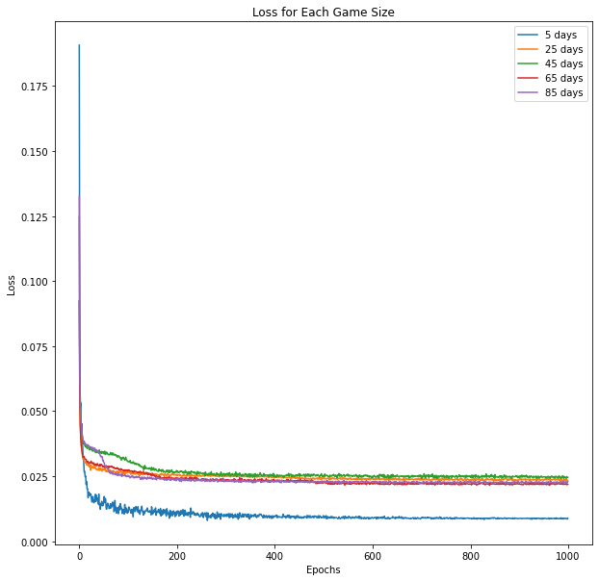

**\*1000 Epochs is overkill, but I wanted to show it anyway**

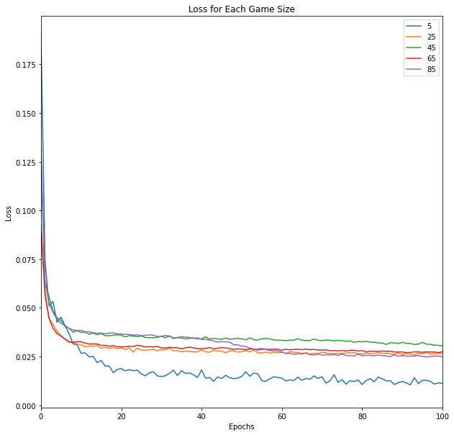

**Zoomed in of the 1000 epoch training**

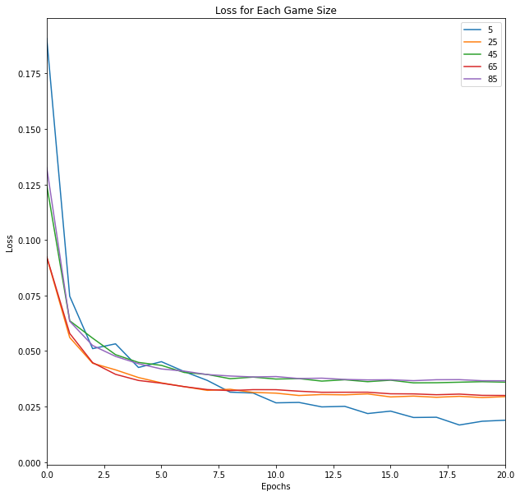

**Zoomed in of the 1000 epoch training**

**Provide a scatter plot with one datapoint per example in the training data. The x-axis should be actual NN output, and the y-axis should be target NN output.**

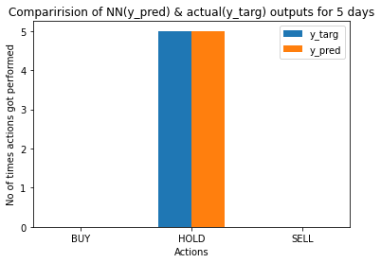

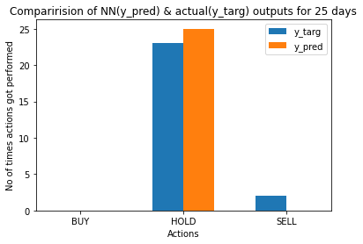

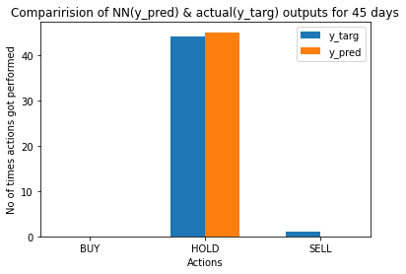

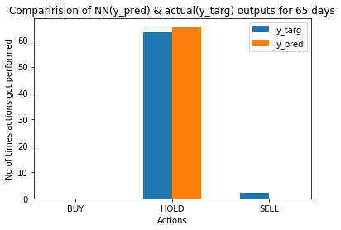

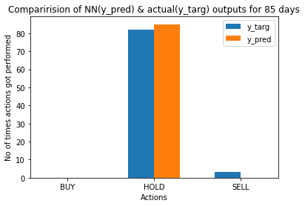

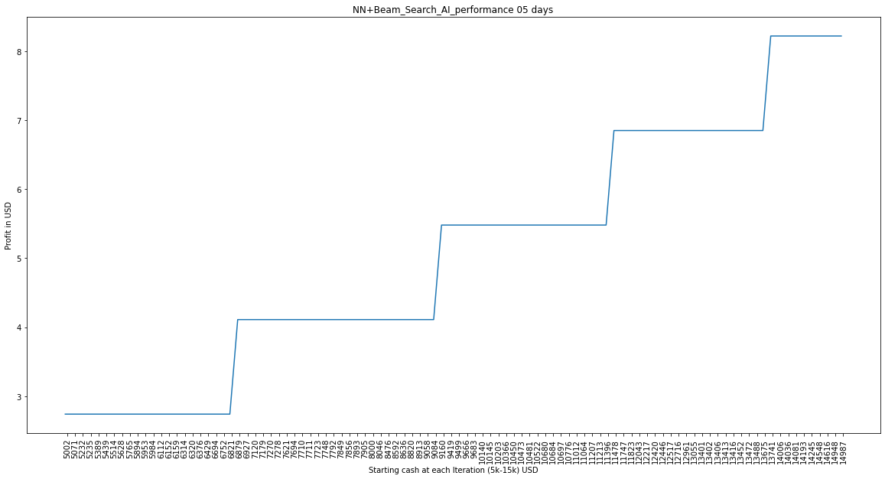

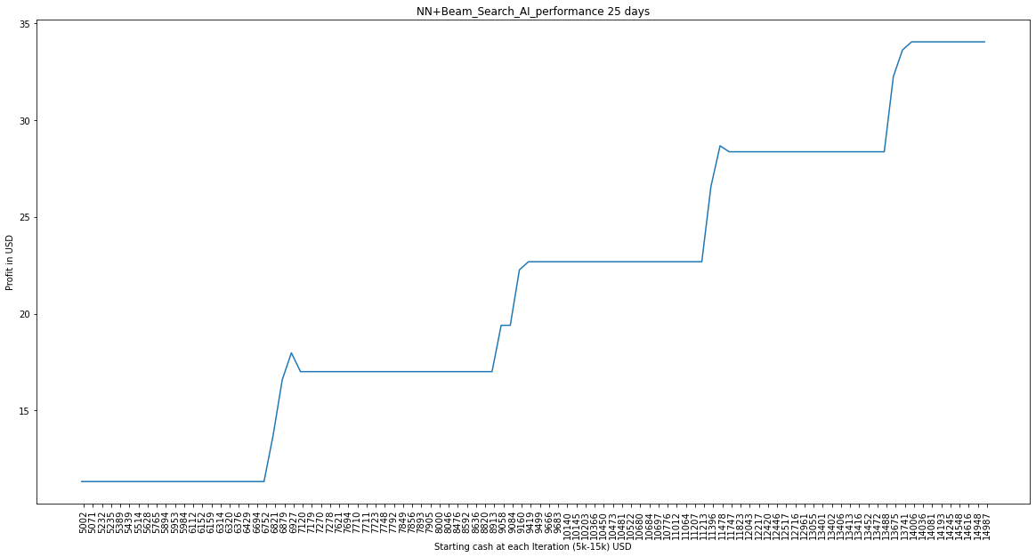

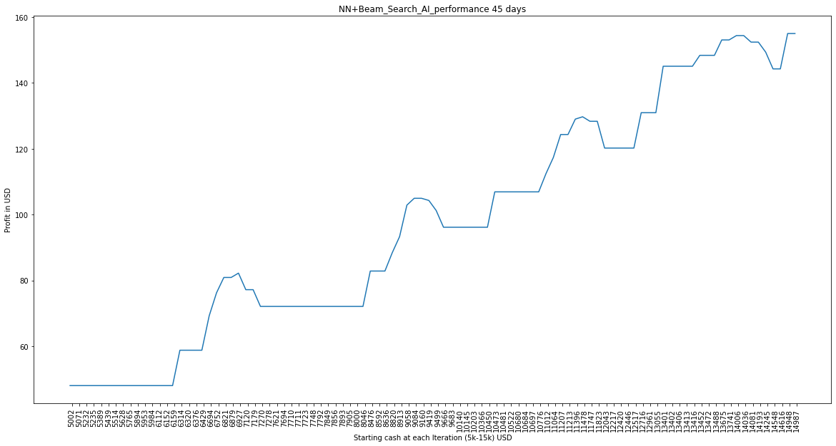

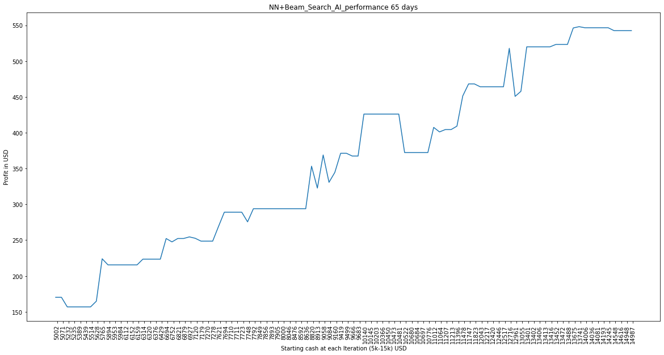

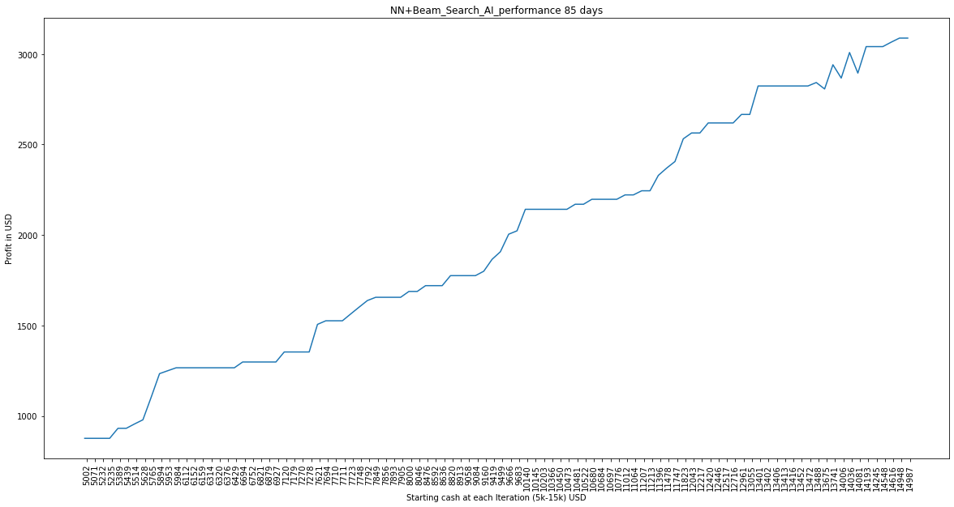

1. **Pavan Kumar Vaddineni Implementation**

My code or work for this part can be found in NN_BeamSearchGraphs.ipynb or LSTM_practice.ipynb.

**What network architecture did you use?**

Long/ Short Term Memory [4][5][6] Recurrent Neural Network.

**How many layers of neurons?**

My neural network consists of 4 layers of neurons.

**How many neurons in each layer?**

There are 60, 60, 80, 120 neurons in the first, second, third and fourth layer respectively.

**What type was each layer?**

The types of each of 4 layers was LSTM [4][5][6] along with drop out layers in between LSTM [4][5][6] layers & Dense layer as final output layer.

**What activation functions were used at each layer?**

ReLU activation function [7].

**Plot the resulting learning curve, which has iteration on the x-axis and error on the y-axis.**

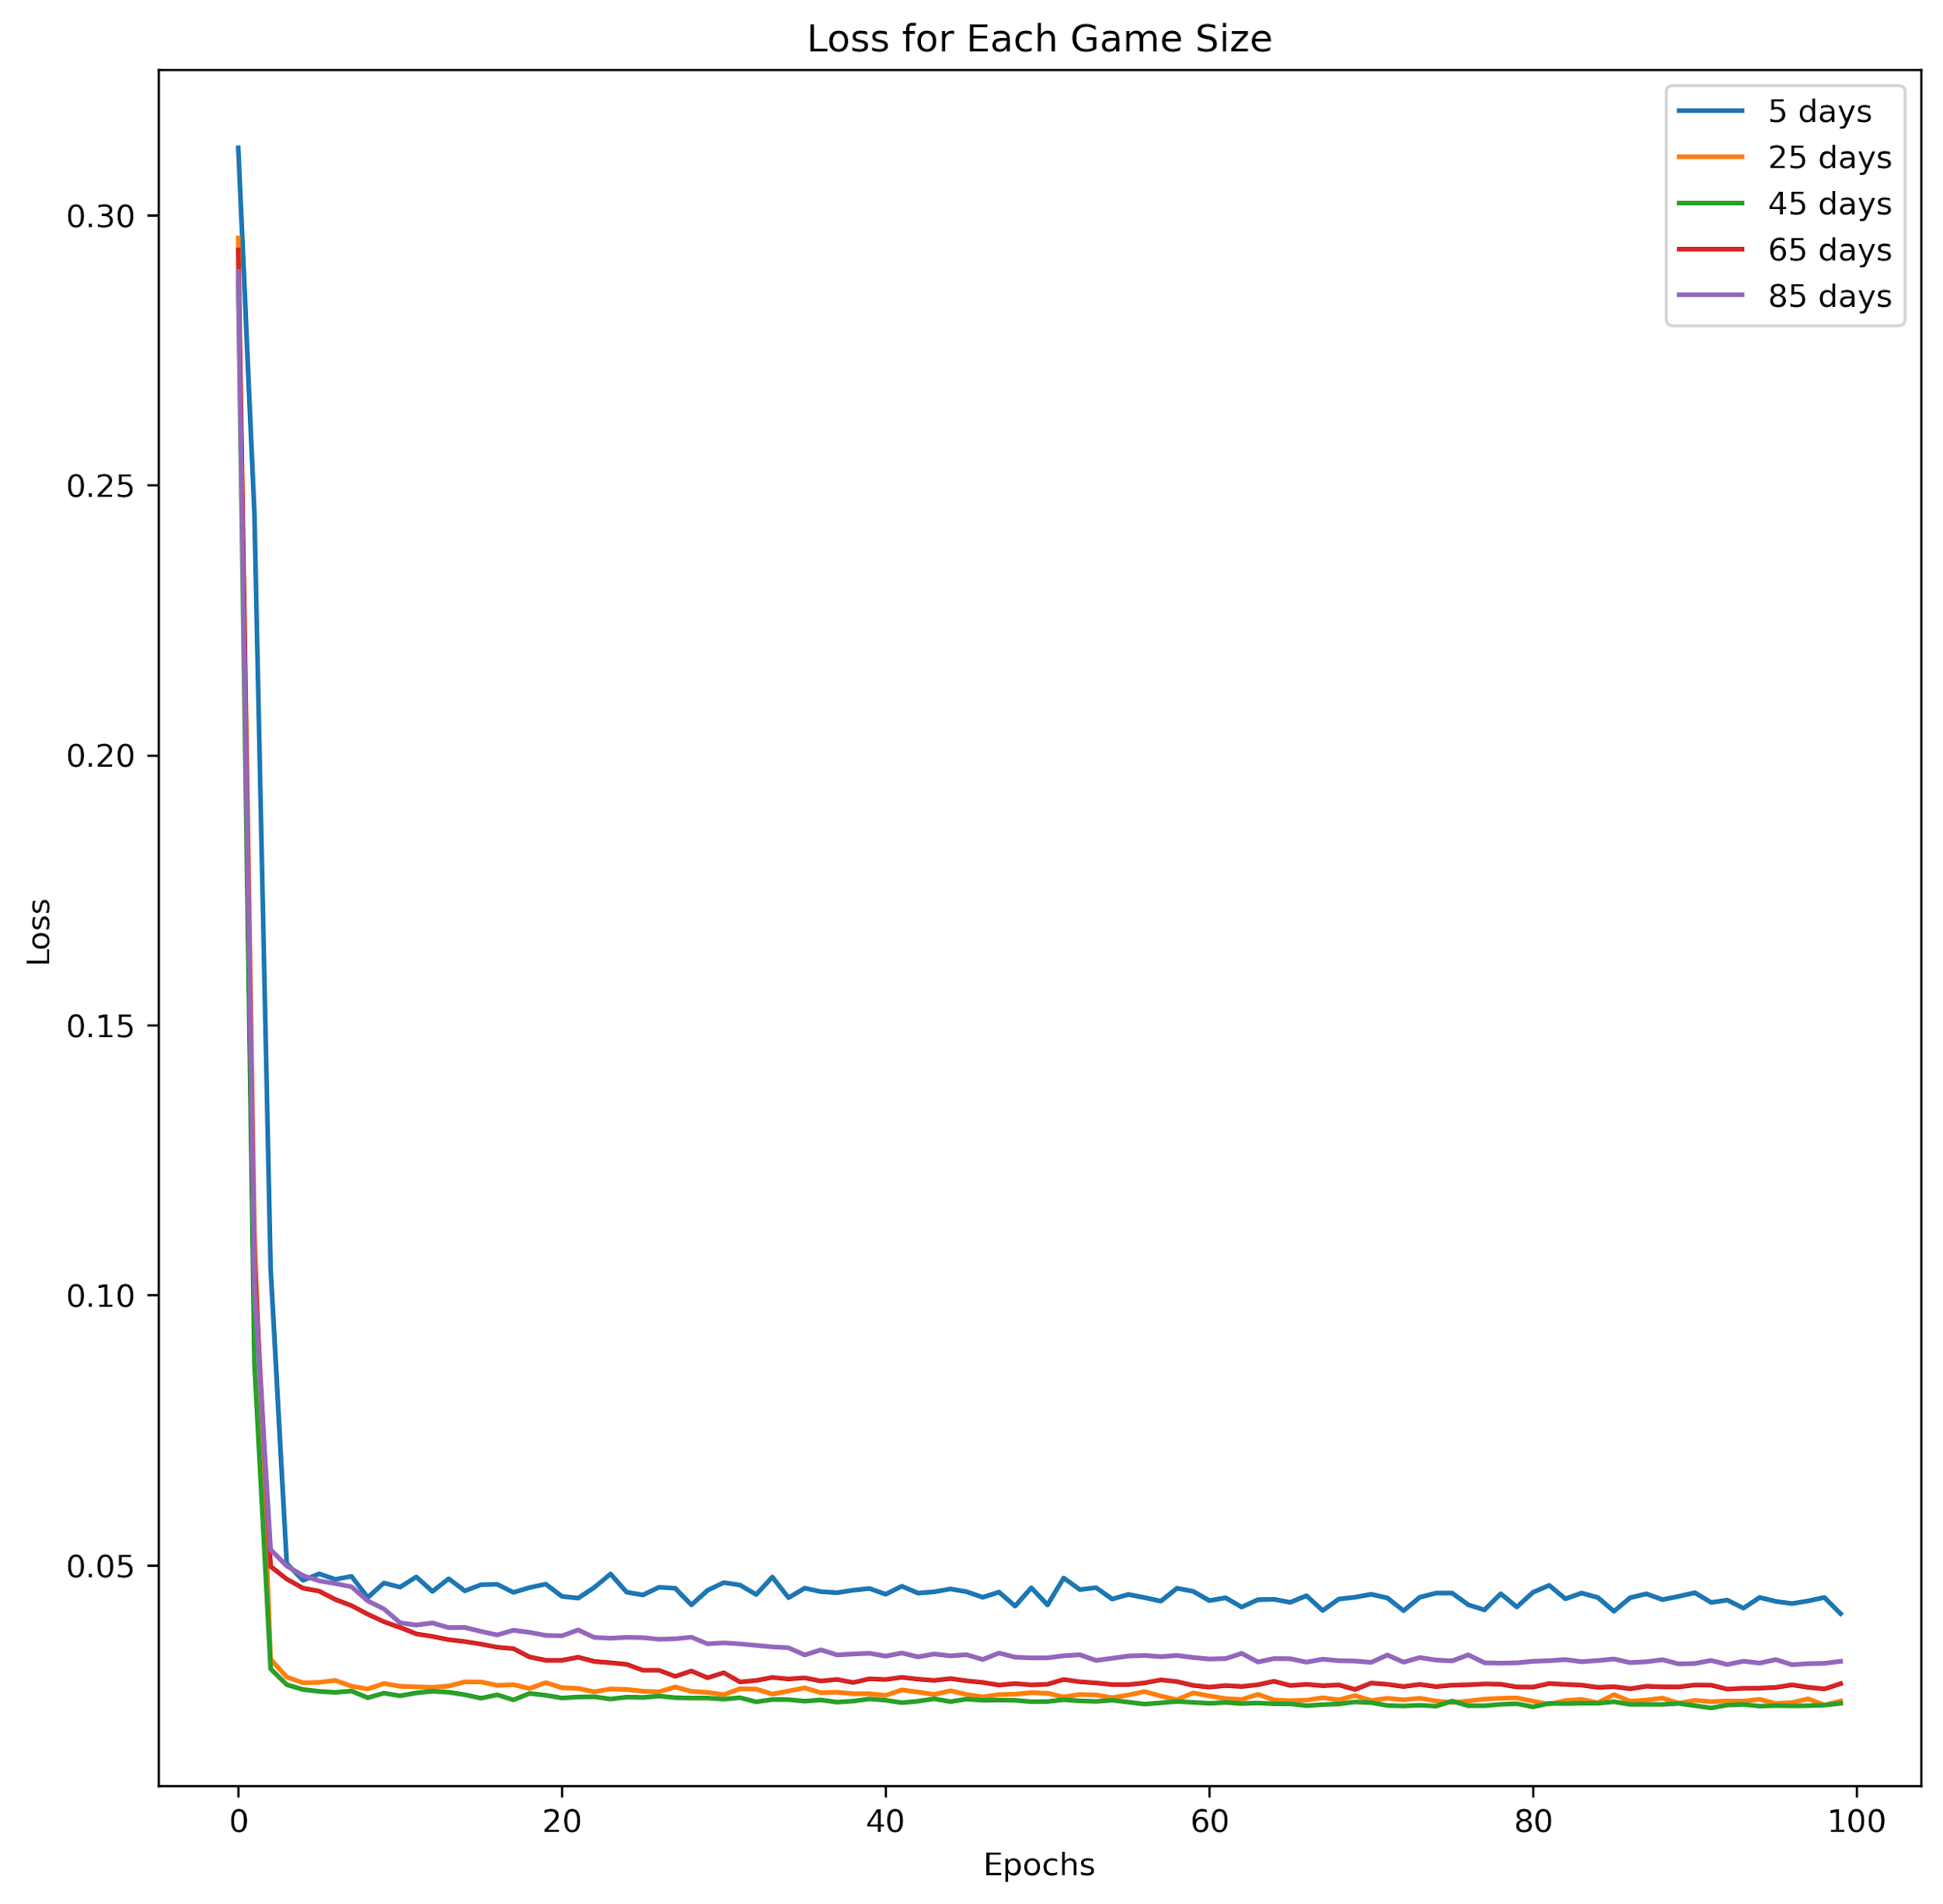

**The x-axis should be the actual NN output, and the y-axis should be the target NN output. So you should have 5 scatter plots, one per problem instance]. Here we thought of plotting bar graphs and compared the total number of buy/ sell/ hold actions that were outputted by the Neural network model with tree based AI outputs (y_targ or actual outputs) for each instance and this would be more meaningful compared to scatter plots.**

actual outputs:['h', 'h', 'h', 'h', 'h'] predicted outputs:['h', 'h', 'h', 'h', 'h'] {This order is same for below 4 instances outputs as well}

{'BUY': 0, 'HOLD': 5, 'SELL': 0} {'BUY': 0, 'HOLD': 5, 'SELL': 0}

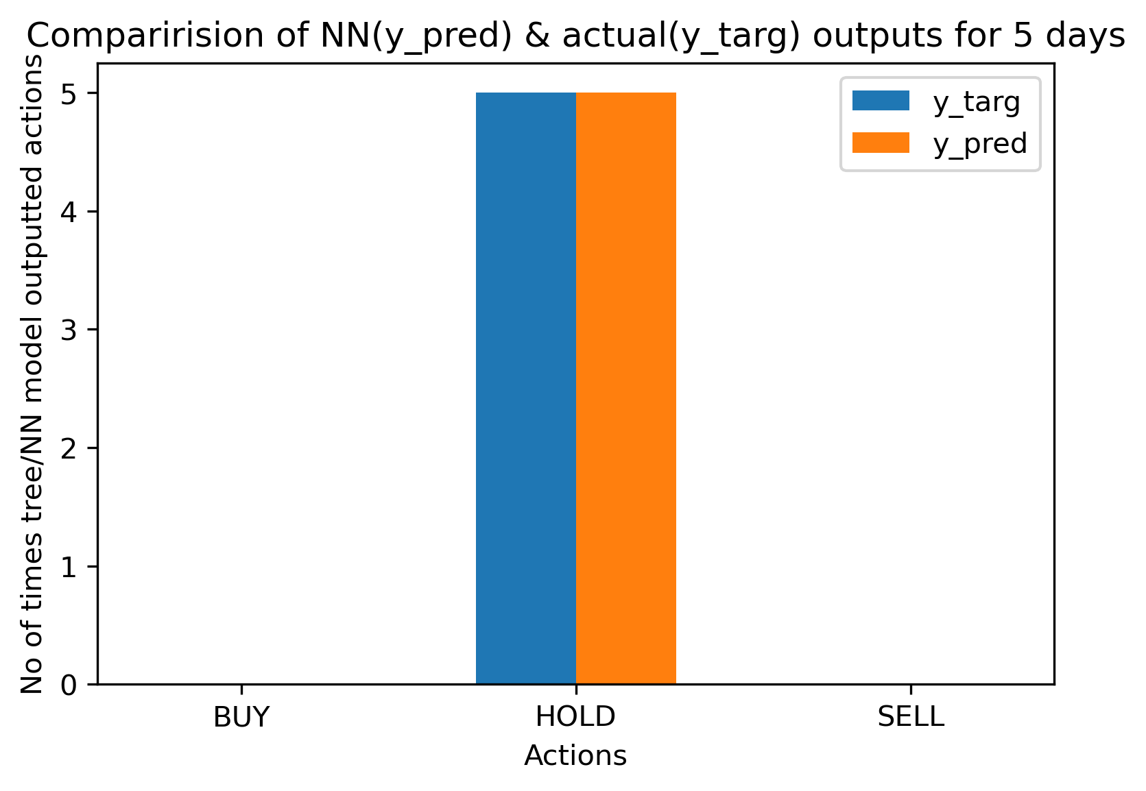

['h', 'h', 'h', 'h', 'h', 'h', 'h', 'h', 'h', 'h', 'h', 's', 'h', 'h', 'h', 'h', 'h', 'h', 'h', 'h', 'h', 'h', 'h', 'h', 'h'] ['h', 'h', 'h', 'h', 'h', 'h', 'h', 'h', 'h', 'h', 'h', 'h', 'h', 'h', 'h', 'h', 'h', 'h', 'h', 'h', 'h', 'h', 'h', 'h', 'h'] {'BUY': 0, 'HOLD': 24, 'SELL': 1} {'BUY': 0, 'HOLD': 25, 'SELL': 0}

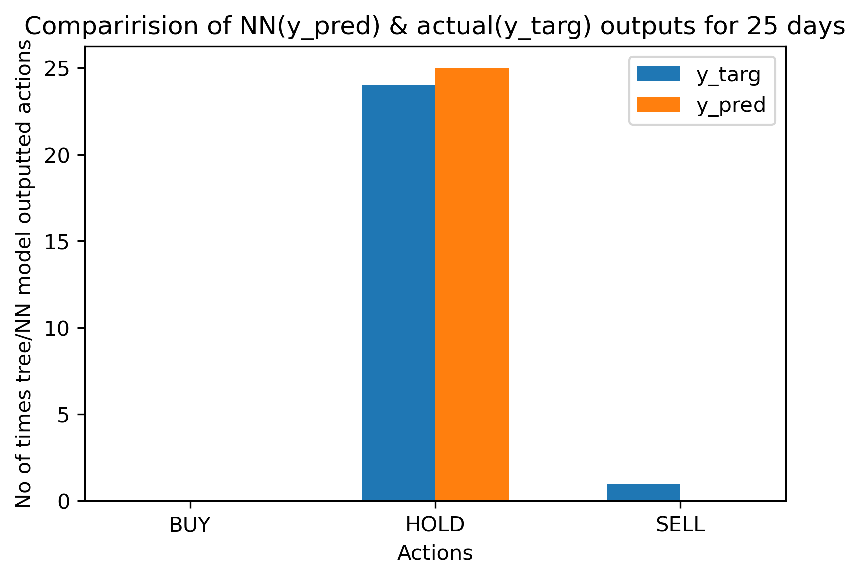

['h', 'h', 'h', 'h', 'h', 'h', 'h', 'h', 'h', 'h', 'h', 'h', 'h', 's', 'h', 'h', 'h', 'h', 'h', 'h', 'h', 'h', 'h', 'h', 'h', 'h', 'h', 'h', 'h', 'h', 'h', 'h', 'h', 'h', 'h', 'h', 'h', 'h', 'h', 'h', 'h', 'h', 'h', 'h', 'h'] ['h', 'h', 'h', 'h', 'h', 'h', 'h', 'h', 'h', 'h', 'h', 'h', 'h', 'h', 'h', 'h', 'h', 'h', 'h', 'h', 'h', 'h', 'h', 'h', 'h', 'h', 'h', 'h', 'h', 'h', 'h', 'h', 'h', 'h', 'h', 'h', 'h', 'h', 'h', 'h', 'h', 'h', 'h', 'h', 'h']{'BUY': 0, 'HOLD': 44, 'SELL': 1} {'BUY': 0, 'HOLD': 45, 'SELL': 0}

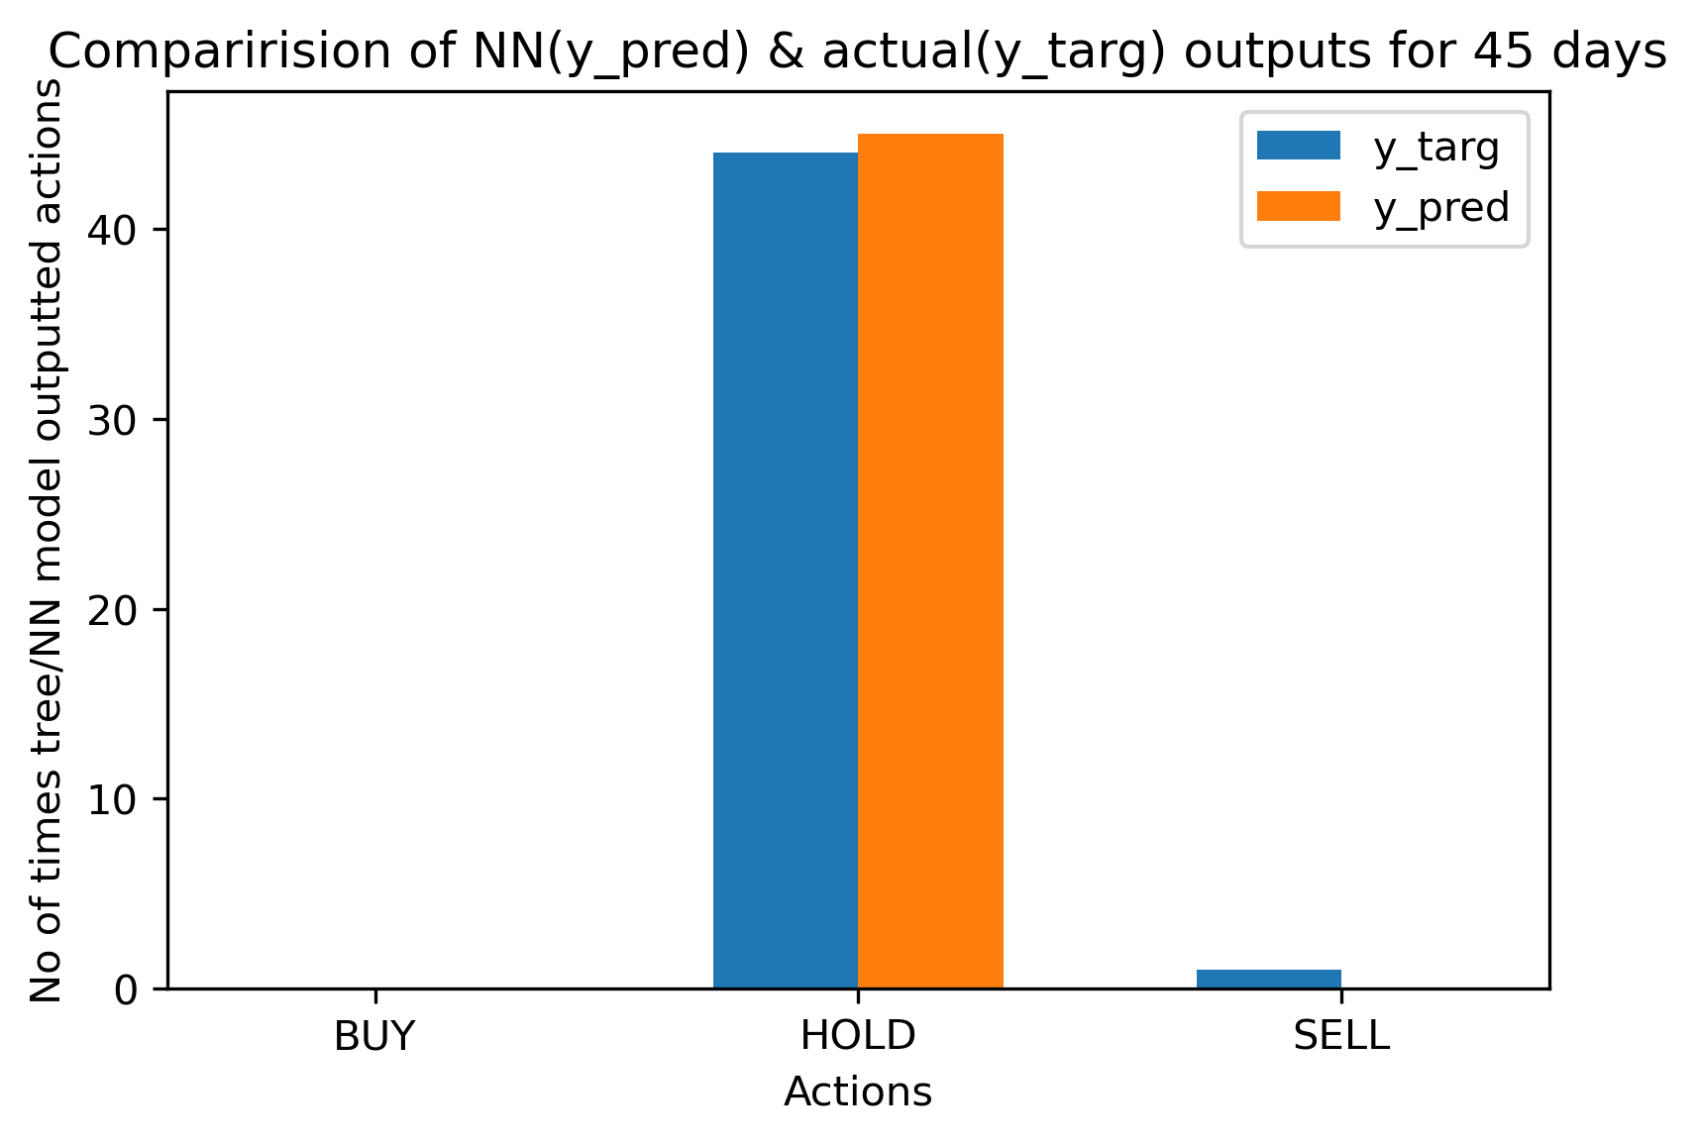

['h', 'h', 'h', 'h', 's', 's', 's', 's', 's', 's', 's', 's', 's', 's', 's', 's', 'h', 'h', 'h', 'h', 'h', 'h', 'h', 'h', 's', 'h', 'h', 'h', 'h', 'h', 'h', 'h', 'h', 'h', 'h', 'h', 'h', 'h', 'h', 'h', 'h', 'h', 'h', 'h', 'h', 'h', 'h', 'h', 'h', 'h', 's', 'h', 'h', 'h', 'h', 'h', 'h', 's', 'h', 'h', 'h', 'h', 'h', 'h', 'h'] ['h', 'h', 'h', 'h', 'h', 'h', 's', 's', 's', 's', 's', 's', 's', 's', 's', 's', 's', 'h', 'h', 'h', 'h', 'h', 'h', 'h', 'h', 'h', 'h', 'h', 'h', 'h', 'h', 'h', 'h', 'h', 'h', 'h', 'h', 'h', 'h', 'h', 'h', 'h', 'h', 'h', 'h', 'h', 'h', 'h', 'h', 'h', 'h', 'h', 'h', 'h', 'h', 'h', 'h', 'h', 'h', 'h', 'h', 'h', 'h', 'h', 'h'] {'BUY': 0, 'HOLD': 50, 'SELL': 15} {'BUY': 0, 'HOLD': 54, 'SELL': 11}

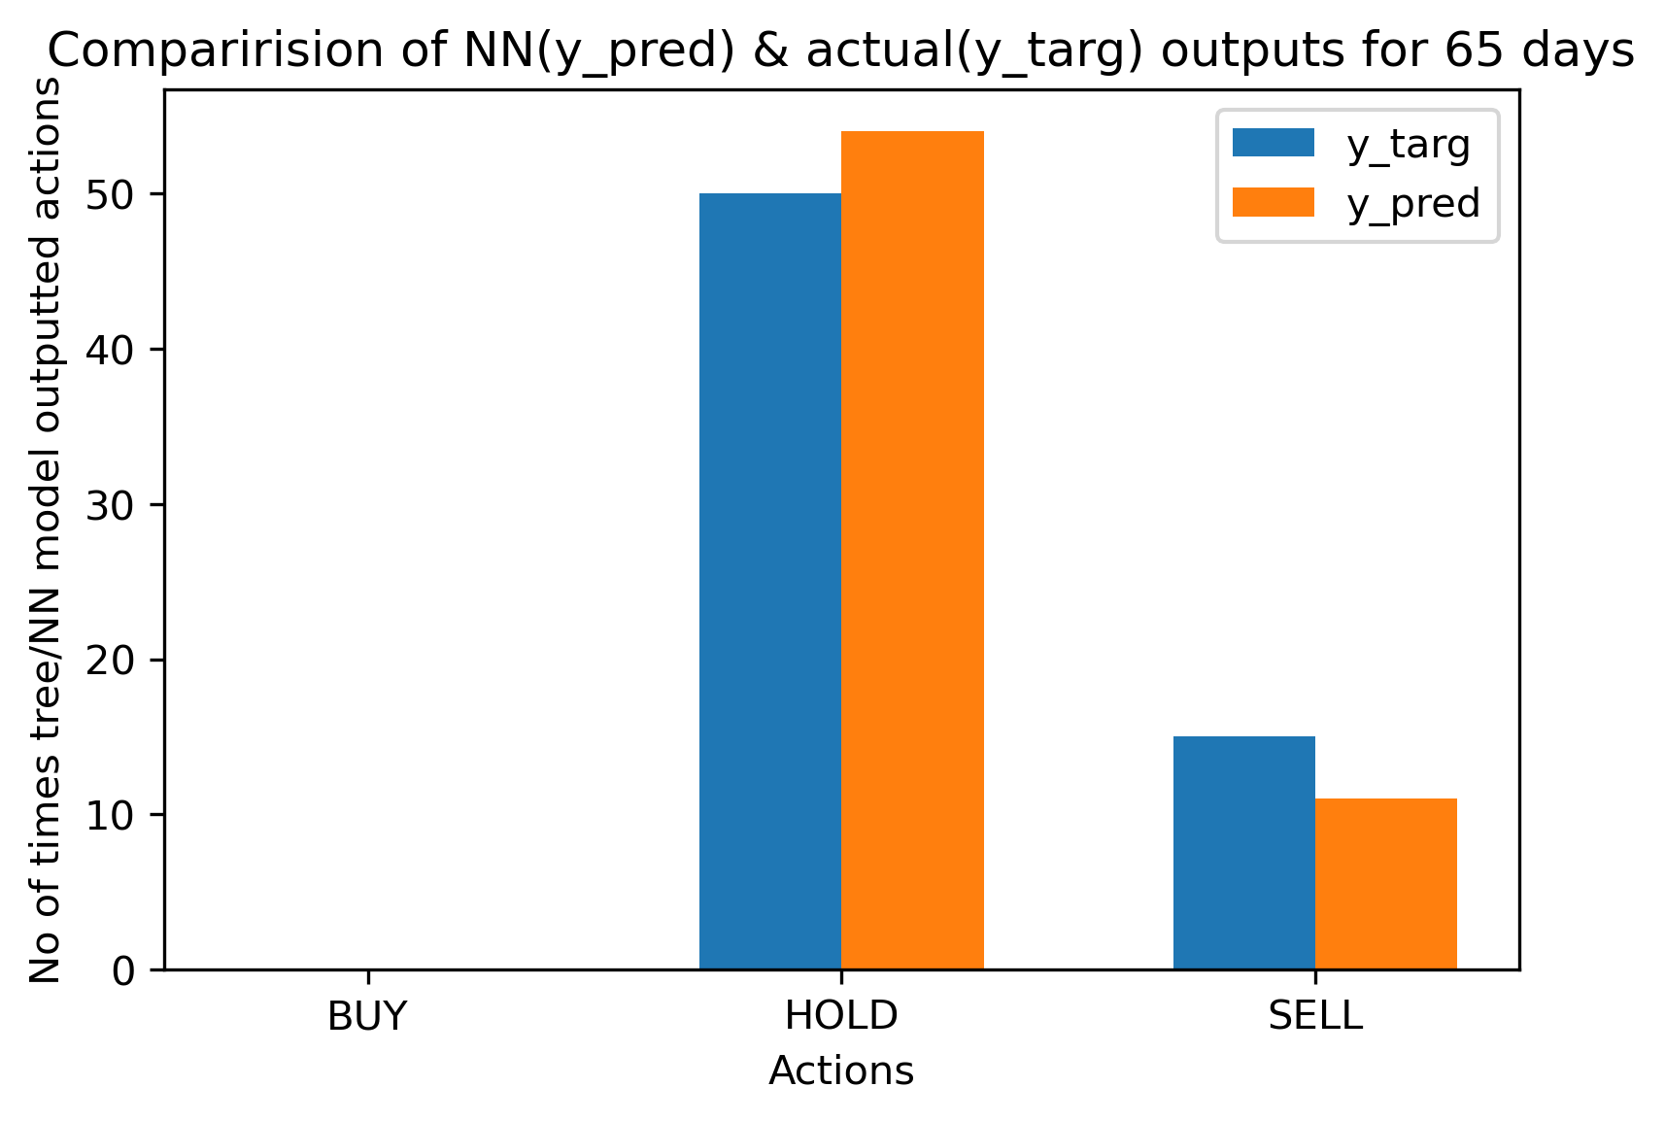

['h', 'h', 'h', 'h', 'h', 'h', 'h', 'h', 'h', 'h', 'h', 'h', 'h', 'h', 'h', 'h', 'h', 'h', 'h', 'h', 'h', 'h', 'h', 'h', 'h', 'h', 'h', 'h', 'h', 'h', 'h', 'h', 'h', 'h', 'h', 'h', 'h', 's', 'h', 'h', 'h', 'h', 'h', 'h', 'h', 'h', 'h', 'h', 'h', 'h', 'h', 'h', 'h', 'h', 'h', 'h', 'h', 'h', 'h', 'h', 'h', 'h', 'h', 'h', 'h', 'h', 'h', 'h', 'h', 'h', 'h', 'h', 'h', 'h', 'h', 'h', 'h', 'h', 'h', 'h', 'h', 'h', 'h', 'h', 'h'] ['h', 'h', 'h', 'h', 'h', 'h', 'h', 'h', 'h', 'h', 'h', 'h', 'h', 'h', 'h', 'h', 'h', 'h', 'h', 'h', 'h', 'h', 'h', 'h', 'h', 'h', 'h', 'h', 'h', 'h', 'h', 'h', 'h', 'h', 'h', 'h', 'h', 'h', 'h', 'h', 'h', 'h', 'h', 'h', 'h', 'h', 'h', 'h', 'h', 'h', 'h', 'h', 'h', 'h', 'h', 'h', 'h', 'h', 'h', 'h', 'h', 'h', 'h', 'h', 'h', 'h', 'h', 'h', 'h', 'h', 'h', 'h', 'h', 'h', 'h', 'h', 'h', 'h', 'h', 'h', 'h', 'h', 'h', 'h', 'h'] {'BUY': 0, 'HOLD': 84, 'SELL': 1} {'BUY': 0, 'HOLD': 85, 'SELL': 0}

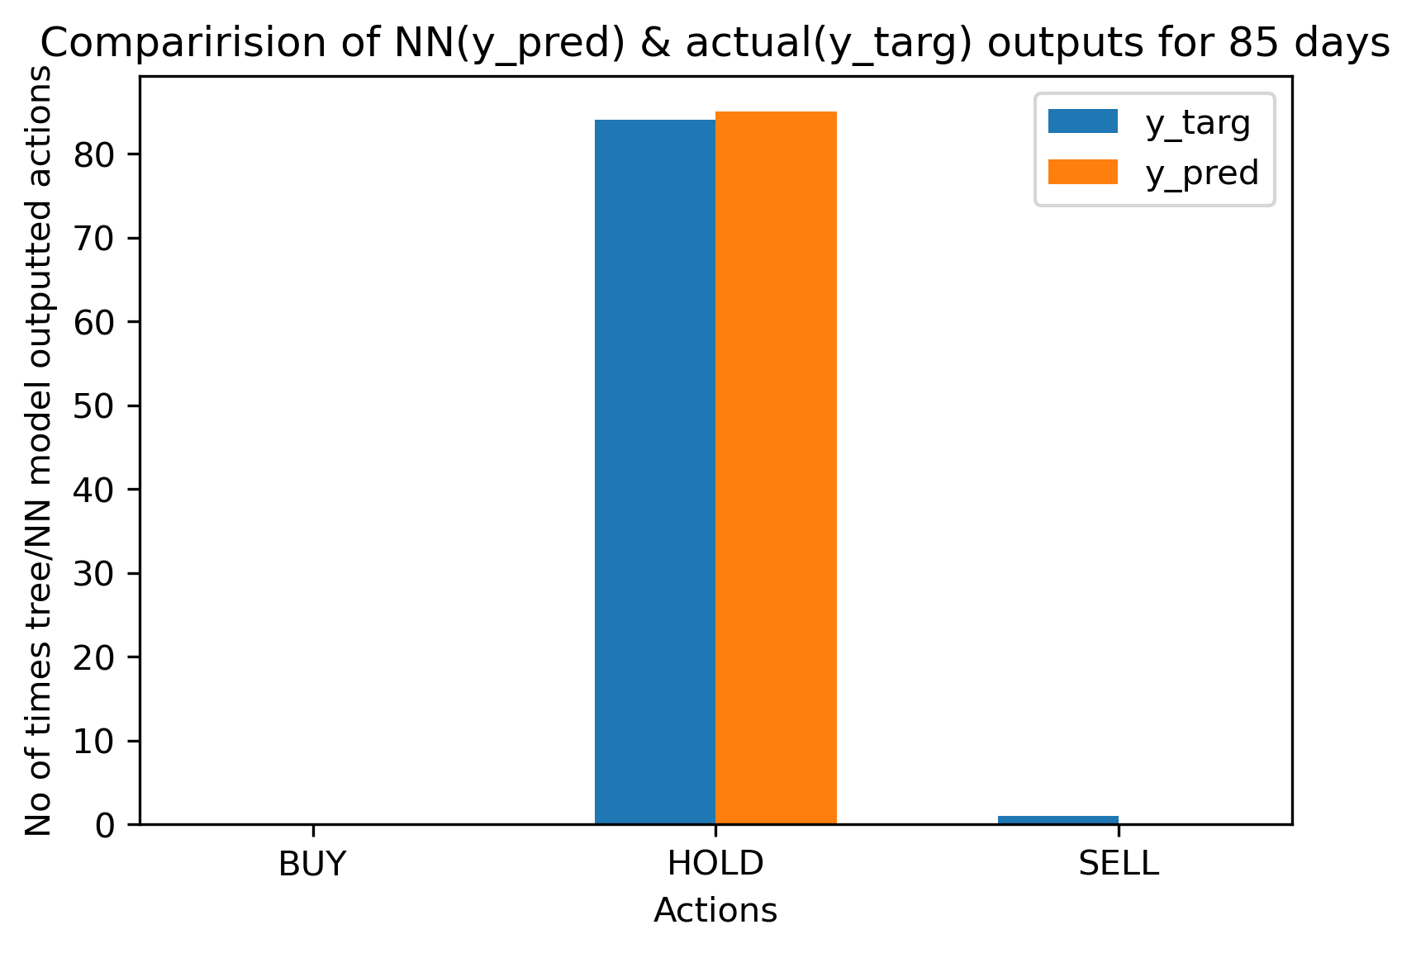

**If your game is one-player, then plot histograms of the final score for each of three AIs: baseline, tree-based, and tree+NN based.**

We already plotted performance/ final score graphs for baseline & tree based AI at each of 5 instances in milestone 2 which can also be seen in the second section above.

**TREE + NN Performance or Final Score graphs for 5 instances (5, 25, 45, 65, 85 days):**

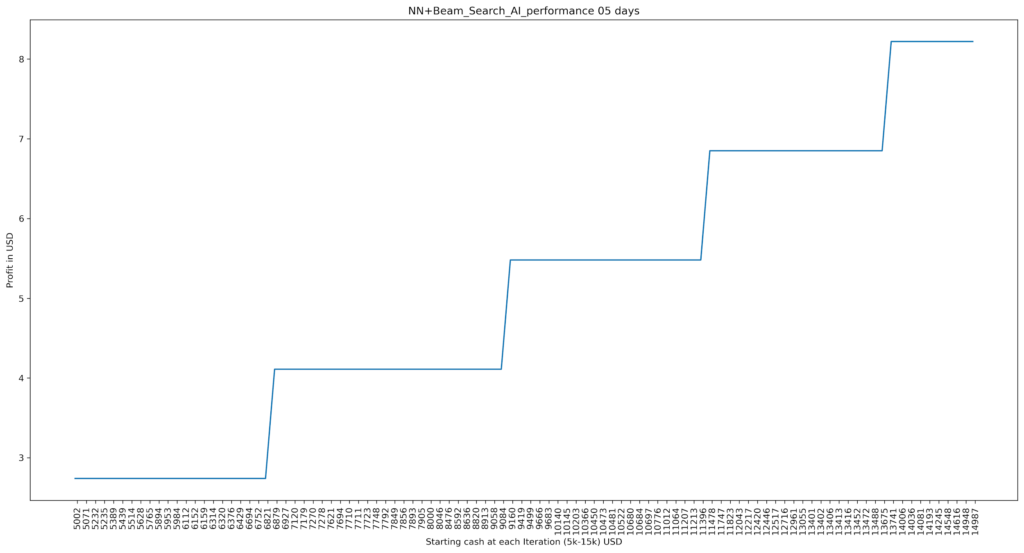

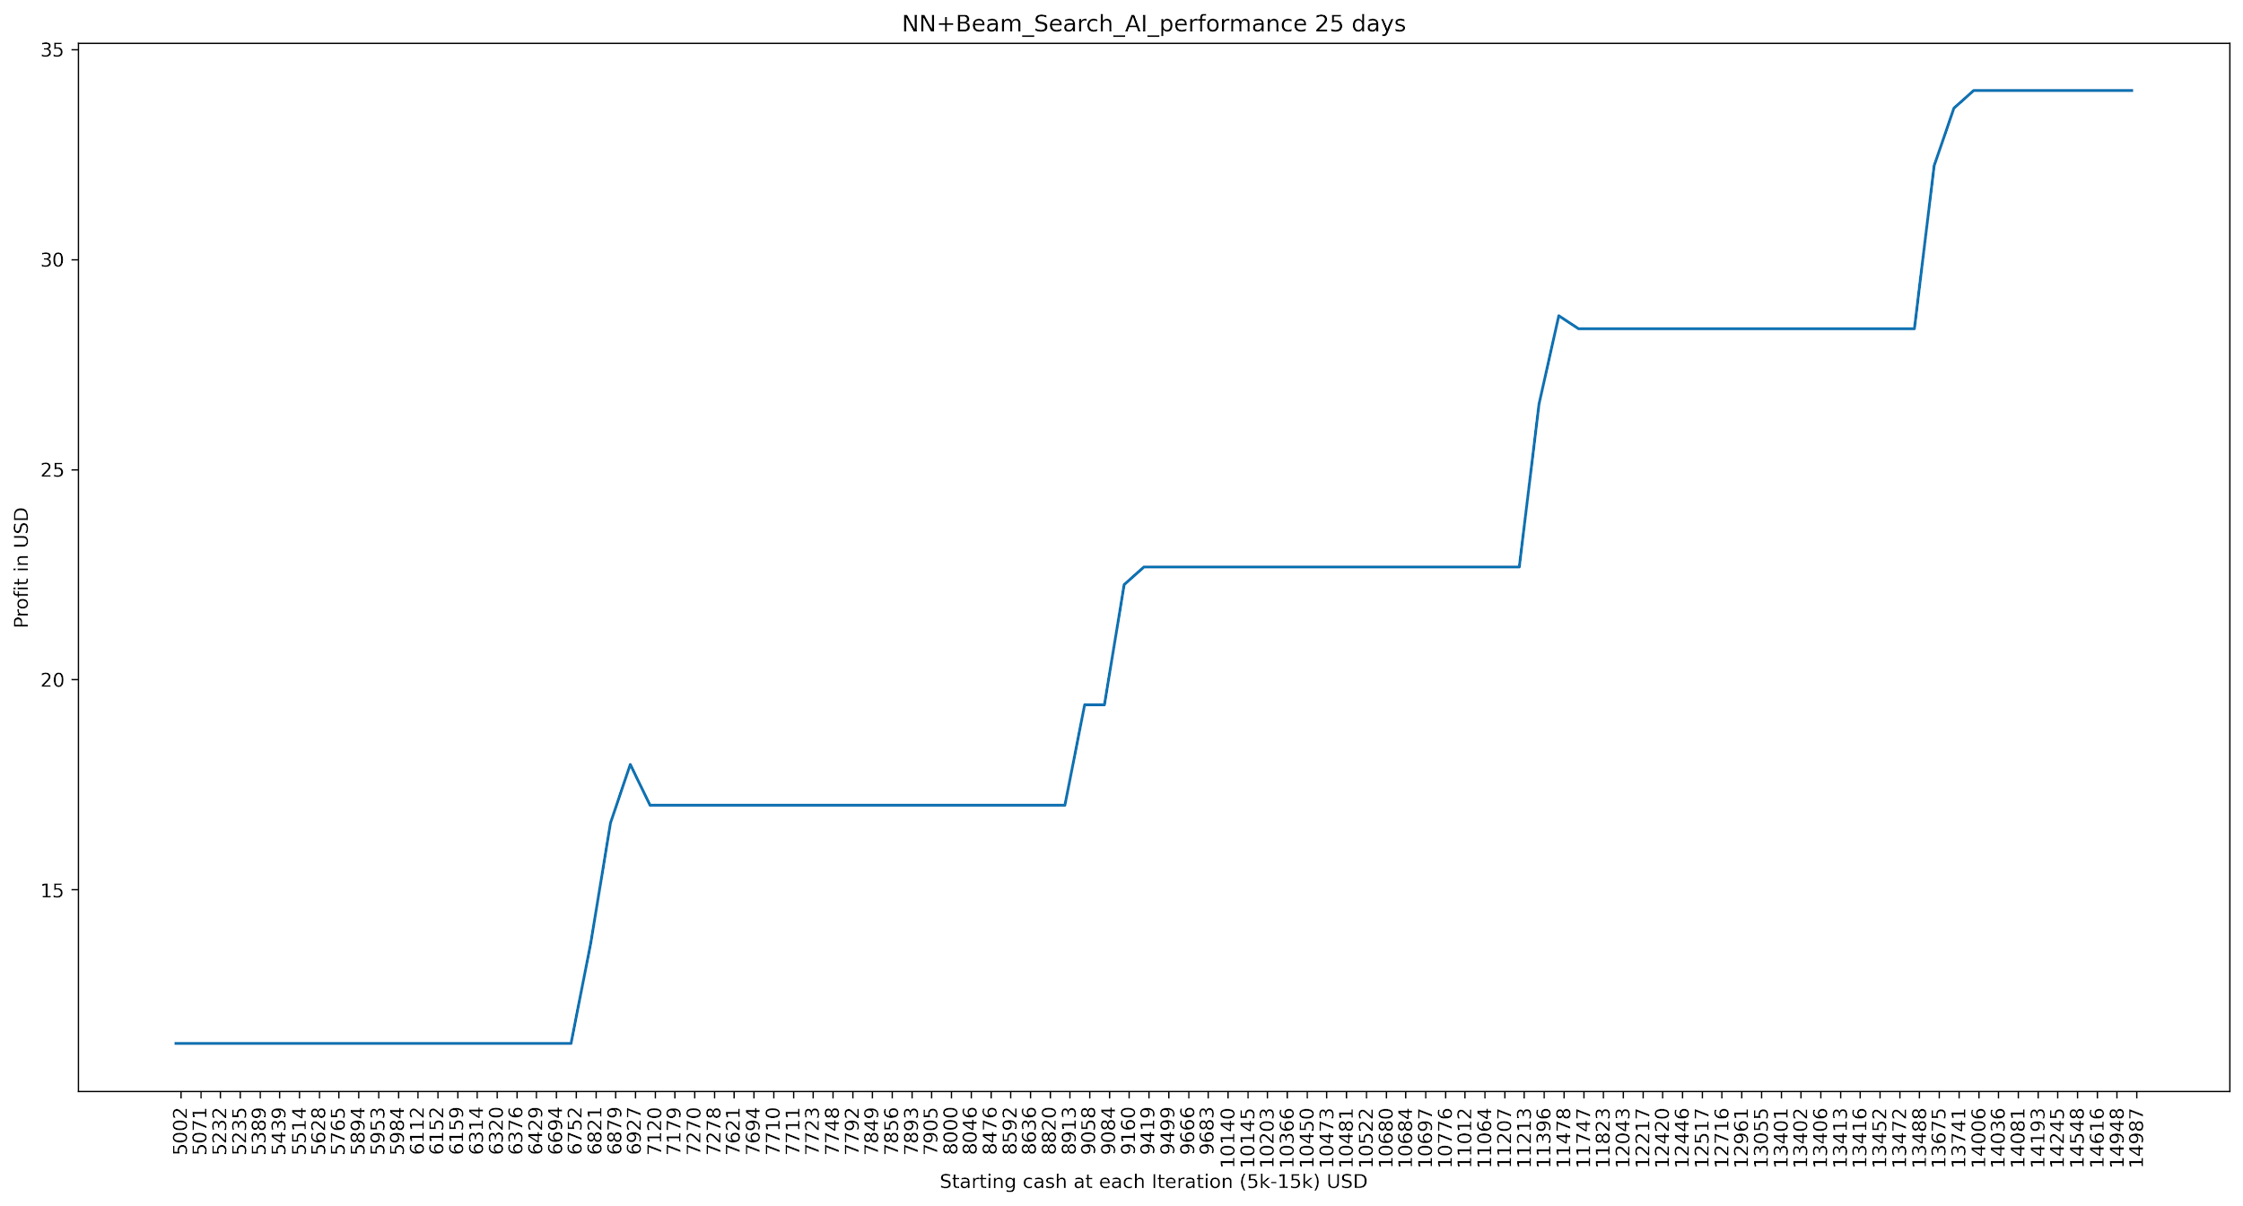

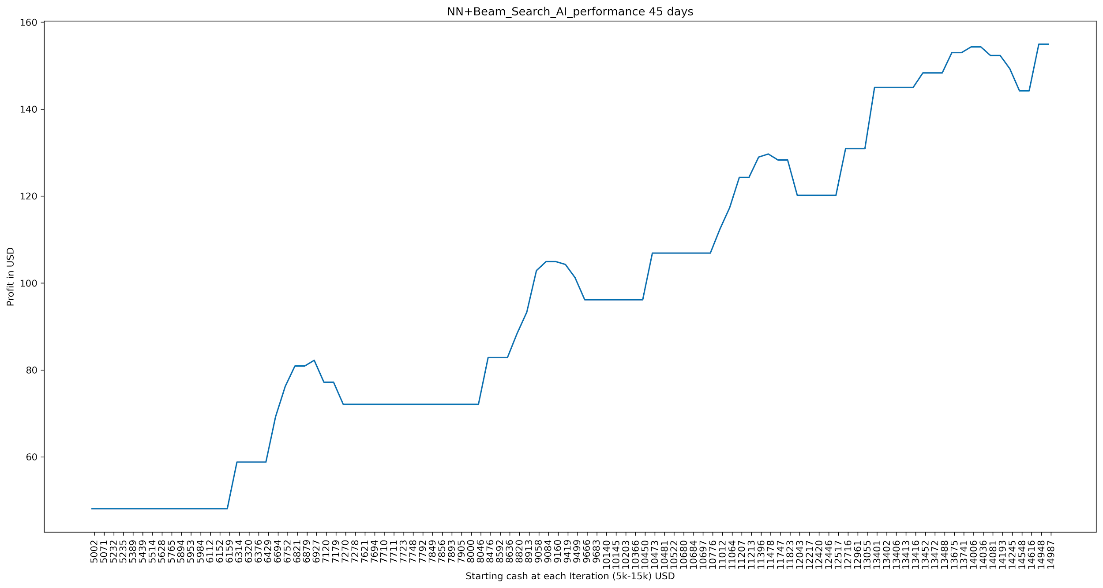

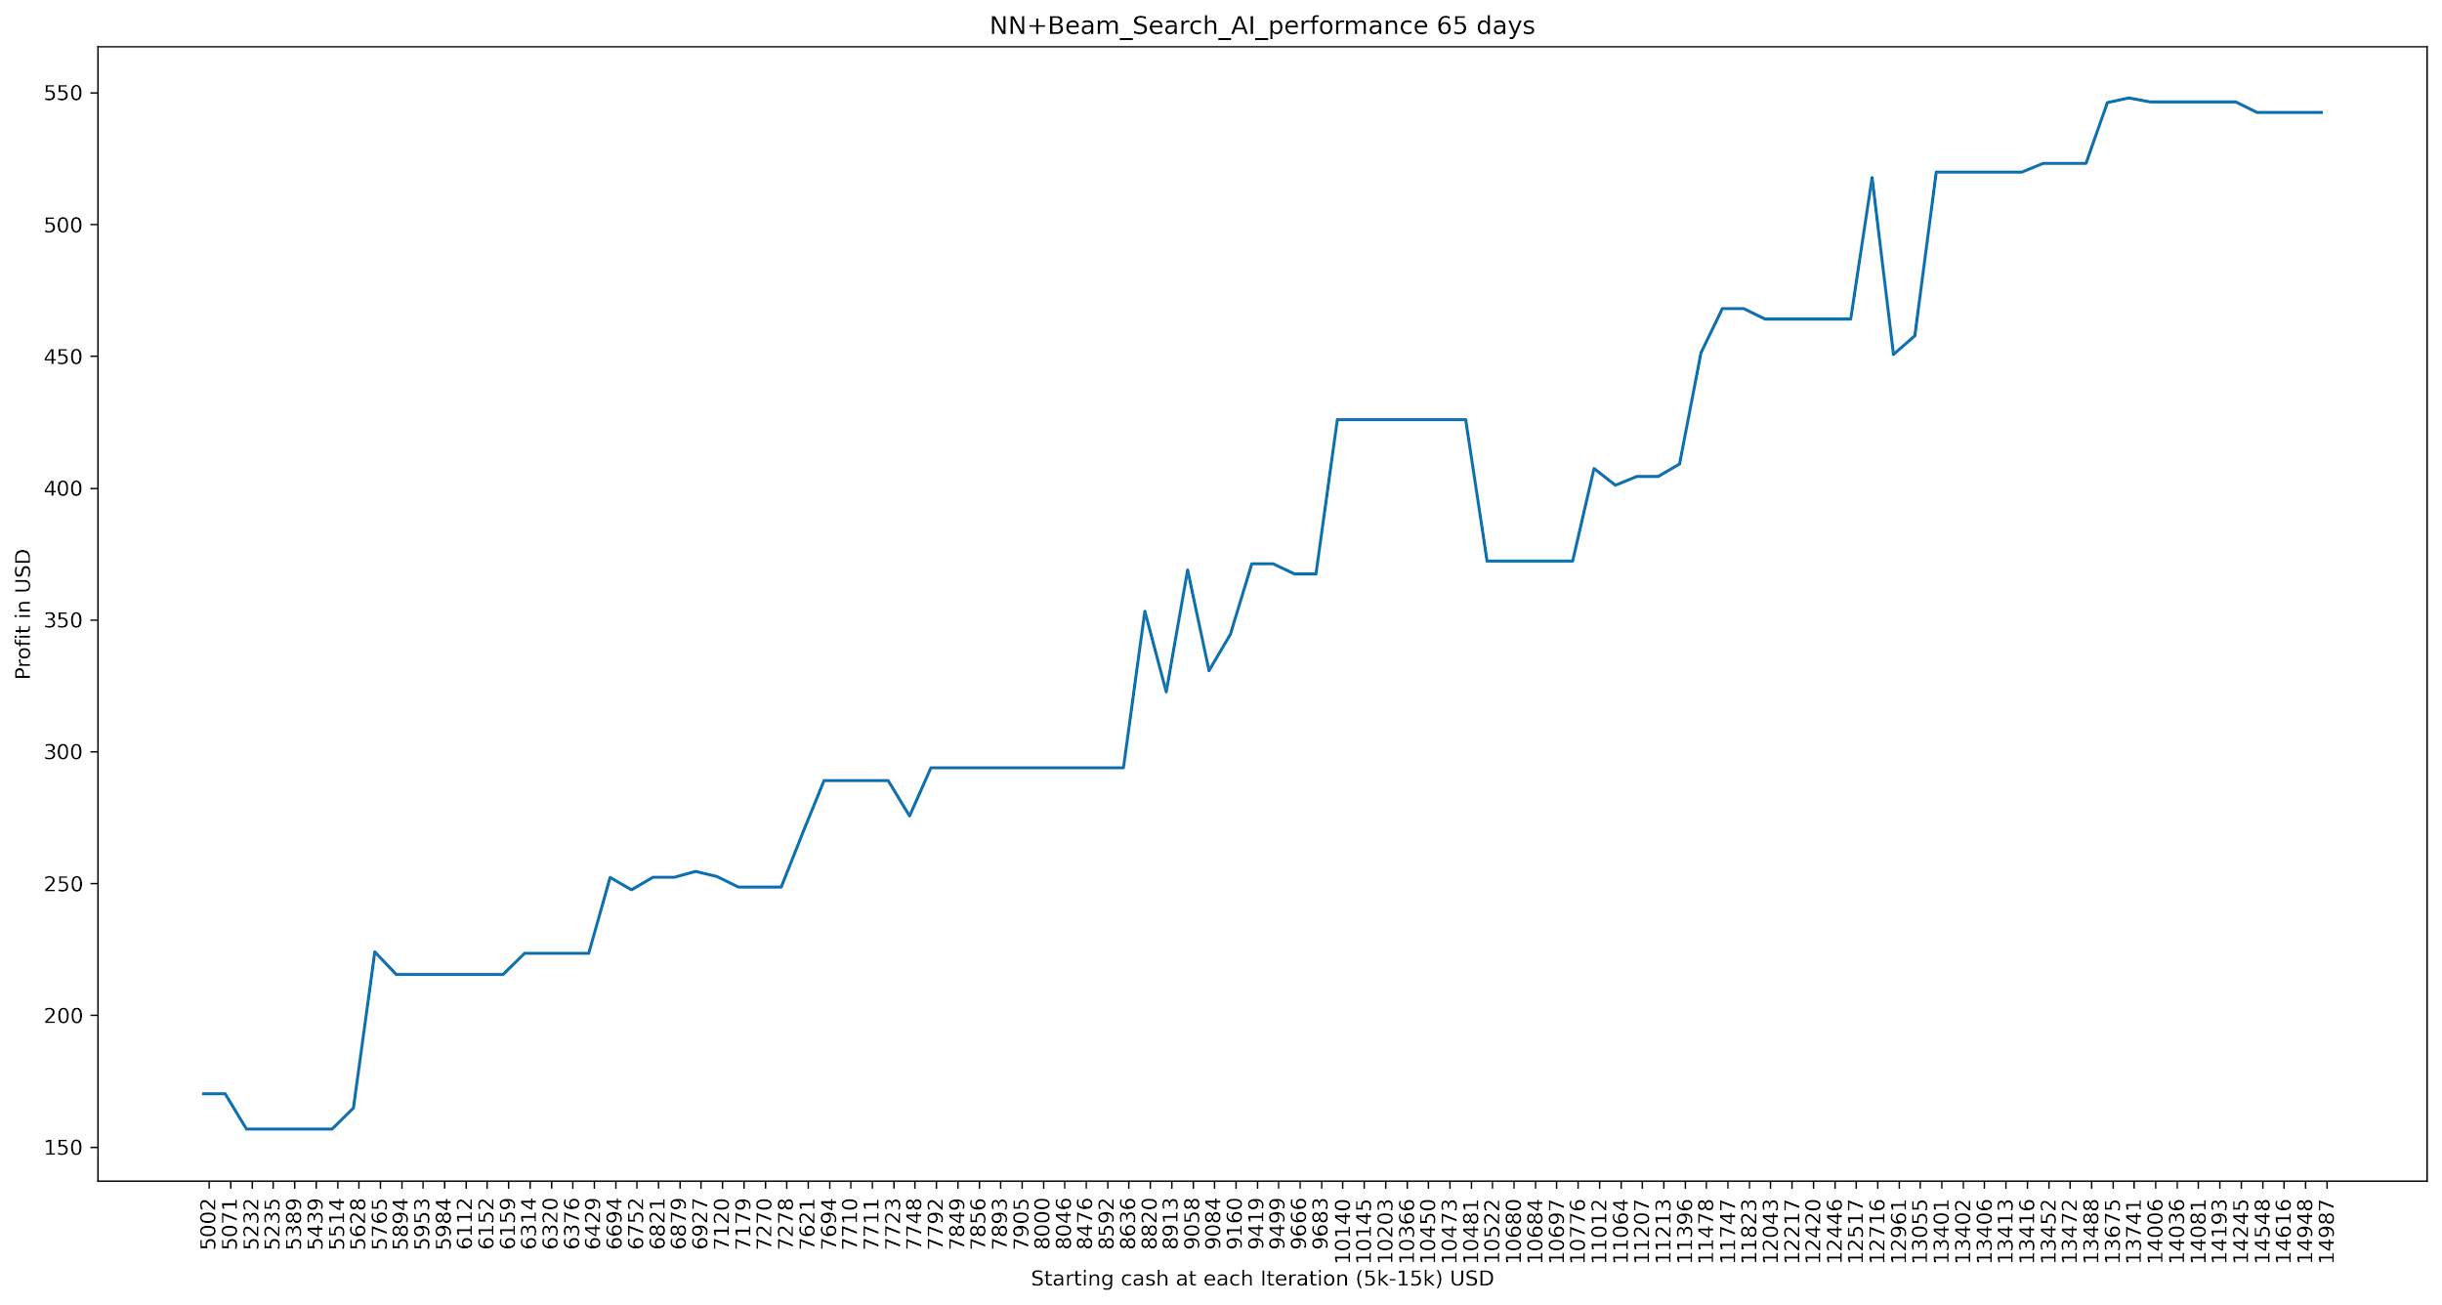

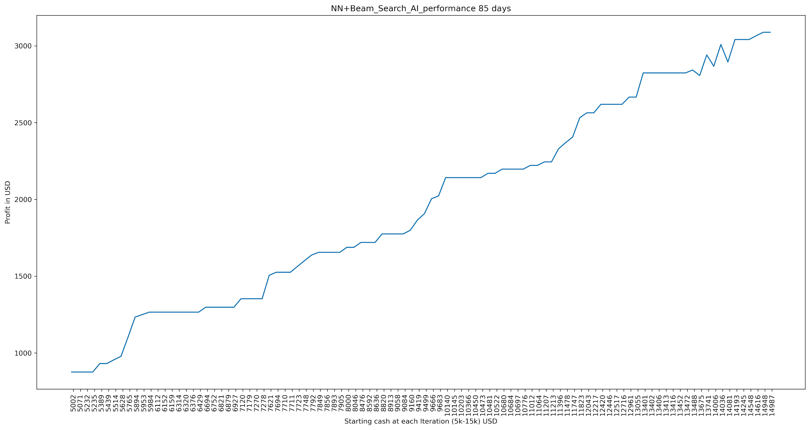

Here I observed that there is not much improvement in profits generated when we compare NN + Tree AI to just Tree AI (results are in section 2) at instances such as 5, 25, 45, 65 & 85 days, profits are almost the same because of the neural network action that we add as 4th action in NN + tree AI actions list is almost ‘holds’ which is same as tree based AI. There can be cases where NN + Tree AI could outperform Tree AI in terms of profits generated but we haven’t come across those cases in our experimentation. Our NN+ Tree AI clearly performs better than baseline AI and generates profits consistently.

1. **Chaitanya Mandava Implementation**

**What network architecture did you use?**

Long/ Short Term Memory [4][5][6] Recurrent Neural Network.

**How many layers of neurons?**

Four layers of neurons present in my neural network.

**How many neurons in each layer?**

In the first, second, third and fourth layer 50, 50, 60, 100 neurons are present respectively.

**What type was each layer?**

LSTM [4][5][6] is used in all four layers consisting of dropout layers between dense layer as a final output layer and every LSTM layers.

**What activation functions were used at each layer?**

Tanh Activation function [8].

**Plot the resulting learning curve, which has iteration on the x-axis and error on the y-axis.**

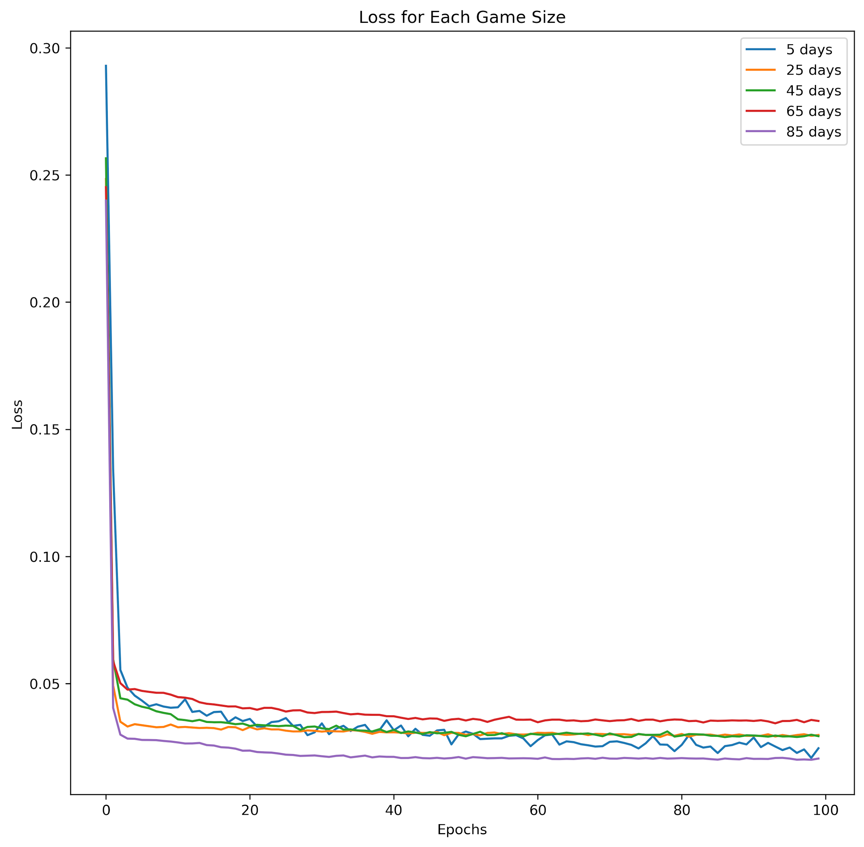

**[The x-axis should be the actual NN output, and the y-axis should be the target NN output. So you should have 5 scatter plots, one per problem instance]. Here we thought of plotting bar graphs and compared the total number of buy/ sell/ hold actions that were outputted by the Neural network model with tree based AI outputs (y_targ or actual outputs) for each instance and this would be more meaningful compared to scatter plots.**

['s', 'h', 'h', 'h', 's'] ['h', 's', 'h', 'h', 'h']

{'BUY': 0, 'HOLD': 3, 'SELL': 2} {'BUY': 0, 'HOLD': 4, 'SELL': 1}

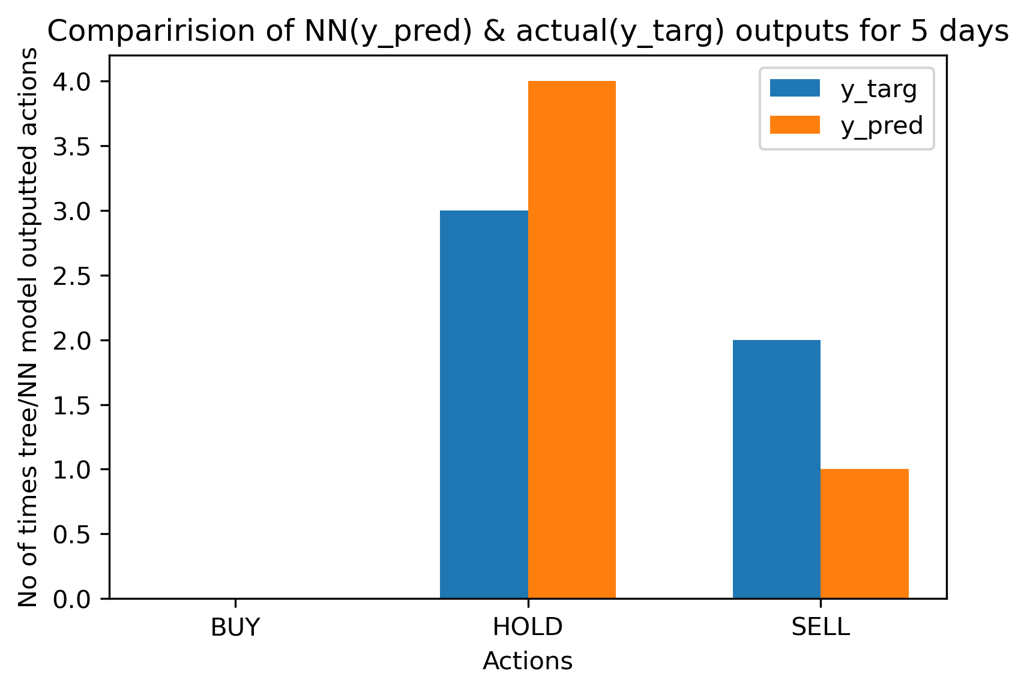

['h', 'h', 'h', 'h', 'h', 's', 'h', 'h', 'h', 'h', 'h', 'h', 's', 'h', 's', 'h', 'h', 'h', 'h', 'h', 's', 'h', 'h', 'h', 'h'] ['h', 'h', 'h', 'h', 'h', 'h', 'h', 'h', 'h', 'h', 'h', 'h', 'h', 'h', 'h', 'h', 'h', 'h', 'h', 'h', 'h', 'h', 'h', 'h', 'h']

{'BUY': 0, 'HOLD': 21, 'SELL': 4} {'BUY': 0, 'HOLD': 25, 'SELL': 0}

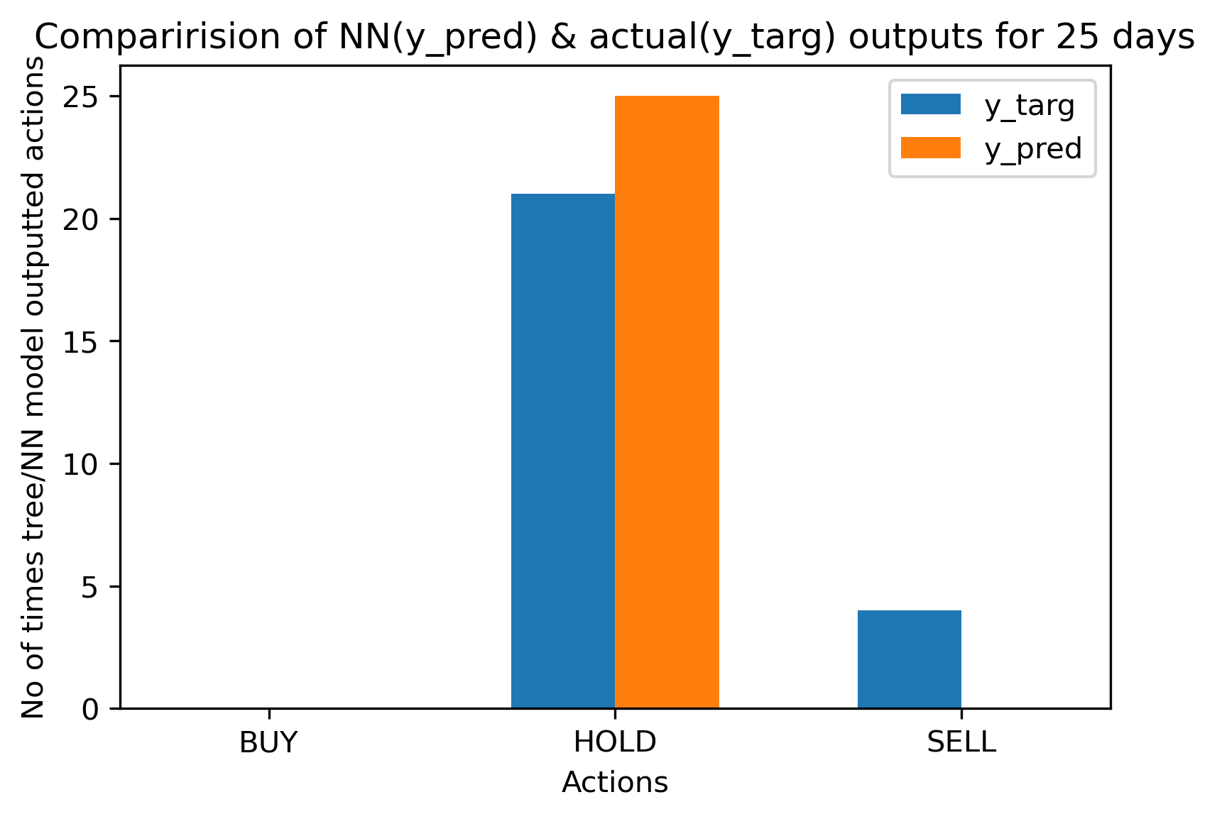

['h', 'h', 'h', 'h', 'h', 'h', 'h', 'h', 'h', 'h', 'h', 's', 'h', 'h', 'h', 'h', 'h', 's', 'h', 'h', 'h', 'h', 'h', 'h', 'h', 'h', 'h', 'h', 'h', 'h', 'h', 'h', 'h', 'h', 'h', 'h', 'h', 'h', 'h', 'h', 'h', 'h', 'h', 'h', 'h'] ['h', 'h', 'h', 'h', 'h', 'h', 'h', 'h', 'h', 'h', 'h', 'h', 'h', 'h', 'h', 'h', 'h', 'h', 'h', 'h', 'h', 'h', 'h', 'h', 'h', 'h', 'h', 'h', 'h', 'h', 'h', 'h', 'h', 'h', 'h', 'h', 'h', 'h', 'h', 'h', 'h', 'h', 'h', 'h', 'h']

{'BUY': 0, 'HOLD': 43, 'SELL': 2} {'BUY': 0, 'HOLD': 45, 'SELL': 0}

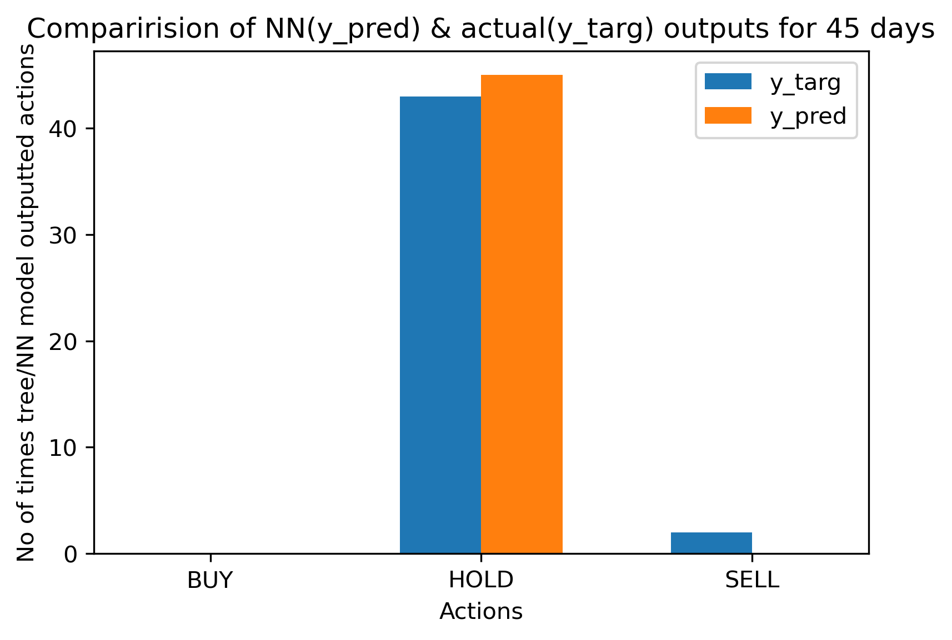

['h', 'h', 'h', 'h', 'h', 'h', 'h', 'h', 'h', 'h', 'h', 'h', 'h', 'h', 'h', 'h', 'h', 'h', 'h', 'h', 'h', 'h', 'h', 'h', 'h', 'h', 'h', 'h', 'h', 's', 'h', 'h', 'h', 'h', 'h', 'h', 'h', 'h', 'h', 'h', 'h', 'h', 'h', 'h', 'h', 'h', 'h', 's', 'h', 'h', 'h', 'h', 'h', 's', 'h', 'h', 'h', 's', 'h', 'h', 'h', 'h', 'h', 'h', 'h'] ['h', 'h', 'h', 'h', 'h', 'h', 'h', 'h', 'h', 'h', 'h', 'h', 'h', 'h', 'h', 'h', 'h', 'h', 'h', 'h', 'h', 'h', 'h', 'h', 'h', 'h', 'h', 'h', 'h', 'h', 'h', 'h', 'h', 'h', 'h', 'h', 'h', 'h', 'h', 'h', 'h', 'h', 'h', 'h', 'h', 'h', 'h', 'h', 'h', 'h', 'h', 'h', 'h', 'h', 'h', 'h', 'h', 'h', 'h', 'h', 'h', 'h', 'h', 'h', 'h']

{'BUY': 0, 'HOLD': 61, 'SELL': 4} {'BUY': 0, 'HOLD': 65, 'SELL': 0}

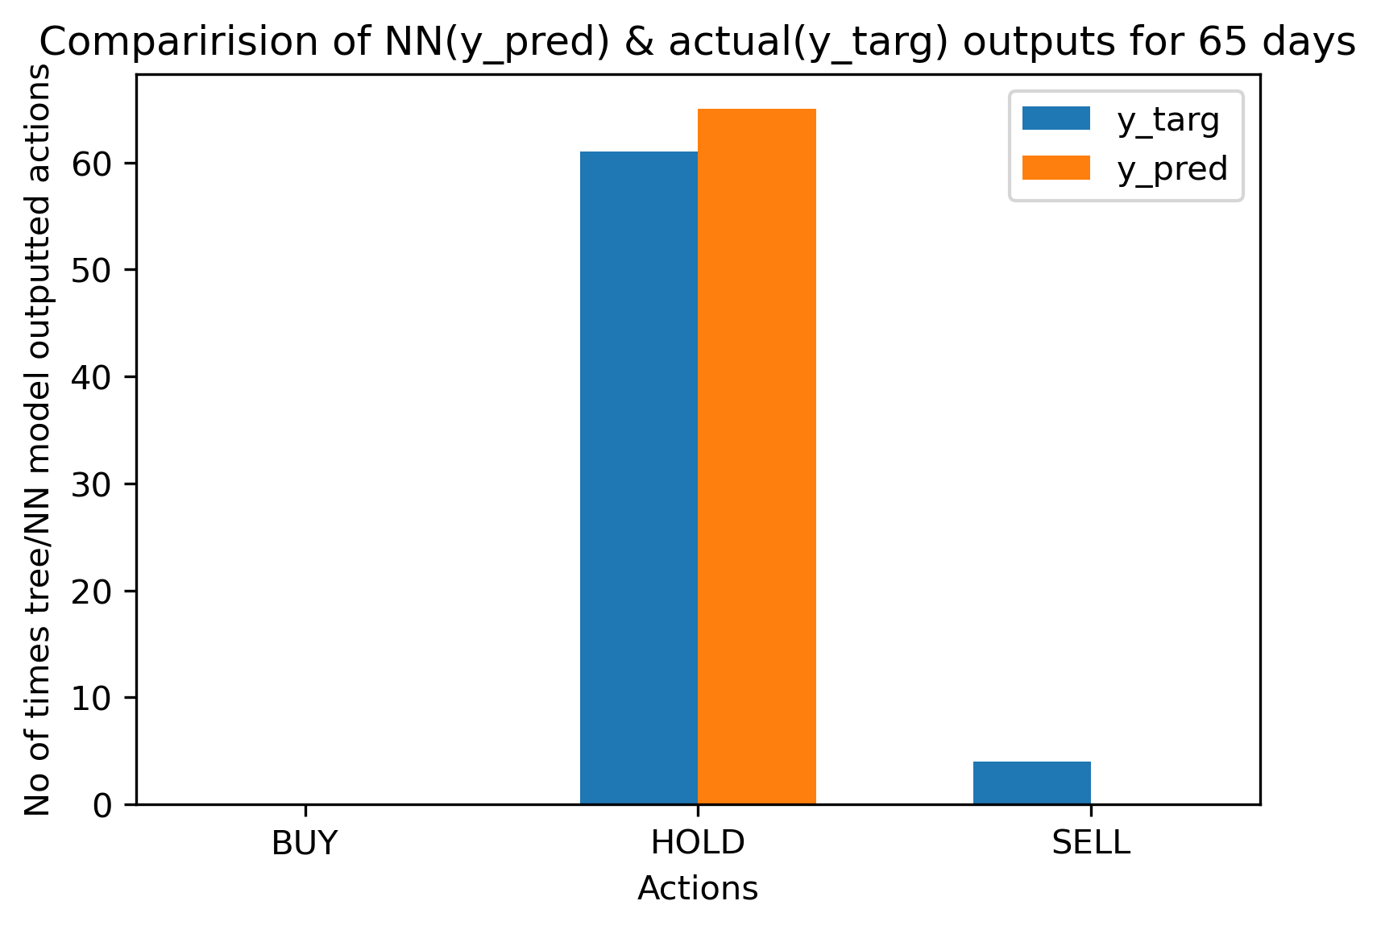

['h', 'h', 'h', 'h', 'h', 'h', 'h', 'h', 'h', 'h', 'h', 'h', 'h', 'h', 'h', 'h', 'h', 'h', 'h', 'h', 'h', 'h', 'h', 'h', 'h', 'h', 'h', 'h', 'h', 'h', 'h', 'h', 'h', 'h', 'h', 'h', 'h', 's', 'h', 'h', 'h', 'h', 'h', 'h', 'h', 'h', 'h', 'h', 'h', 'h', 'h', 'h', 'h', 'h', 'h', 'h', 'h', 'h', 'h', 'h', 'h', 'h', 'h', 'h', 'h', 'h', 'h', 'h', 'h', 'h', 'h', 'h', 'h', 'h', 'h', 'h', 'h', 'h', 'h', 'h', 'h', 'h', 'h', 's', 'h'] ['h', 'h', 'h', 'h', 'h', 'h', 'h', 'h', 'h', 'h', 'h', 'h', 'h', 'h', 'h', 'h', 'h', 'h', 'h', 'h', 'h', 'h', 'h', 'h', 'h', 'h', 'h', 'h', 'h', 'h', 'h', 'h', 'h', 'h', 'h', 'h', 'h', 'h', 'h', 'h', 'h', 'h', 'h', 'h', 'h', 'h', 'h', 'h', 'h', 'h', 'h', 'h', 'h', 'h', 'h', 'h', 'h', 'h', 'h', 'h', 'h', 'h', 'h', 'h', 'h', 'h', 'h', 'h', 'h', 'h', 'h', 'h', 'h', 'h', 'h', 'h', 'h', 'h', 'h', 'h', 'h', 'h', 'h', 'h', 'h']

{'BUY': 0, 'HOLD': 83, 'SELL': 2} {'BUY': 0, 'HOLD': 85, 'SELL': 0}

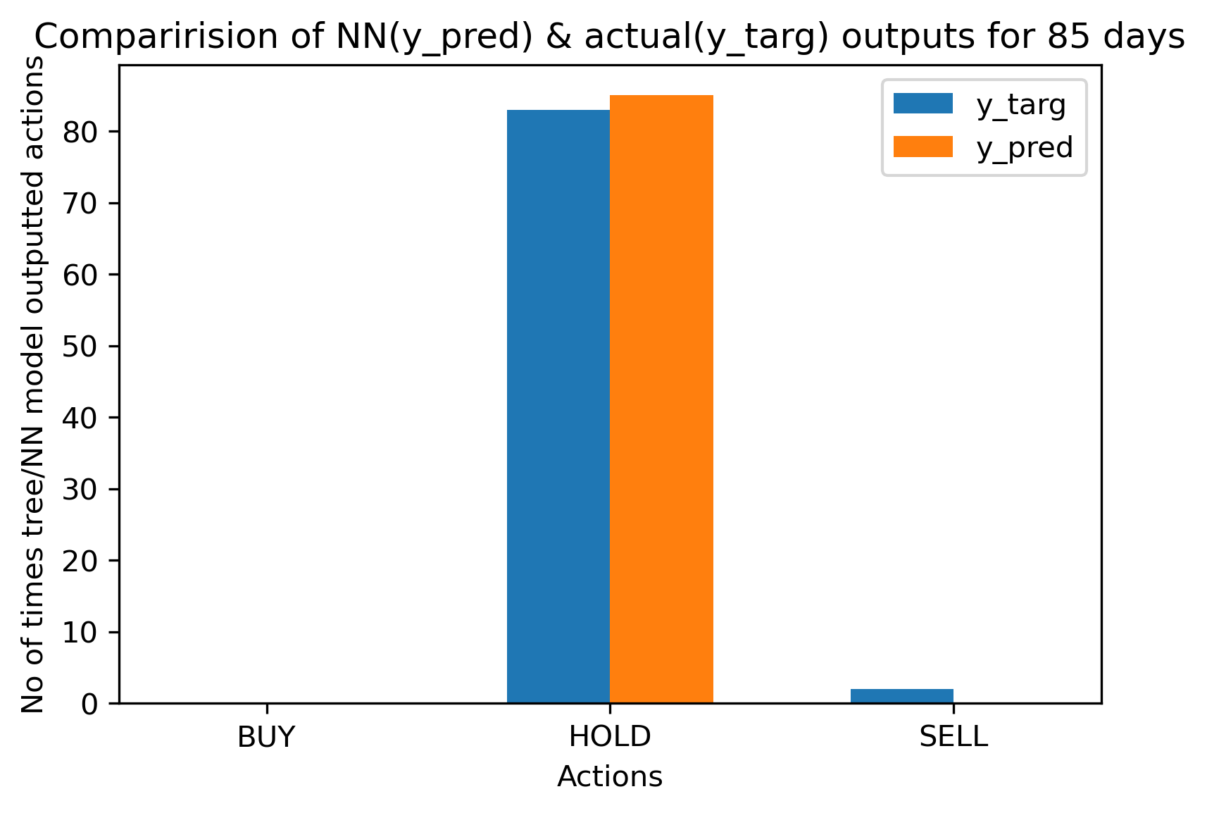

**If your game is one-player, then plot histograms of the final score for each of three AIs: baseline, tree-based, and tree+NN based.**

We already plotted performance/ final score graphs for baseline & tree based AI at each of 5 instances in milestone 2 which can also be seen in the second section above.

**TREE + NN Performance or Final Score graphs for 5 instances (5, 25, 45, 65, 85 days):**

**TREE + NN Performance or Final Score graphs for 5 days:**



**TREE + NN Performance or Final Score graphs for 25 days:**



**TREE + NN Performance or Final Score graphs for 45 days:**



**TREE + NN Performance or Final Score graphs for 65 days:**



**TREE + NN Performance or Final Score graphs for 85 days:**



1. **Wanning Ding Implementation**

**What network architecture did you use?**

Long/ Short Term Memory [4][5][6] Recurrent Neural Network.

**How many layers of neurons?**

My neural network has 4 layers of neurons.

**How many neurons in each layer?**

There are 60 neurons in the first layer.

And there are 60 neurons in the second layer.

And there are 60 neurons in the third layer.

And there are 80 neurons in the fourth layer.

**What type was each layer?**

The types of each layer are both LSTM [4][5][6] along with drop out layers in between LSTM [4][5][6] layers and the Dense layer as the final output layer.

**What activation functions were used at each layer?**

sigmoid activation function[21]

**Plot the resulting learning curve, which has iteration on the x-axis and error on the y-axis.**

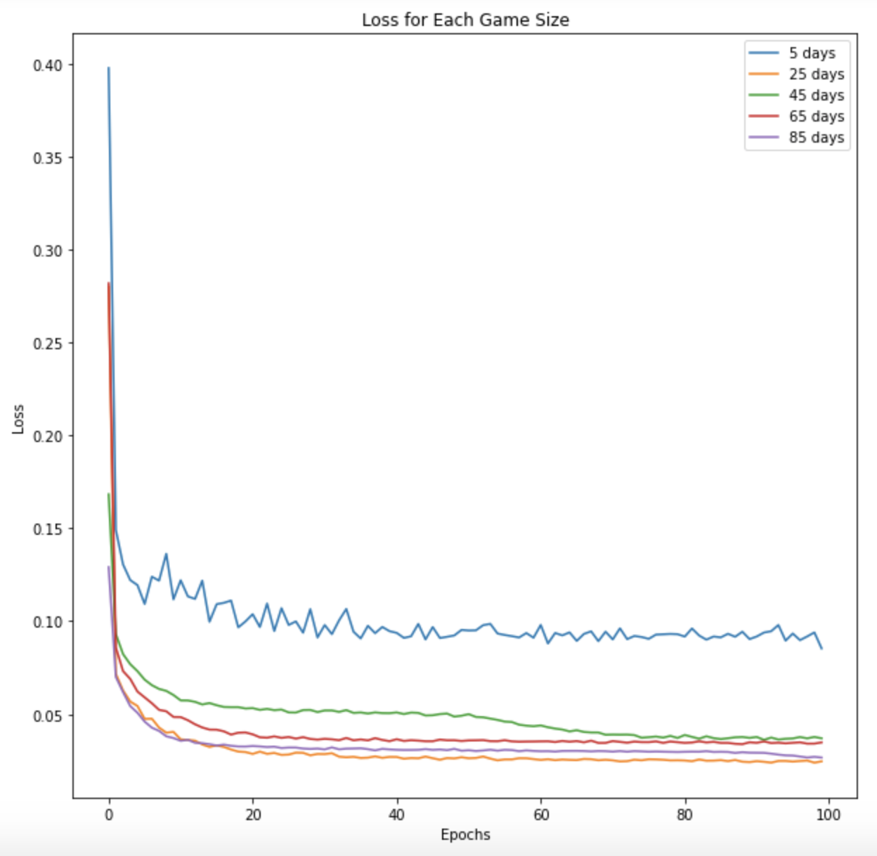

**Provide a scatter plot with one datapoint per example in the training data. The x-axis should be actual NN output, and the y-axis should be target NN output.**

**The comparison between y_targ and y_pred for 5 days**

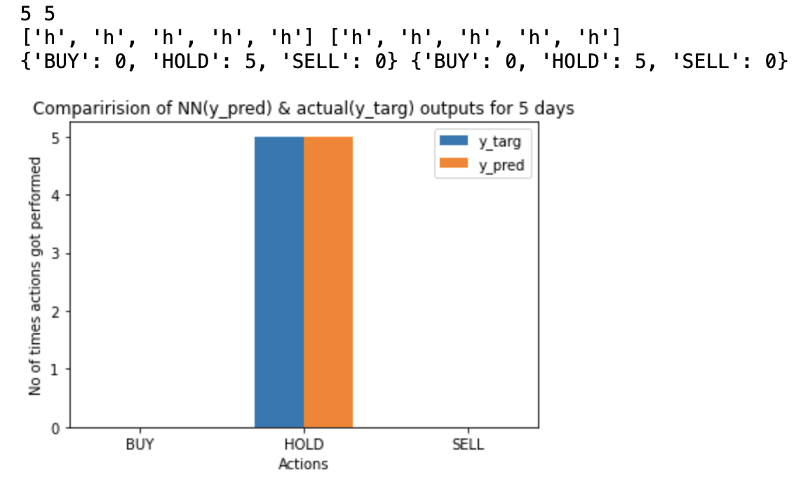

**The comparison between y_targ and y_pred for 25 days**

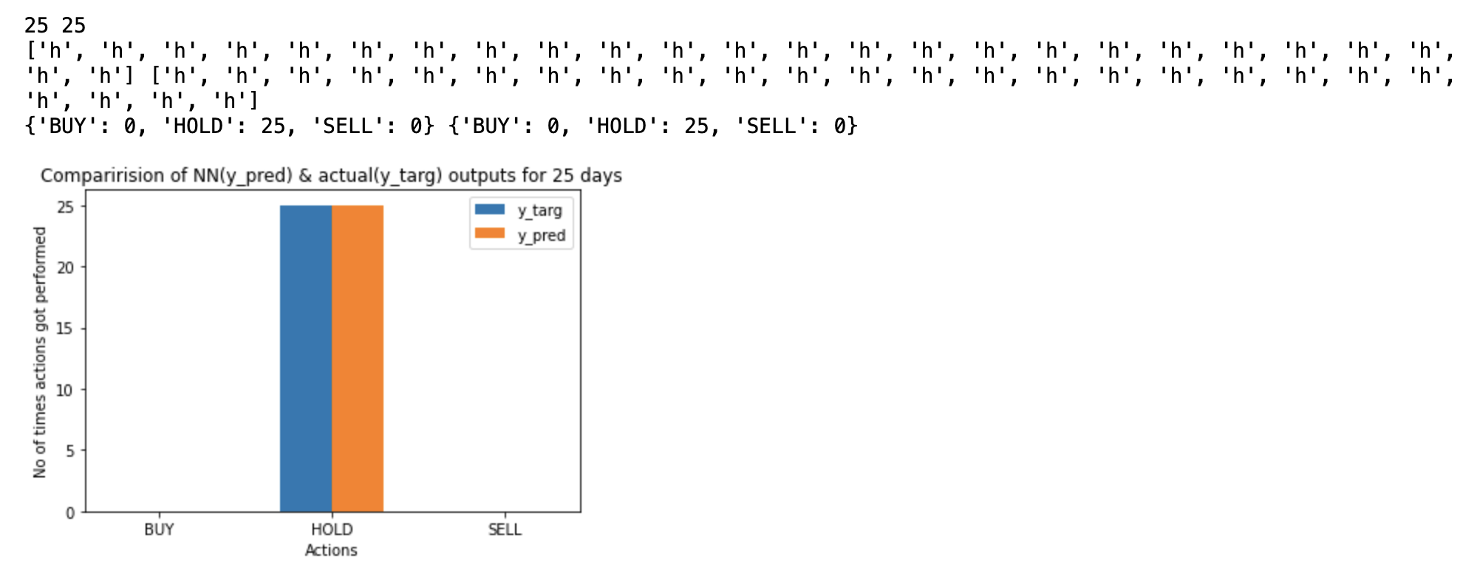

**The comparison between y_targ and y_pred for 45 days**

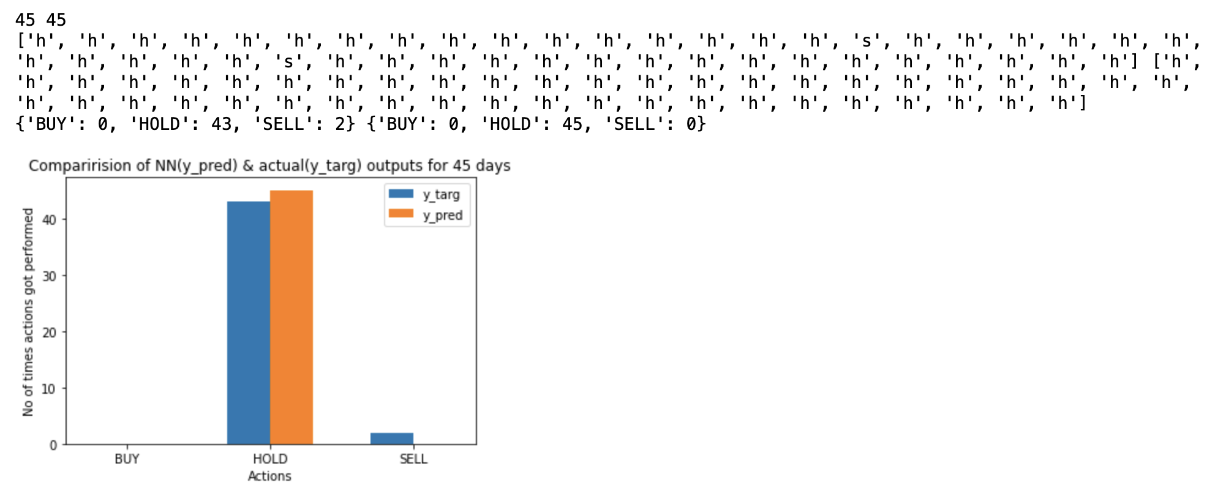

**The comparison between y_targ and y_pred for 65 days**

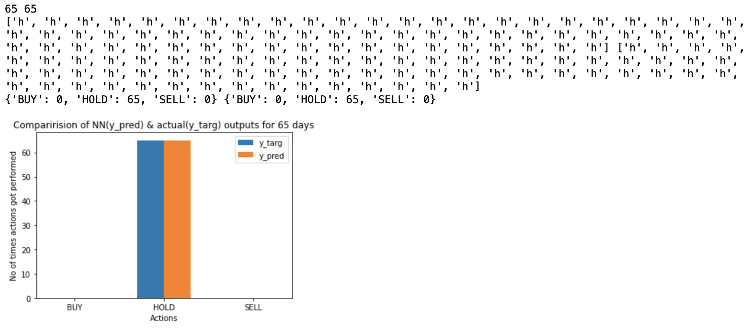

**The comparison between y_targ and y_pred for 85 days**

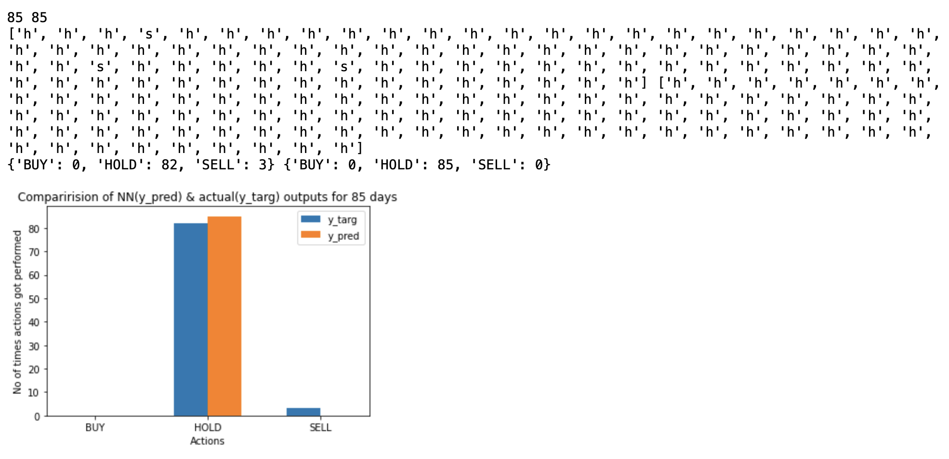

**After training, use 100 games at each problem instance size to show the performance of your NN-based AI, similar to milestone 2. If your game is one-player, then plot histograms of the final score for each of three AIs: baseline, tree-based, and tree+NN based. If it is multi-player, use the tree+NN-based AI for one player and the tree-based AI for the other players, and plot histograms of the final score for the tree+NN-based AI.**

The performance of final score graphs for baseline & tree based AI at each of 5 instances were already plotted in milestone 2 which can also be seen in the second section above.

**The final score graph of NN+Beam search AI [3] for 5 days**

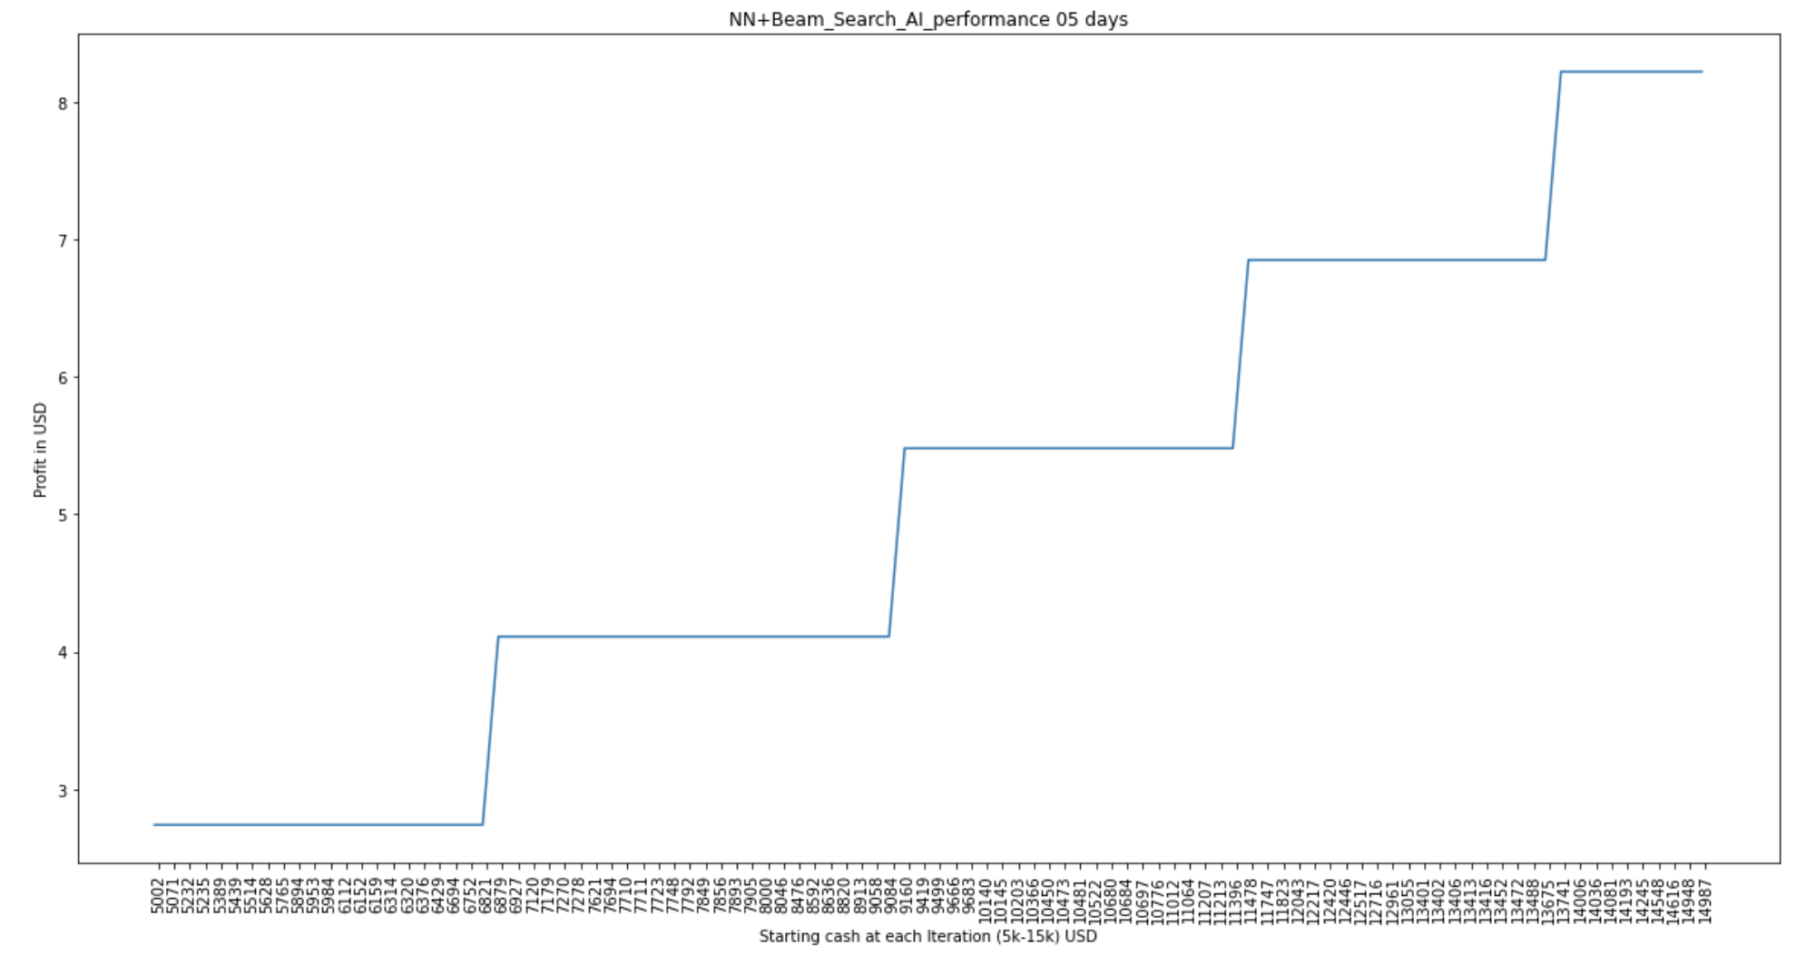

**The final score graph of NN+Beam search AI [3] for 25 days**

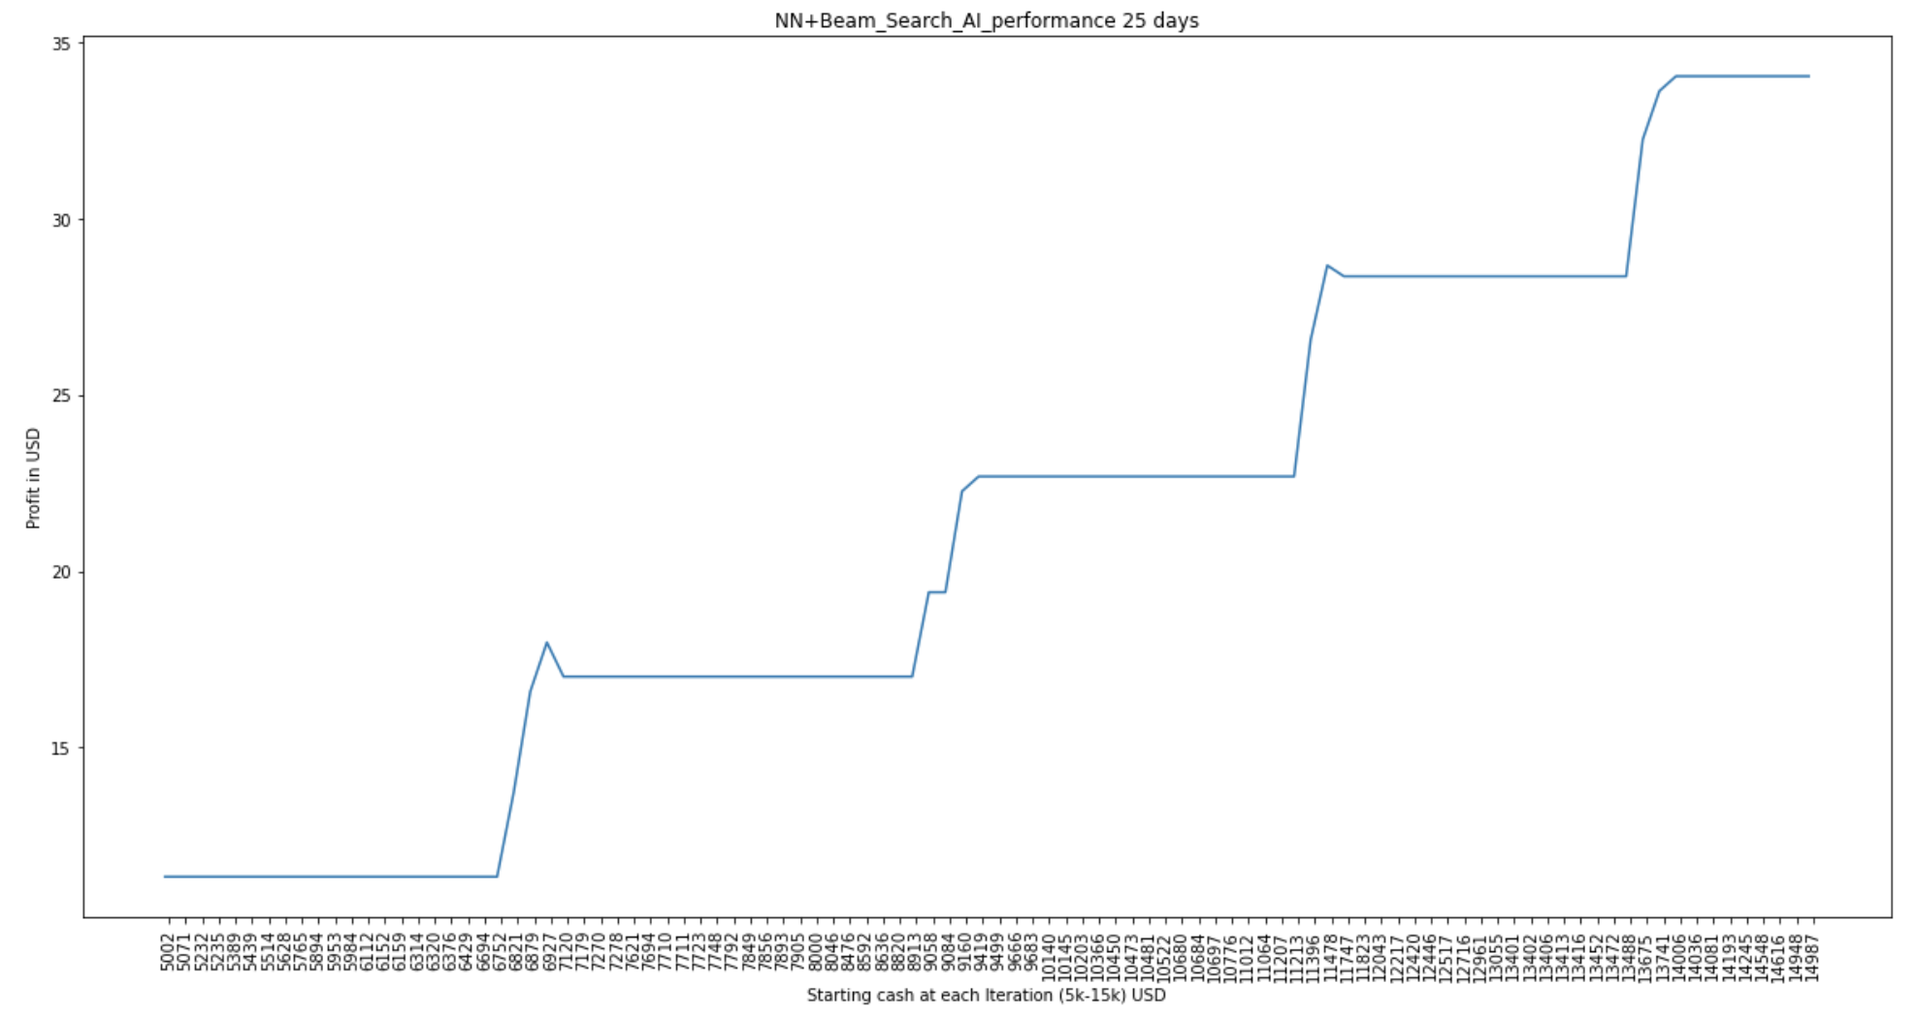

**The final score graph of NN+Beam search AI [3] for 45 days**

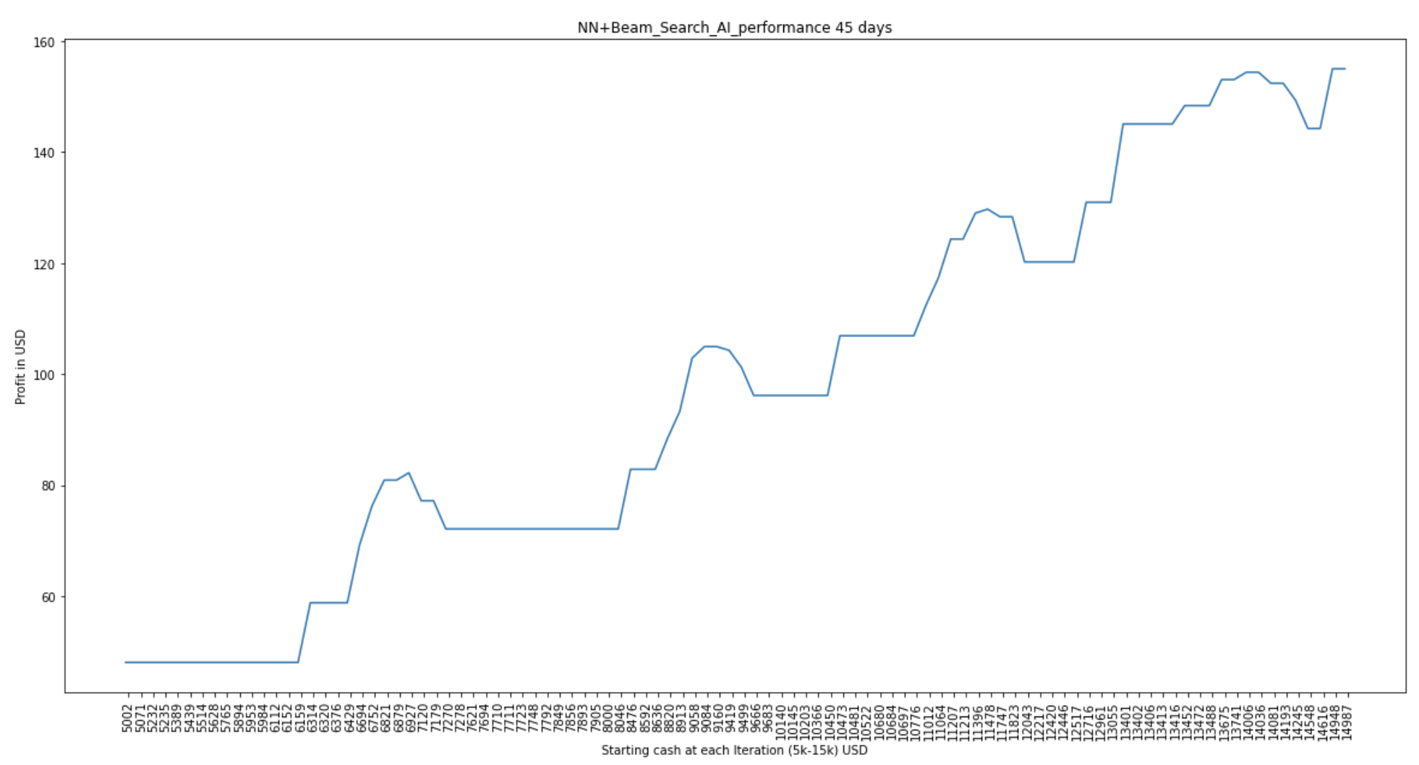

**The final score graph of NN+Beam search AI [3] for 65 days**

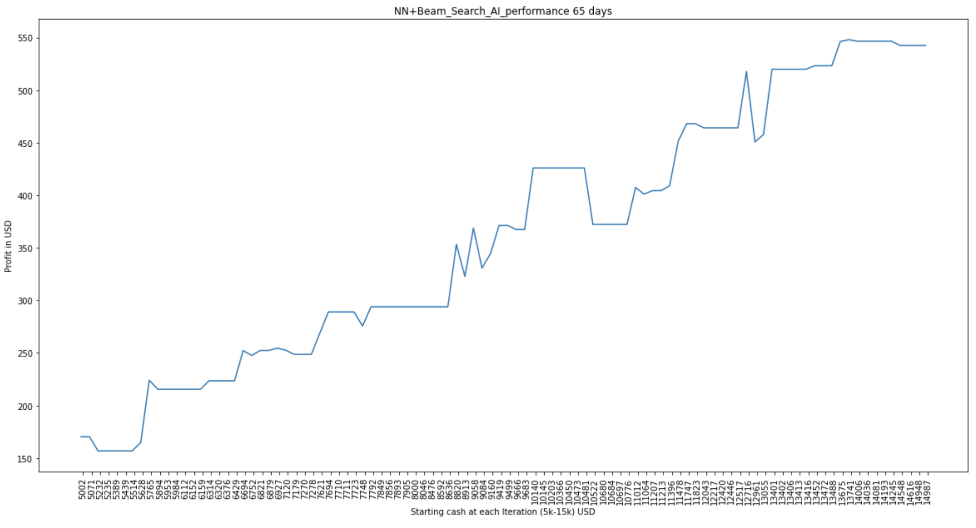

**The final score graph of NN+Beam search AI [3] for 85 days**

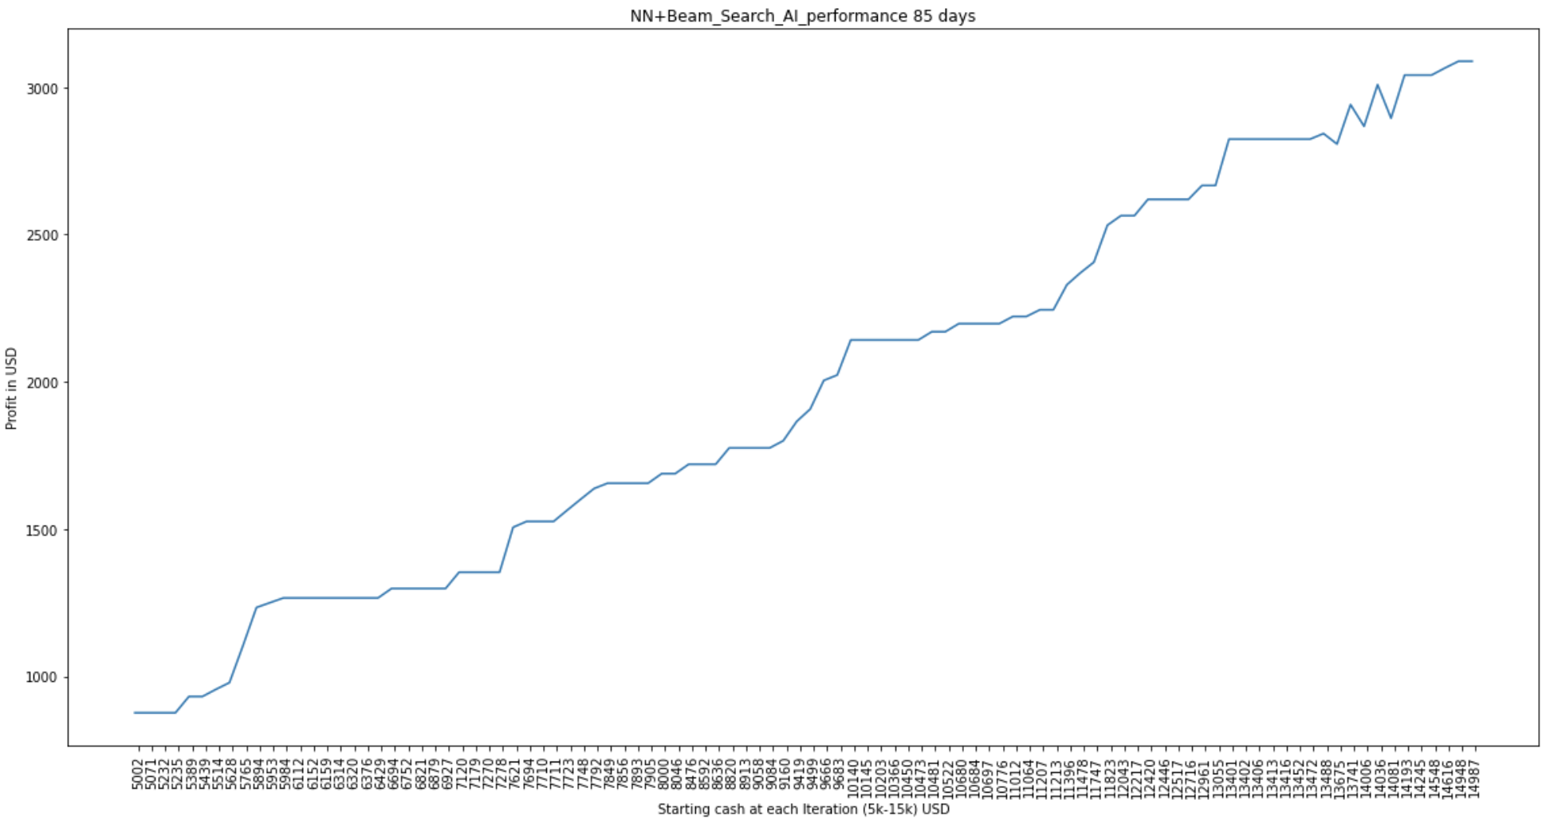

1. References

[1] FactSet: FactSet Research Systems. (n.d.). Apple Inc. [Company profile]. Retrieved September 18, 2020, from [https://www.factset.com](https://www.factset.com/)

[2] Yahoo! Finance: NASDAQ. (2020, September 17). (AAPL). [Stock quote]. Retrieved from <https://finance.yahoo.com/quote/AAPL>

[3] Beam Search: Reddy, D. Raj. "Speech Understanding Systems: A Summary of Results of the Five-Year Research Effort. Department of Computer Science." 1977.

[4] Sepp Hochreiter; Jürgen Schmidhuber (1997). "Long short-term memory". Neural Computation. 9 (8): 1735–1780. doi:10.1162/neco.1997.9.8.1735. PMID 9377276. S2CID 1915014.

[5] Sepp Hochreiter; Jürgen Schmidhuber (21 August 1995), Long Short Term Memory, Wikidata Q98967430.

[6] Sepp Hochreiter; Jürgen Schmidhuber (1997), "LSTM can Solve Hard Long Time Lag Problems" (PDF), Advances in Neural Information Processing.

[7] ReLU Activation: Vinod Nair and [Geoffrey Hinton](https://en.wikipedia.org/wiki/Geoffrey_Hinton) (2010). [Rectified Linear](https://www.cs.toronto.edu/~hinton/absps/reluICML.pdf) Units Improve Restricted Boltzmann Machines (PDF). ICML. https://keras.io/api/layers/activations/#relu-function

[8] Tanh Activation: <https://keras.io/api/layers/activations/#tanh-function>

[9] One Hot Encoding: Harris, David and Harris, Sarah (2012-08-07). Digital design and computer architecture (2nd ed.). San Francisco, Calif.: Morgan Kaufmann. p. 129. ISBN 978-0-12-394424-5.

[10] Gradient Descent: [Lemaréchal, C.](https://en.wikipedia.org/wiki/Claude_Lemar%C3%A9chal) (2012). ["Cauchy and the Gradient Method"](https://www.math.uni-bielefeld.de/documenta/vol-ismp/40_lemarechal-claude.pdf)(PDF). Doc Math Extra: 251–254.

[11] Python: van Rossum, Guido (31 January 2007). "(Python-Dev) Happy Birthday, Guido!". Python-Dev mailing list. Archived from the original on 8 September 2009.

[12] Numpy: "Releases – numpy/numpy". Retrieved 2 November 2020 – via GitHub.

[13] Pandas: Wes McKinney (2011). "pandas: a Foundational Python Library for Data Analysis and Statistics" (PDF). Retrieved 2 August 2018.

[14] Adam Optimizer: Diederik, Kingma; Ba, Jimmy (2014). "Adam: A method for stochastic optimization". [arXiv](https://en.wikipedia.org/wiki/ArXiv_(identifier)):[1412.6980](https://arxiv.org/abs/1412.6980) [[cs.LG](https://arxiv.org/archive/cs.LG)].

[15] Pytorch: Yegulalp, Serdar (19 January 2017). ["Facebook brings GPU-powered machine learning to Python"](https://www.infoworld.com/article/3159120/artificial-intelligence/facebook-brings-gpu-powered-machine-learning-to-python.html). InfoWorld. Retrieved 11 December 2017.

[16] Pytorch: Lorica, Ben (3 August 2017). ["Why AI and machine learning researchers are beginning to embrace PyTorch"](https://www.oreilly.com/ideas/why-ai-and-machine-learning-researchers-are-beginning-to-embrace-pytorch). O'Reilly Media. Retrieved 11 December 2017.

[17] Pytorch: Ketkar, Nikhil (2017). "Introduction to PyTorch". Deep Learning with Python. Apress, Berkeley, CA. pp. 195–208. [doi](https://en.wikipedia.org/wiki/Doi_(identifier)):[10.1007/978-1-4842-2766-4_12](https://doi.org/10.1007%2F978-1-4842-2766-4_12). [ISBN](https://en.wikipedia.org/wiki/ISBN_(identifier)) [9781484227657](https://en.wikipedia.org/wiki/Special:BookSources/9781484227657).

[18] Tensorflow: [A System for Large-Scale Machine Learning"](https://www.usenix.org/system/files/conference/osdi16/osdi16-abadi.pdf) (PDF). 2016.

Google (2015).

[19] Keras: Chollet, François (2016). "Xception: Deep Learning with Depth Wise Separable Convolutions". arXiv:1610.02357.

[20] Mean Squared Error (MSE): "List of Probability and Statistics Symbols". Math Vault. 2020-04-26. Retrieved 2020-09-12.

[21] Mean Squared Error (MSE): "Mean Squared Error (MSE)". www.probabilitycourse.com. Retrieved 2020-09-12.

[22] MinMaxScaler: https://scikit-learn.org/stable/modules/generated/sklearn.preprocessing.MinMaxScaler.html

[23] Sigmoid Activation: Han, Jun; Morag, Claudio (1995). ["The influence of the sigmoid function parameters on the speed of backpropagation learning"](https://archive.org/details/fromnaturaltoart1995inte/page/195). In Mira, José; Sandoval, Francisco (eds.). From Natural to Artificial Neural Computation. Lecture Notes in Computer Science. 930. pp. [195–201](https://archive.org/details/fromnaturaltoart1995inte/page/195). [doi](https://en.wikipedia.org/wiki/Doi_(identifier)):[10.1007/3-540-59497-3_175](https://doi.org/10.1007%2F3-540-59497-3_175). [ISBN](https://en.wikipedia.org/wiki/ISBN_(identifier)) [978-3-540-59497-0](https://en.wikipedia.org/wiki/Special:BookSources/978-3-540-59497-0).

[24] Moving Averages: Hydrologic Variability of the Cosumnes River Floodplain (Booth et al., San Francisco Estuary and Watershed Science, Volume 4, Issue 2, 2006)